**Red Hat Cloud-Native School Training**

**Module 1**: Ground zero (10 hours) – Week 1

**Module Objective**: Learner should be able to explain basic concepts of Microservices, API (Application Programing Interface), Cloud Native applications, 12 Factor app, Docker & K8s, and DevOps processes.

**1. Course Name**: Kick-Off Call

**Focus Area:** Introduction of Red Hat Cloud-Native School

Imp. Points  
> A **structured training program** to enable our teams to be Cloud Ready, focus on building cloud-native skills that would help us address the needs of the future and build effective cloud-based solutions. The program is designed to be use case driven and provide hands-on experience to participants on the Red Hat OpenShift Cloud Platform.

**> Learning Objective:**

• Working with microservices, containers & Kubernetes

• Cloud-Native Application Development

• Developing & Deploying on Red Hat OpenShift Container Platform

**> Program Scope**

• Microservices application development using Spring Boot/Node.js

• Mix of self-paced, VITL training, hands-on

• Real-life project experience as a case study for evaluation

**> Cloud-Native School: Curriculum**

Red Hat Cloud-Native School: Graduation

Ground Zero: Cloud Native & Microservices Fundamentals

OpenShift: Cloud-Native Application Development

Cloud-Native Application Development: Case Study

Microservices: Deep Dive

**> Benefits of learning this course**

•Opportunity to work on client projects with Red Hat / IBM cloud-native demands.

•Opportunity to set a road map for Red Hat OpenShift Container Platform certification (Development)

•Opportunity to reinforce the learnings on the Red Hat OpenShift

|  |  |  |  |  |  |
| --- | --- | --- | --- | --- | --- |
| Module | Module Name | Week | Duration | Module Objectives | Completion Dates |
| Module-1 | Ground Zero | Week 1 | 10 hours | Learner should be able to explain basic concepts of Microservices, API (Application Programing Interface), Cloud Native applications, 12 Factor app, Docker & K8s and DevOps processes. | Feb 14 -Feb 20 |
| Module-2 | Microservices: Deep Dive | Week 2 & 3 | 26 hours | Learners should be able to create microservices which are independently scalable applications and expose them as APIs (using either Spring Boot or Node.js). | Feb 21 -Mar 6 |
| Module-3 | Cloud-Native Application Development on OpenShift | Week 4, 5, 6, 7 | 45 hours | Learners should be able to able to deploy new or existing applications, as well as perform other DevOps-related tasks using the Red Hat OpenShift Container Platform. | Mar 7 -Apr 1 |
| Module-4 | Case Study Assessment | Week 8 | 15 hours | Learners will be tested on their ability to develop cloud-native applications focusing on implementing business capability using microservices communicate via Application Programing Interface Container adoption to support application deployment and self-contained execution environment | Apr 1 -Apr 8 |

> What’s Next

•Red Hat Cloud-Native Specialist

•Red Hat Accreditation & Certification

**2. Course Name:** Cloud-Native Applications with Microservice Architectures

**Focus Area**: Identify the proper frameworks & tools to build your microservices architecture

**Resource:** Register on Red Hat with personal or official mail id individually for this course.

**Red Hat Url**: <https://www.redhat.com/en/services/training/do092-developing-cloud-native-applications-microservices-architectures?section=Overview>

**Contents Covered:**

|  |  |
| --- | --- |
| Sr. No. | Topics |
| 1. | Deploying Cloud-Native Applications with Microservices Architectures Introduction |
| 2. | Microservices Overview: What and Why? |
| 3. | API: Building and Deploying a Microservice (and demonstration) |
| 4. | Discovery and Invocation (and demonstration) |
| 5. | Microservices Patterns (and demonstration) |
| 6. | Circuit Breakers (and demonstration) |
| 7. | Pipelines (and demonstration) |
| 8. | Authentication (and demonstration) |
| 9. | Logging, Monitoring, and Tracing (and demonstration) |
| 10. | Blue/Green Deployment (and demonstration) |
| 11. | Canary Deployment (and demonstration) |
| 12. | Moving from Monolith to Microservices |

**1. Deploying Cloud-Native Applications with Microservices Architecture Introduction**

> We’re going to focus on how to build an API, both the development of that API & the deployment of it into Docker & Kubernetes otherwise known as OpenShift backplane.

> We’re going to see service discovery & invocation. The concept that A can find & call B is very, very critical in a microservices architecture.

> We’re going to demonstrate elasticity as well as patterns of how you actually invoke & execute things.

> We’re going to see resilience in action. So, if you have heard of a Circuit breaker, & Hystrix where you can kind of see what it means when invocation happens & the invocation fails, or the invocation is too slow & that can be very critical in the microservices architectures.

> We’re going to see the pipeline i.e., Jenkins for continuous integration, delivery & deployment pipeline.

> We’re going to see security because securing these endpoints is very important. The overall microservice system has some form of authentication & authorization.

> We’re going to see the basics of logging, monitoring & tracing i.e., the concept that where you need to be able to find where a transaction has gone throughout your system. For e.g., let’s say a business transaction comes in from an end-user & now you need to actually have the tracing of A calling B calling C calling D, so you actually see all those downstream invocations, and actually know what transaction they are tied to.

**2. Microservices Overview: What and Why?**

> In short, a microservice **architectural style** (*style is a keyword here means that like all styles, they will tend to fade over time*) is an approach for developing a single application as a **suite of small services** (*the idea is you don’t have a single code base, you have many codebases, otherwise known as microservices & many independent teams managing those independent codebases*), each running in its **own process** (i.e., its own operating system process) & communicating with lightweight mechanisms, often an HTTP resource API.

> These services are built around business capabilities & independently deployable by fully automated deployment machinery. There is a bare minimum of centralized management of these services, which may be written in different programming languages & use different data storage technologies.

> HTTP is the most common invocation mechanism, you can use some other invocation mechanism whether be AMQP or MQTT, UDP, TCP, etc.

> Microservices is fundamentally about **agility** & agility breeds **speed**.

> One way you get greater agility, though, is by breaking this 3-month deployment cycle. 3-month deployment cycle is the primary metric to know how fast your organization is delivering value to the business itself. Your code offers no value to the actual business until it lands in production, & if it only lands there every 3 months, that’s the only time you’re offering value that’s once every 3 months i.e., 4 times a year so we actually want to shorten this deployment cycle & we can do that with numerous techniques.

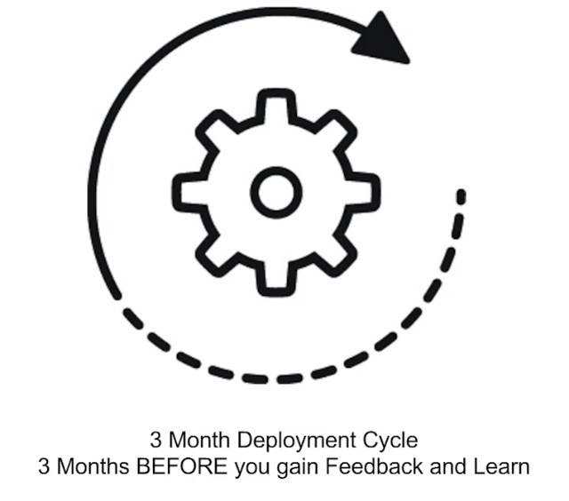

> One, you need to reorganize to **DevOps**. If you’re still fundamentally in the mode where the developer throws it over the wall to the operations team & basically runs away from their software & hopefully the operations folks can actually make that mess run but the developers are responsible for it. That’s a fundamental problem, & that’s the part of the culture you’ll have to change as we go forward.

So, **keep that in mind that the developers have to also be part of the ownership of the actual software package.**

> **Elasticity** is also very critical. Elasticity, in this case, means **infrastructure as code** i.e., we should have an API that allows us to provision a new virtual machine (VM), at will. Getting the new container stood up right away is an example of that.

> **Automation** i.e., if we’re still manually SSHing into servers & actually setting up different initd, system, scripts & things of that nature, we have a problem, we need to fix that. We need to have that thing fully baked out as an immutable image, as a gold standard, rather it be the VM, or the container image itself & ensure that we can actually recreate it at will using tools like **Ansible playbook**. We can also script around **Kubernetes** or **OpenShift** to do the same thing.

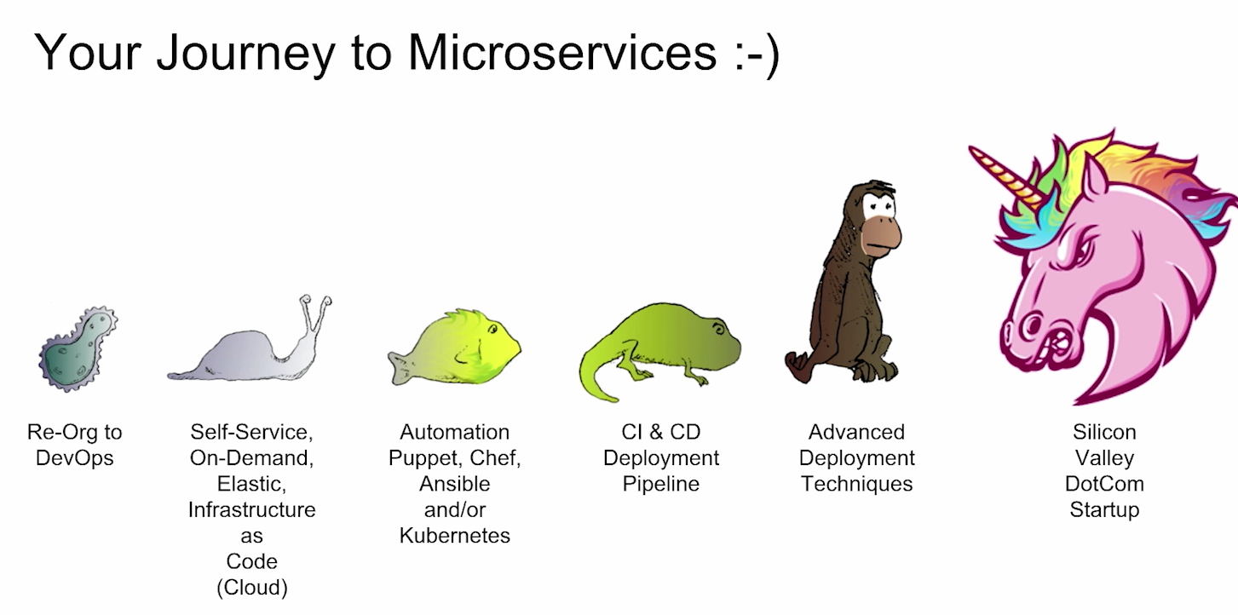

> **CI & CD** i.e., Here we want to talk about the practice of CI, not the tool like Jenkins. So, the practice of CI means that we can actually deploy from our trunk to production right now i.e., our truck is always ready to go & more importantly all developers on that project check in the trunk every day.

So, are these 2 rules part of the world you live in from a CI standpoint? Are you truly continuously integrating? Or do you have feature branches that last for like 3 weeks at a time? So, if you have a developer who’s on a feature branch & only integrates once every 3 weeks, that’s not continuous integration, that’s every 3-week integration.

> Advanced Deployed Techniques are supercritical if we want to go fast. It covers blue/Green deployment, canary deployment.

> If we do all these things, we can be like a super cool unicorn ourselves & ready for microservices is the ultimate example here.

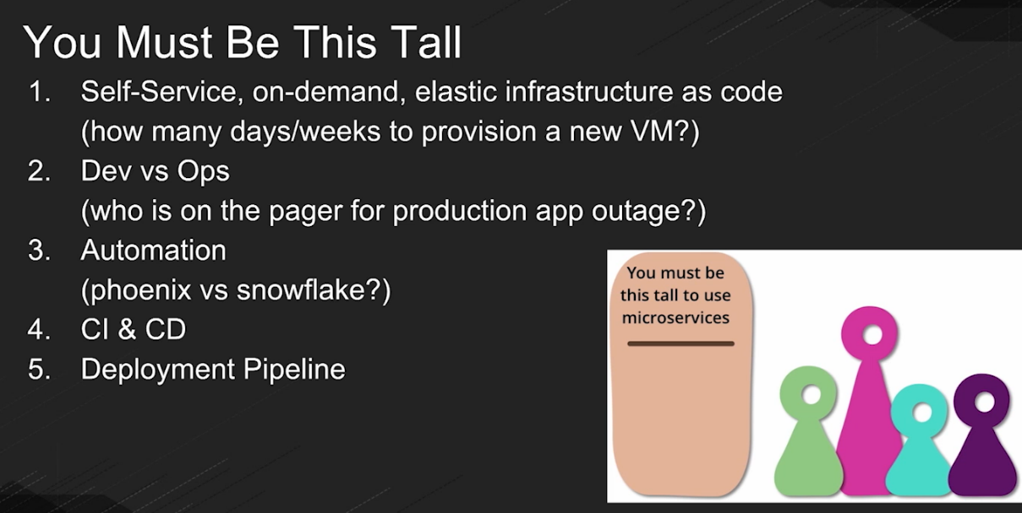

i.e., if you’re not mature enough or not big enough or not skilled enough, we probably don’t want to get on the microservices ride.

> For getting started with Microservice for this course, we need to download these contents from <https://developers.redhat.com/>

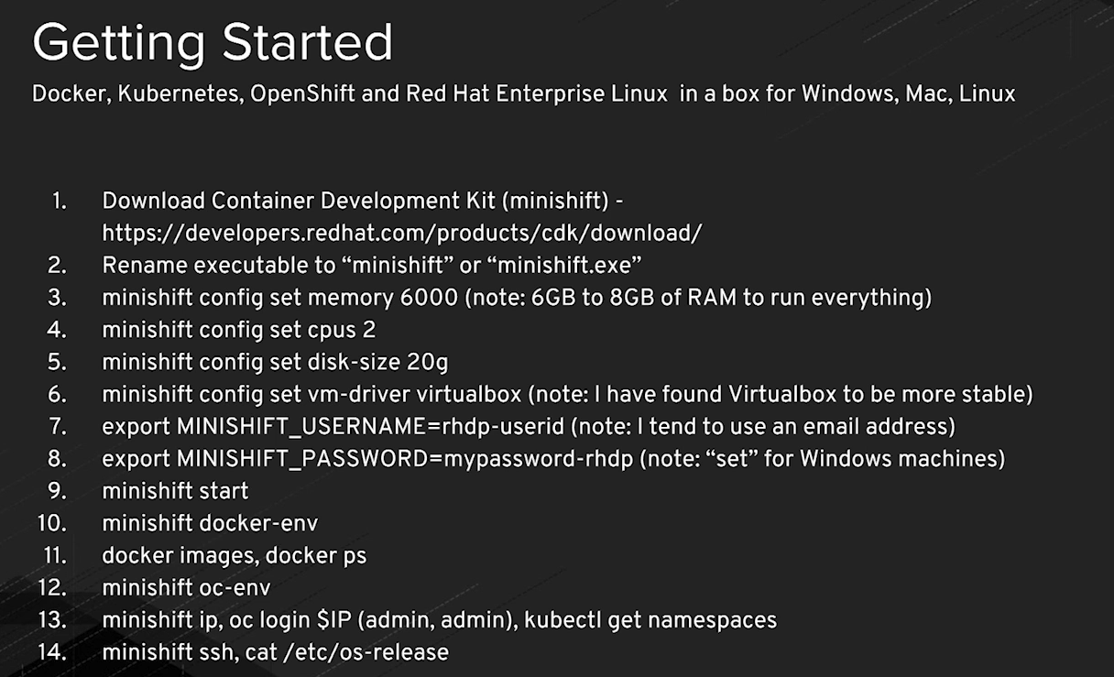

**Water Scrum Fall**

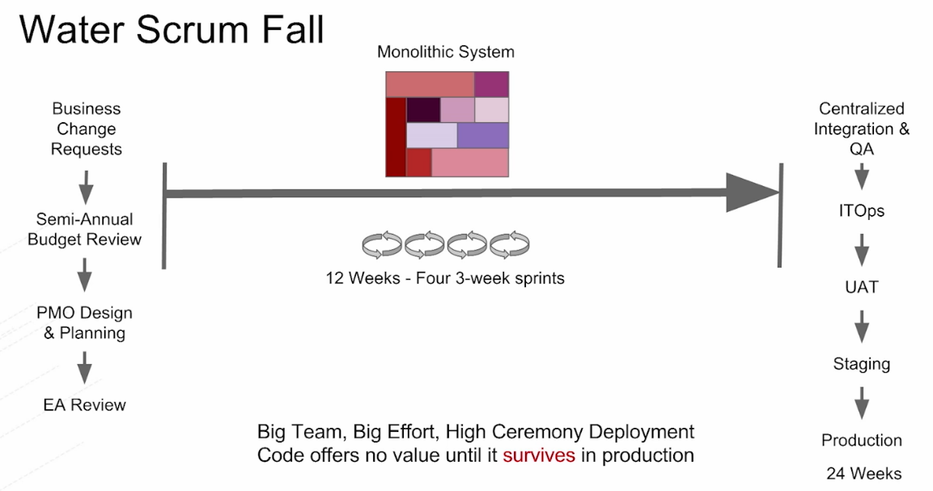

> Most of us at this point probably practice some form of agile sprint cycle i.e., we have a 2-week sprint or 3-week sprint cycle, daily meeting, burn down chart, etc. we do all the Agile kind of things.

> The problem is with Water Scrum fall, on the front end of that i.e., the waterside of it, we might have a 6-month planning cycle i.e., basically, we’ve planned in advance for budget & we’ve actually had a budgetary committee that had to weigh in on which projects we’re going to do this year, we’ve had an enterprise architectures team work on it, we’ve had a PMO design it, sign off on it, & of course all that’s part of the upfront that takes months in many cases before we can even start doing our development.

You also have the back end of that. So, on the other end, you have maybe a centralized QA team, an integration team they’re responsible for ensuring that the package delivered to production is exactly what they thought it should be & so on i.e., these things take a long time so this is a big cycle in the end & that’s it’s called Water Scrum fall.

> So, here, if we think of our monolithic system that we have today, it might be that it takes every 12 weeks to actually build it, have as much automated testing run as possible, & then deliver it. Ideally, we do that in a 12-week window.

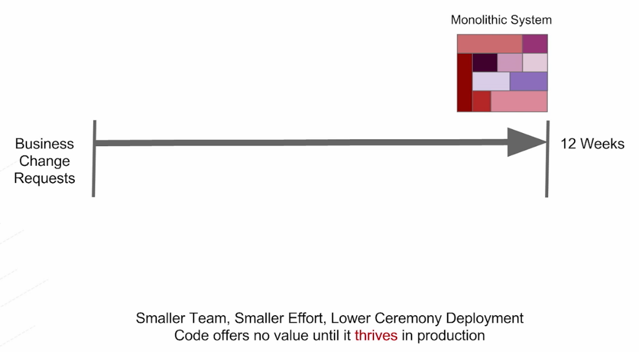

> Now, if we bring in a little bit more agile thinking though, we can think of the 12 weeks as 4 * 3-week sprints or maybe 6 * 2-week sprints. It really depends on each organization.

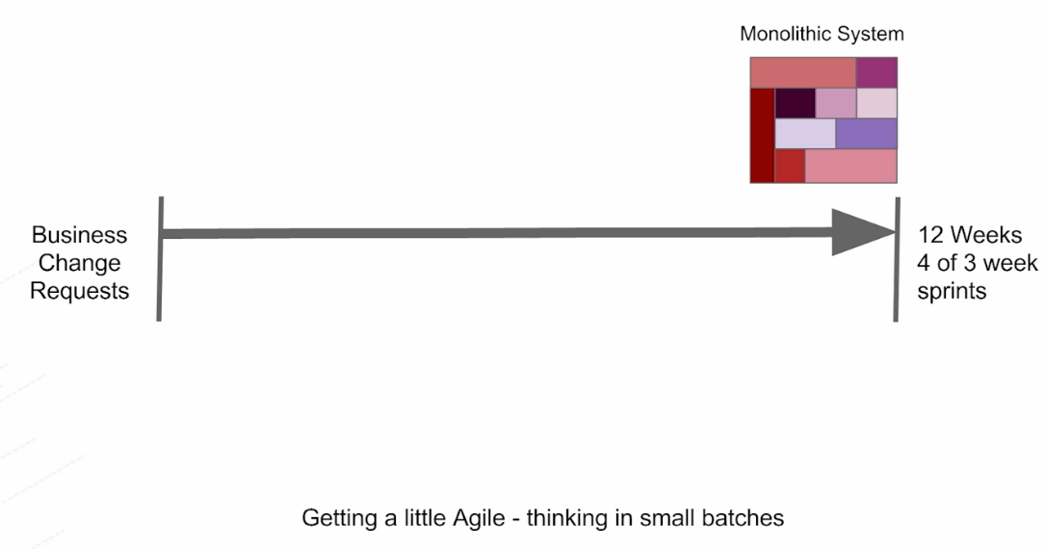

> Now, we have to think in terms of how we make it faster. For instance, if I actually bring in tons of great automated testing instead of manual testing, we can shrink that original 12-week bucket right down to 6-weeks, just through automation of simple things like testing.

> We also have to think in terms of automating our continuous integration & build automation, the people who are using proper version control, getting their continuous integration correct, getting their build automation correct is still a challenge for them.

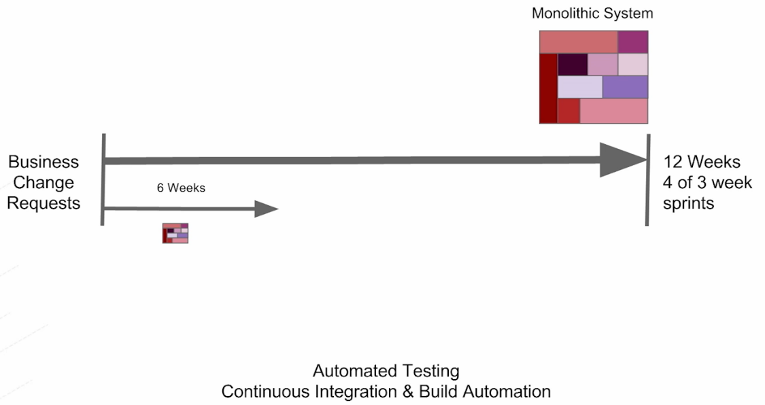

> Now if we start thinking in terms of really automating it & adopting things like, either great VM technology, specifically where we can manage & orchestrate our virtual machines at scale, or in containers. So, little containers are even lighter weight, easier to manage, & we have something like OpenShift or Kubernetes to work with that then it makes that automation even easier & we can actually shrink that cycle time.

> Now the developer no longer waits for a week or two, or three for that resource, they wait maybe 30 seconds to start doing the development.

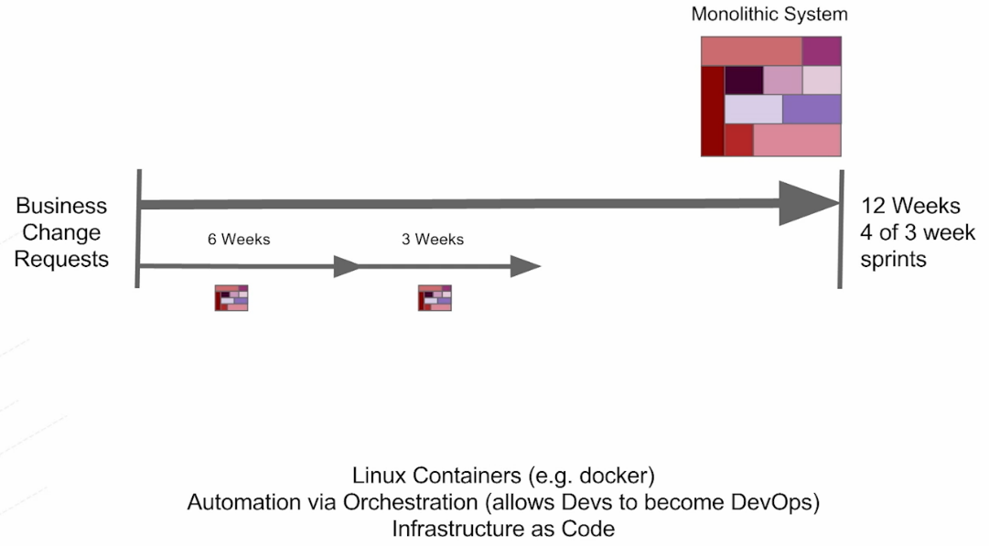

> Now, we can start thinking in terms of the continuous delivery (CD) pipeline. CD means that we’re now automating all the other tasks. We’re not just doing automated builds for every check-in as we do with CI, we’re now actually saying, let’s actually take the package that went through some form of pull request ideally, did the automated testing, did the code review, & then went into the actual rest of the pipeline.

> Everything prior to production is really part of the continuous delivery pipeline & continuous deployment is when you actually get to production.

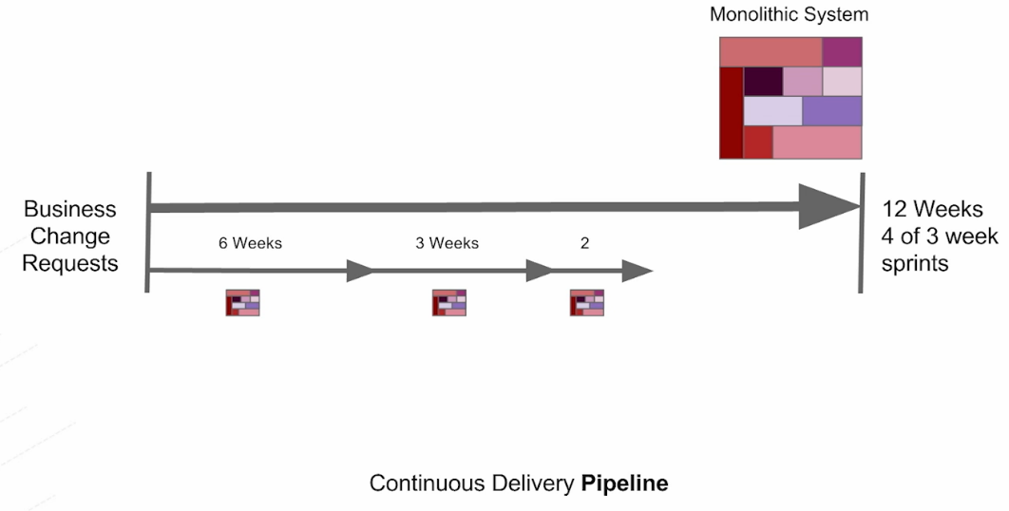

> Now we can start thinking in terms of zero-downtime deployment strategies. One thing that’s always a concern for people is when they actually are deploying really, really super-fast. If we deploy in 3 months, that’s fine for us. That’s fast. Because if we actually broke that speed barrier & start going even faster then we’d be breaking things in production.

> Well the concept of the blue/green deployment & the canary deployment allows you to break things in production. We basically deploy to production & when it’s broken, we roll it right back instantaneously.

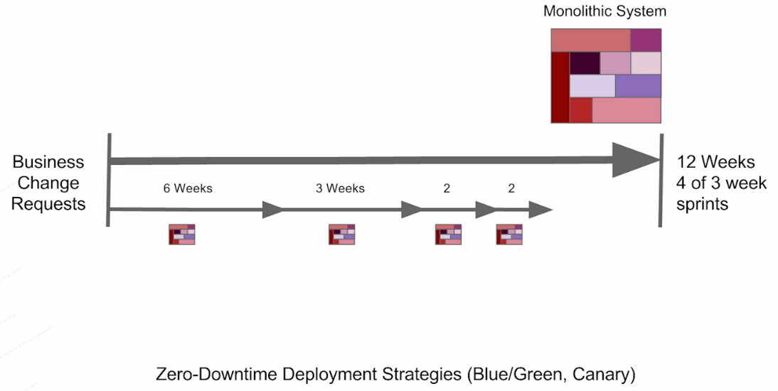

> Over time we’re going to be building a high trust environment i.e., if everybody has this great automation, great tooling, great scripting, the great synergy between Dev & Ops and Security and QA, & all the appropriate parties associated with that overall package, & delivery of that package, we will have a higher trust environment, & we will deliver even as fast as one-week increments.

> So, we’ve seen organizations adopt many of these strategies & actually deliver, from what it was a 3-month deployment cycle, now is a 1-week deployment cycle.

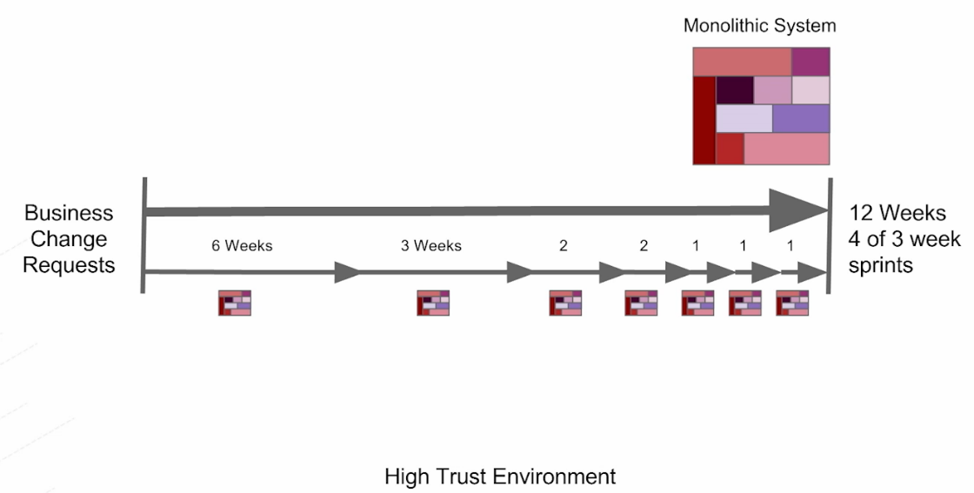

> Now there’s something odd about this chart i.e., if we have 3-week sprints, how do we actually go faster to production than every 3-weeks? In this case, we can get down to 1-week intervals.

> So, we have to start thinking in terms of all of our deliverables. It’s not just the one & done software package that you’ve created, the one microservice, the one application you’ve created, but it’s also all the patches at OS level, developer level, container level, VM level or JVM level or maybe the server, or framework, etc. over time. So, that would help us get faster than 3-weeks.

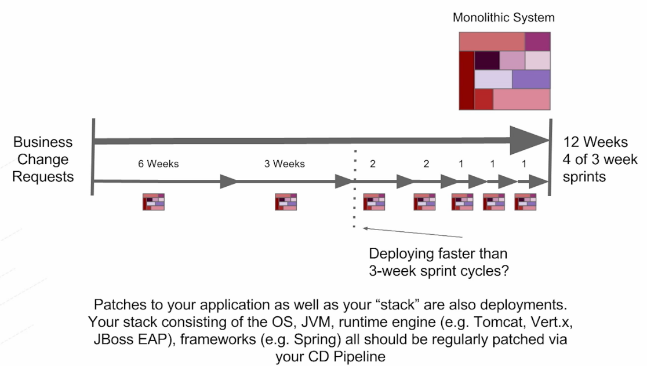

> Now things have evolved and there can be 50 deployments per day. So, the concept of going even as slow as one week is still too slow for a lot of these organizations.

Q. How do you actually move at the speed of, let’s say, a Silicon Valley unicorn? How do you get to 10 deployments per day?

Ans: - Well, we have to take that component i.e., one monolithic system & break it up into let’s say 10 individual components with 10 individual teams, that can deliver at their own pace, at their own interval, patching what they need to patch when it should be done, & actually deploying the functional aspects of that to their business, building new business capability with the pace the business needs them to match. So, in this case, now we could go faster than once a week. We could actually go every day if we needed to, with the new deployment into the production environment, just simply by breaking up that one big code base into smaller pieces.

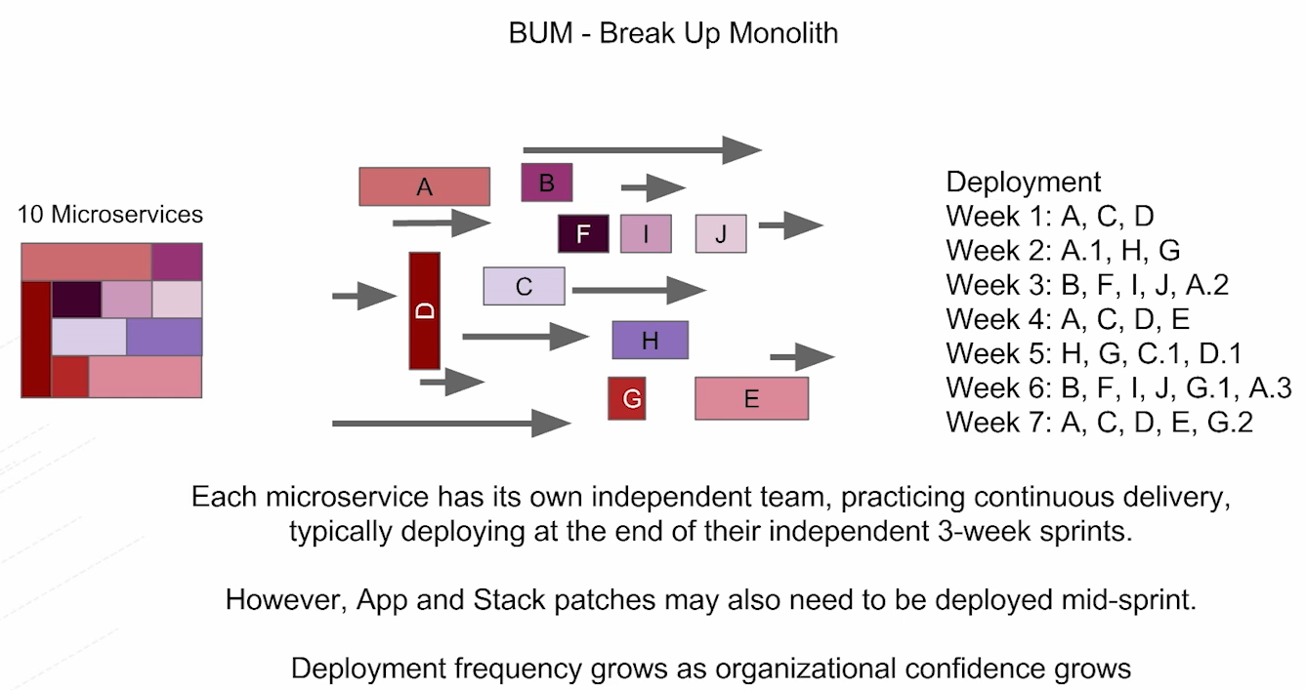

> We have the JVM sitting on top of OS. Inside OS, we have the application server where we package our application into EAR & in our EAR, I would pack in multiple WARs or JARs & of course all that gets put into this one monolithic application.

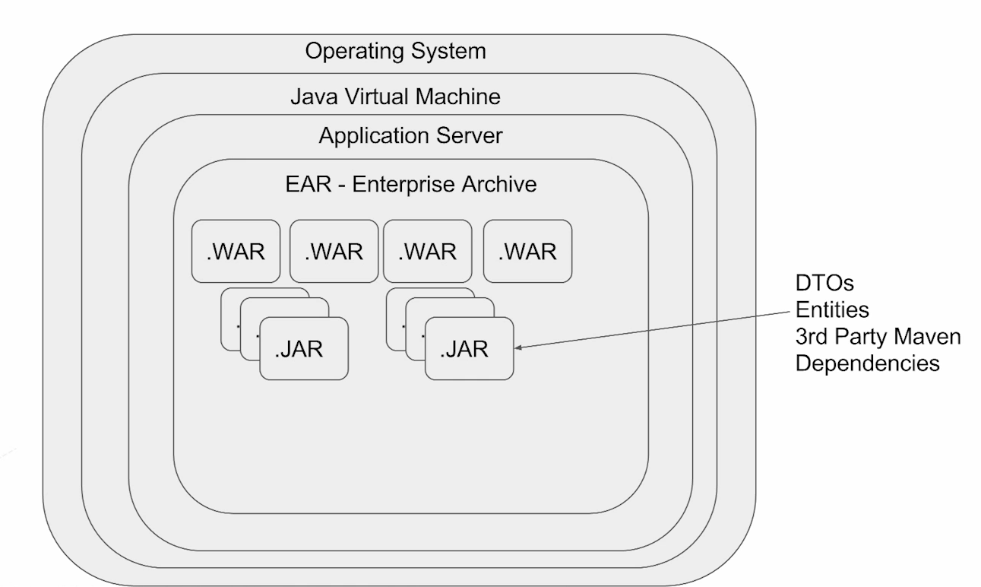

> So, the real problem with this architecture

• Everyone has to agree on the version of the OS, JVM version, App server version, Spring version, hibernate version the configuration of all these things, including the patch level, & then we all have to agree on all our third-party dependencies. So, we want to make sure that we actually do agree on all of these dependencies.

• We might have a relatively large team to actually babysit this overall monolithic system. Like in this case, we have 40 plus individuals, there is 18 programmers, 6 operations professionals, DBAs, etc. all these folks are part of that extended team. And this is the challenge right here.

How long does it take to get 40 people to agree to anything & that’s one reason that this overall monolithic system actually move so slow.

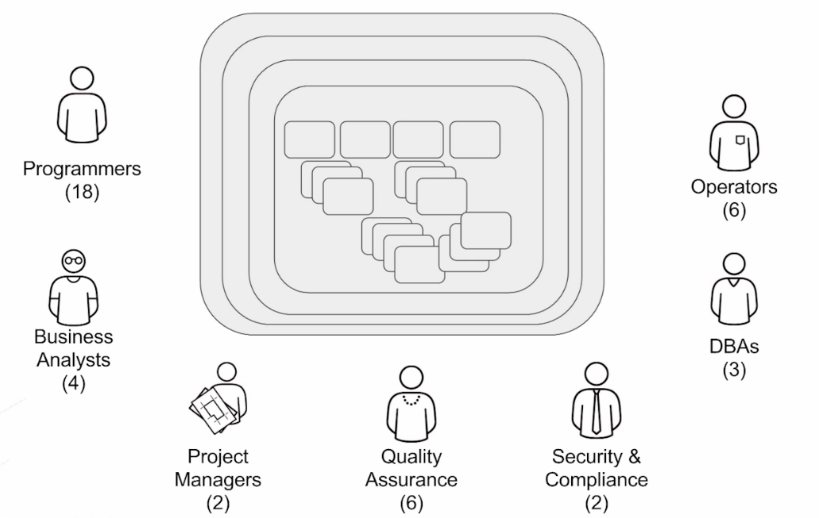

> Now, you might break up those teams into individual delivery teams that have their own individual product, their own individual component, and capability, known as the microservice & they actually are cross-functional teams i.e., they have all the skills they need to deliver their capability.

> This concept of accountability is one of the reasons these teams actually build better software faster.

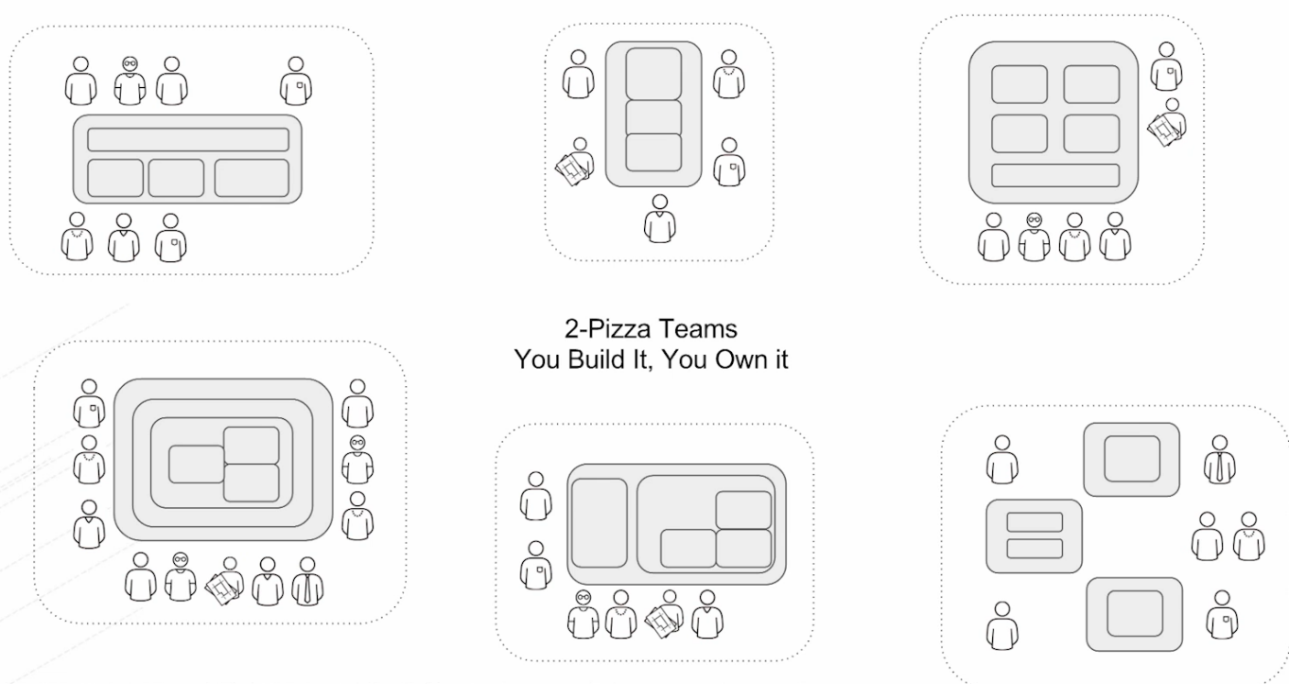

**Microservice Principles/Characteristics**

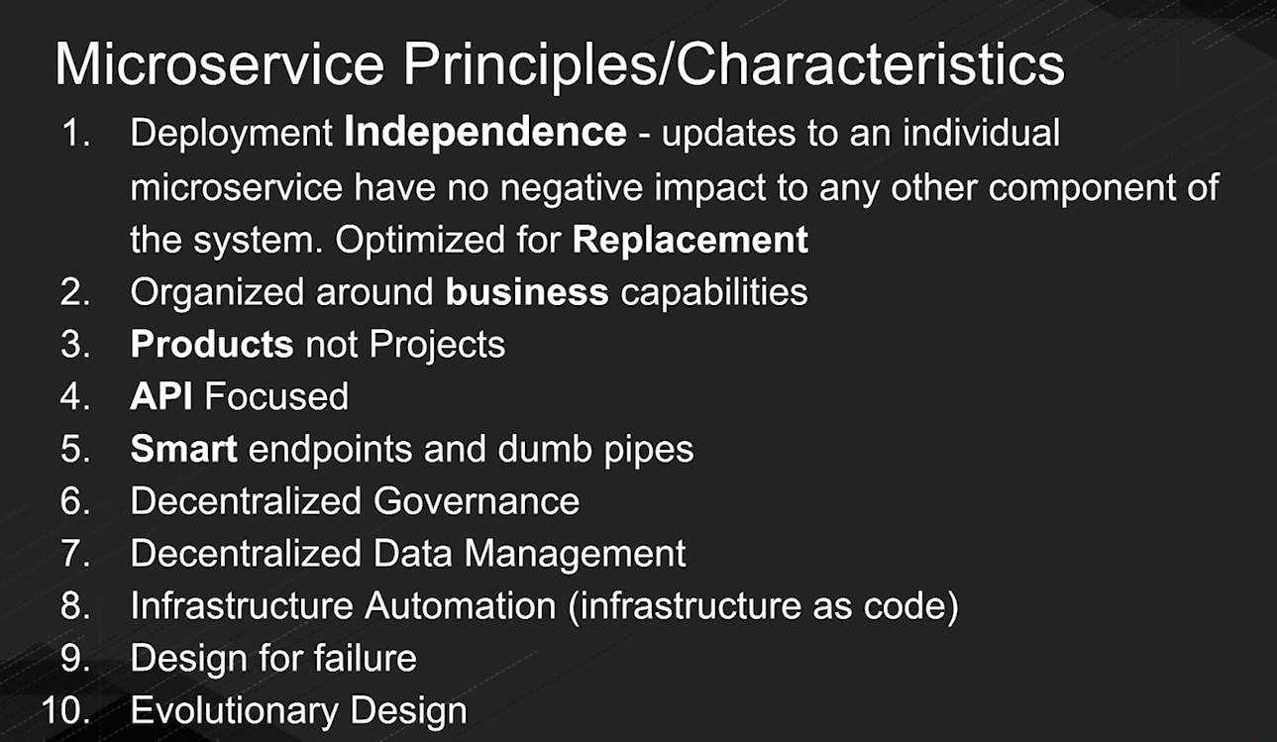

**Deployment Independence**

> We have to better deploy each of these components completely independent of each other. That’s a speed enabler. That’s an agility enabler.

> Basically, as each component comes into the system, we can do roll a change into production with zero downtime to the rest of the system. So, that’s critical.

**Organized around business capabilities**

> Typically, these folks are organized around a specific business unit or business capability. Some aspect of the system that really matters to the business, & really matters to the end-users; we wouldn’t necessarily put all this effort into some little utility component that no one really cares about.

> We got to really think about what’s offering the best business value, what does it mean to offer that business value faster by getting new software components & new software capability to that business faster.

**API Focused**

> Be very API-focused. We’re married to our public APIs, a microservice developer.

> If we break our API, we break backward compatibility, that’s the same for us as a microservice developer.

**Decentralized Governance**

> Each team is responsible for their microservices, they are responsible for building it with the technologies that matter to that specific capability

> Decentralized governance means that we can actually have teams responsible for their business capability, responsible for their delivery cycle, pick the technology that they want & quickly put that out into production.

**Decentralized Data Management**

> If we have a centralized database administration team, DBA team like many people do, they won’t let us change our schema when we want to.

> We have to decentralize this as this is of course is a big problem when it comes to any kind of speed, any kind of agility, we want a bit of change the schema based on the business requirement.

> Refer book: Refactoring Databases by Scott W. Ambler

3. API: Building and Deploying a Microservice (and demonstration)

Key Properties of Microservices

> Here we want to show you what it means to actually build, not only a thing inside the circle i.e., the individual microservice in any language/framework which is fairly easy but also all the capabilities around it that are super-critical to actually managing that thing at scale, managing it at runtime.

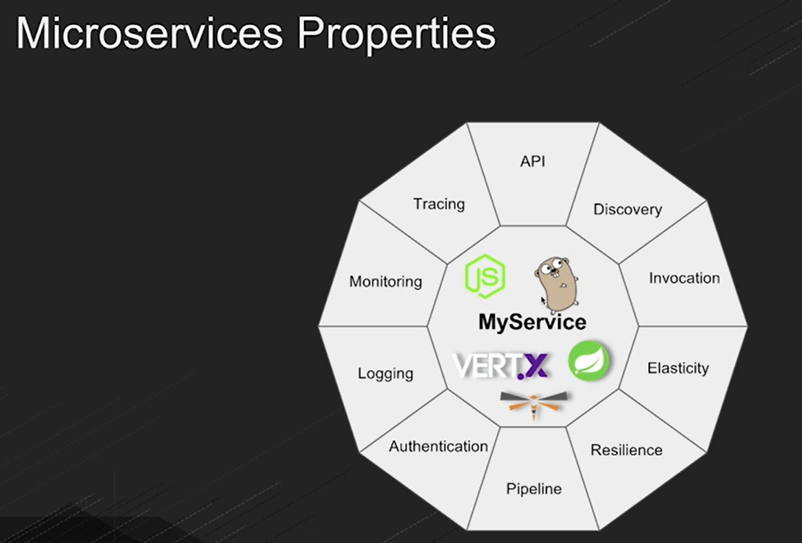

> So, let’s go into the API side of it. Making an individual microservice in different technologies is super easy. There are all these great frameworks, especially in the Java community.

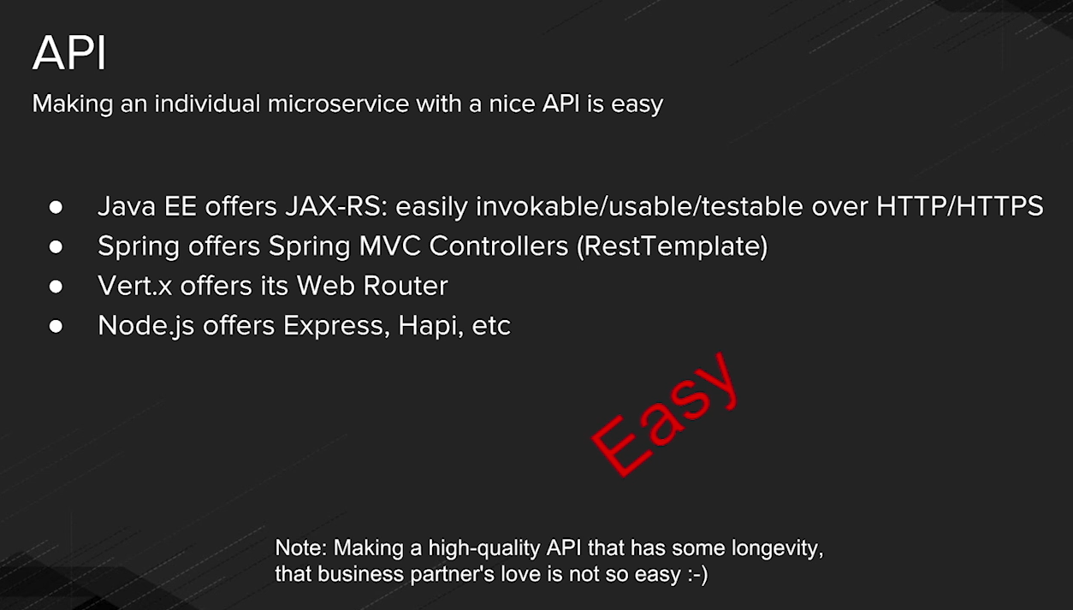

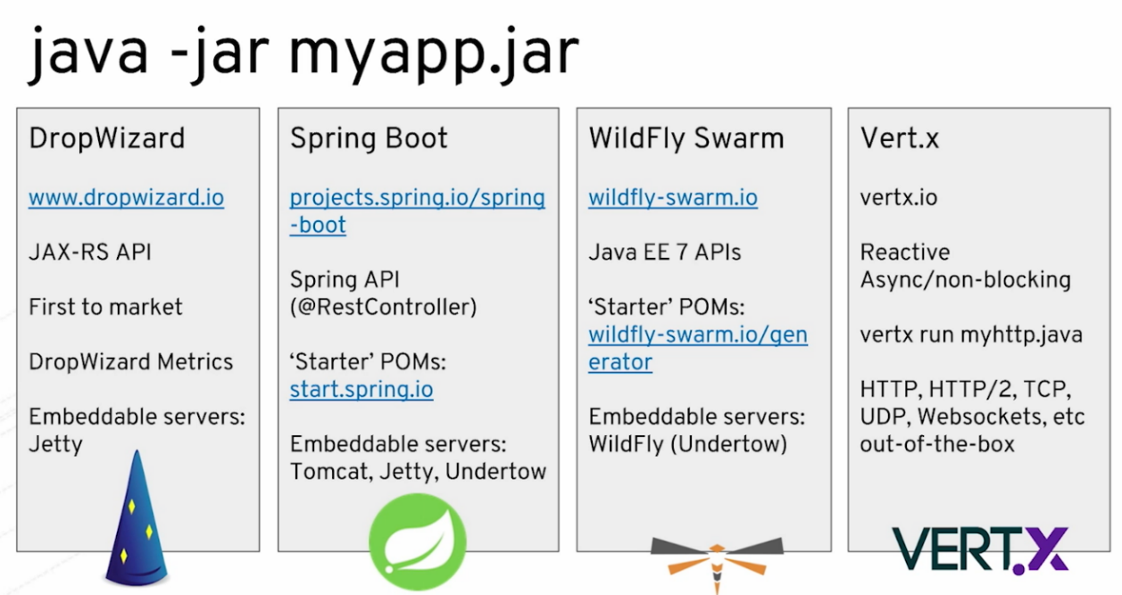

Code Snippet

> Spring Boot

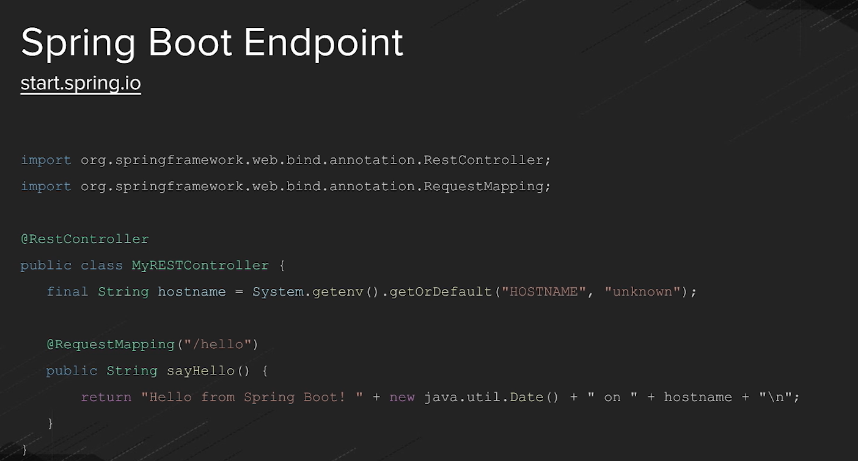

> Vert.x

> In this case, we have a Reactive Programming Model & we specifically have this concept of the router.

> This actually is a single file. We can just run directly from our command line which is very nice also. So, we actually treat, from a Vert.x standpoint, we treat Java like it’s a dynamic language.

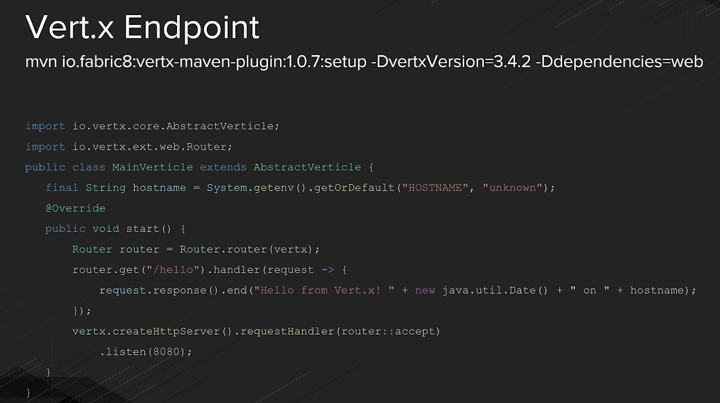

> Node.js

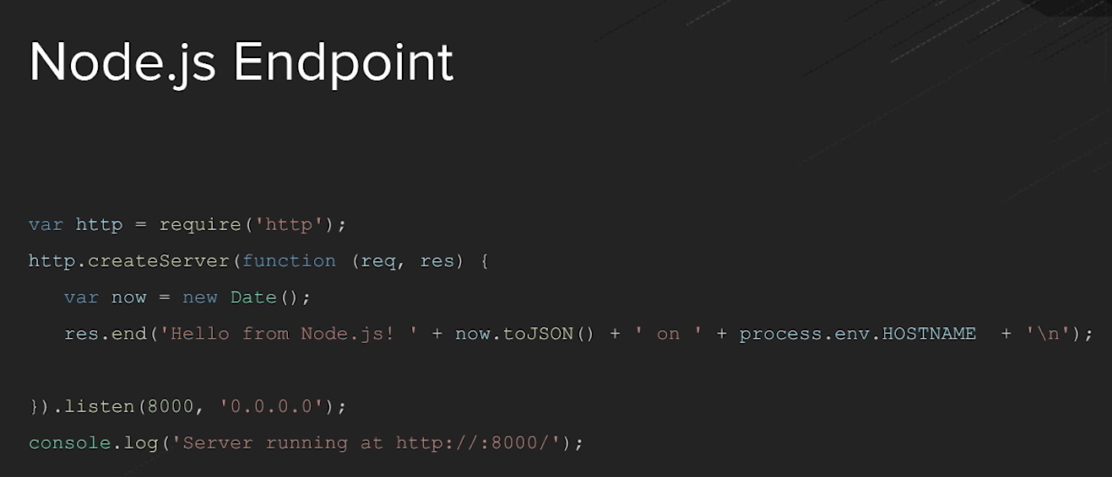

> Building a new API, building a new REST endpoint is super easy in most different technologies. It’s really a matter of how you run them, & how you execute them, and how you wire them together, to build an overall system. That’s really where the magic of microservices really comes in.

> Here is a key tip for you. Look at the fabric8 Maven plugin. So, there’s the URL here specifically, & you can use the fabric8 Maven plugin to go into an existing Spring Boot, WildFly Swarm, Vert.x, or even a Java EE application, it’ll look at your pom.xml & it’ll instrument itself in there for easy deployment, for easy docker build, for easy Kubernetes deployment or for easy OpenShift deployment.

> Once fabric8 set up, it’ll update your pom.xml & from that point forward you do fabric8 deploy and you’re now deploying into the backbone of an existing cloud, Kubernetes base cloud or OpenShift base cloud.

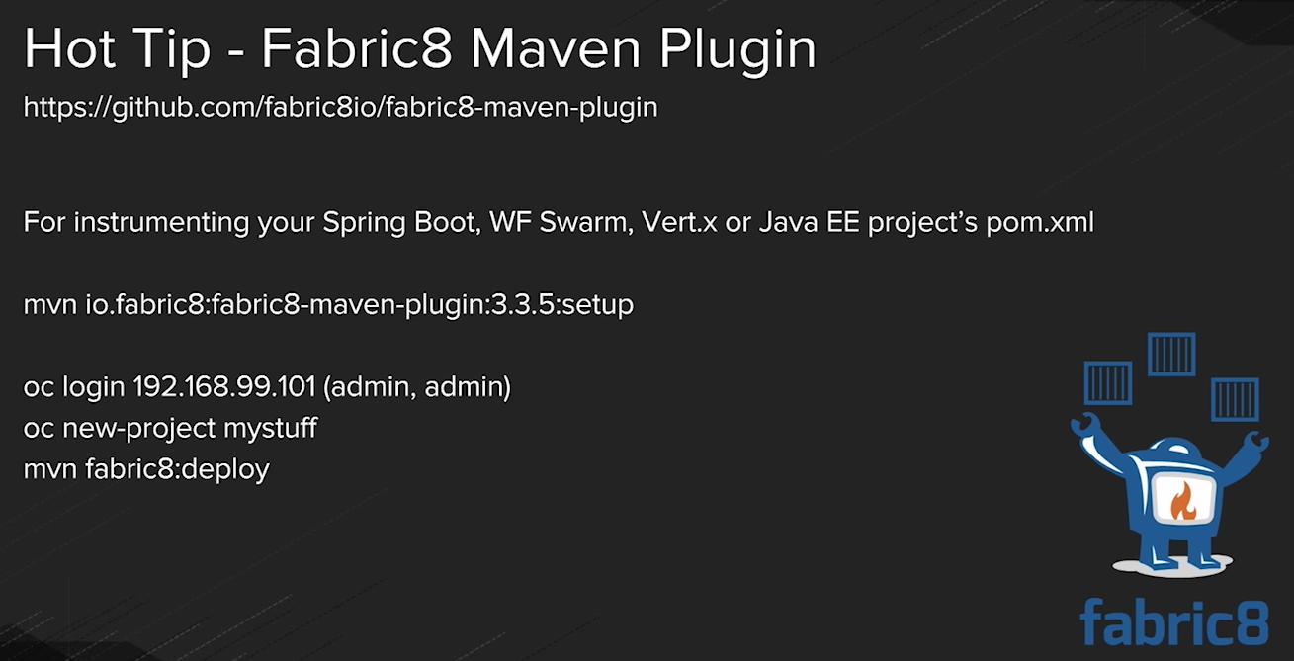

> Dropwizards, Spring Boot, WildFly Swarm or Vert.x, these are all fat JAR or uber JAR architecture.

> We can of course do a thin WAR architecture with our Dockerfile if you’re familiar with the Docker technology & how it does its layered file system. You can easily add a WAR into the existing backbone of an application server where all you’re paying each build is for the few kilobytes of that WAR file versus let’s say the multi-megabytes of the fat JAR file. So, it goes either way.

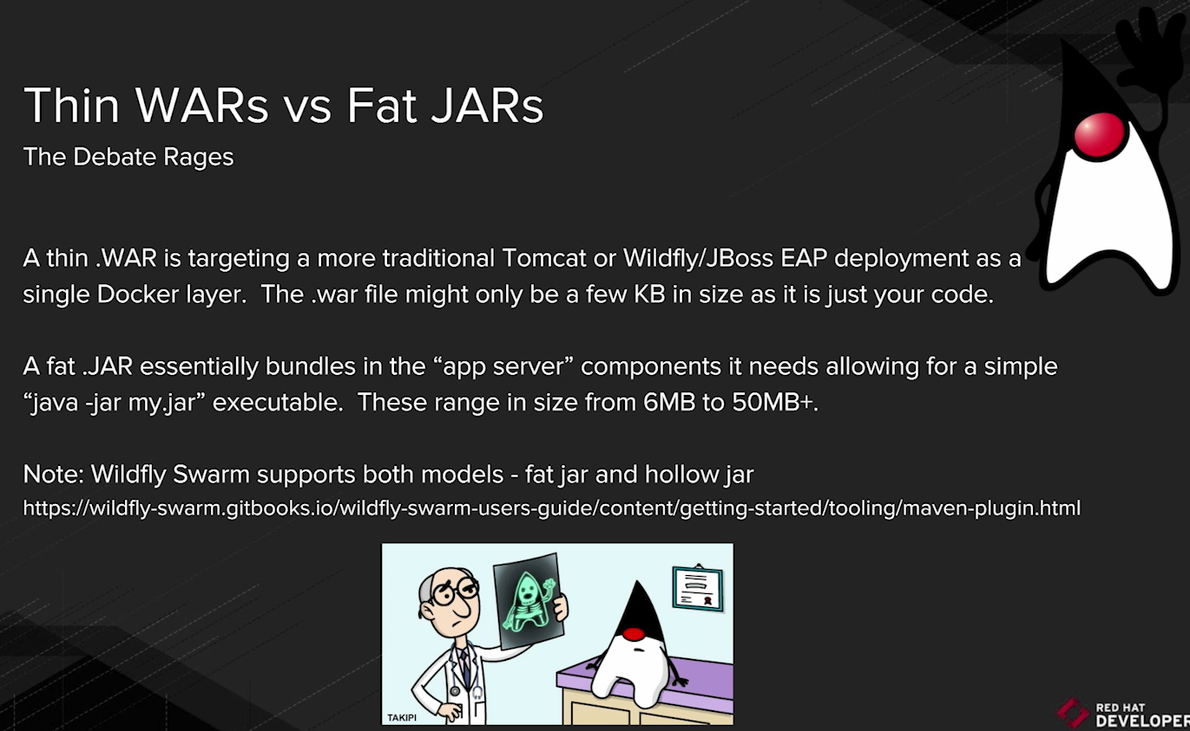

**4. Discovery and Invocation (and demonstration)**

> So far, we’ve seen how easy it is to build the new endpoint, build a new microservice, & deploy it in Docker, Kubernetes, & OpenShift.

> Now we’re going to show you how to kind of weave two of them together, because really what happens when you go from a monolithic architecture to a microservice architecture is you have many microservices, potentially 20,30,500 all with their own little independent teams deploying them.

Q. But how does one find the other? How does service A find service B & then how does it invoke? & this is a huge architectural challenge you’ll have to decide on for your organization.

Ans: Many people are leveraging HTTP because it’s easy to test each individual component, each individual API, each individual microservice & then of course allow that HTTP to come from anywhere.

> But in this specific case, we’re going to show you what it means to do discovery & invocation with Kubernetes specifically because we don’t need Eureka or Ribbon. A lot of people are taking advantage of Eureka & Ribbon specifically as Netflix projects that are out there, part of Spring Cloud Universe.

> But in the case of the Kubernetes organization, we don’t need that. Basically, every service you create, every service that we create with a load balancer built into it, we get that for free.

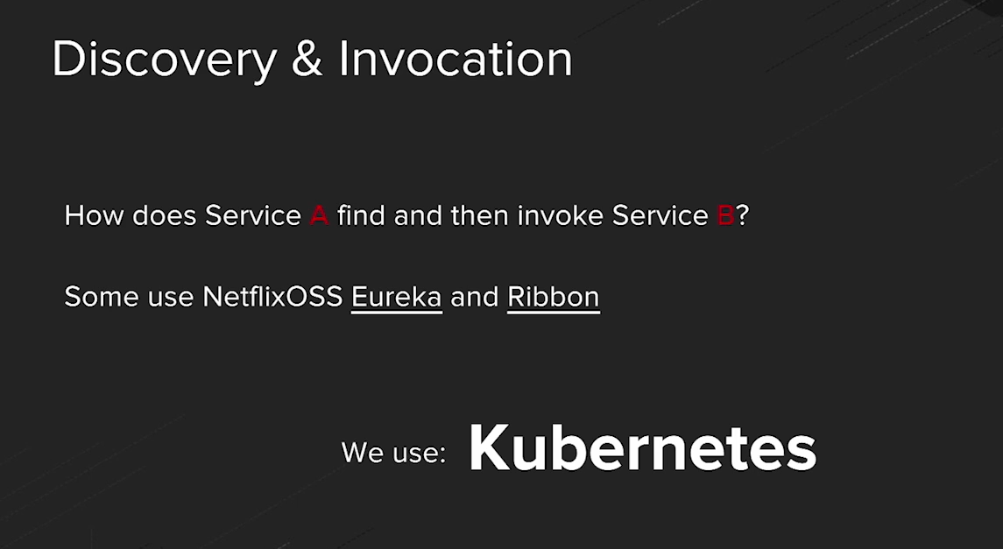

**5. Microservices Patterns (and demonstration)**

> Now we’re going to explore some invocation patterns. In this case, we’re going to talk about not just A calling B, as we saw earlier, where the consumer calls the producer. Let’s actually get a little more complicated, show you more complicated architecture

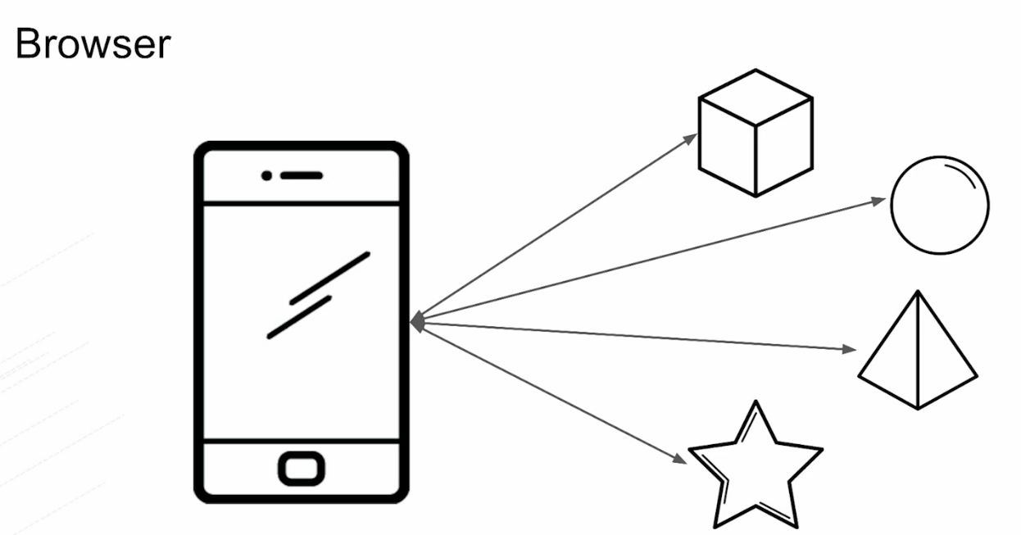

**6. Circuit Breakers (and demonstration)**

> Now we’re going to talk about resilience in our microservices architecture & circuit breakers are super-critical when it comes to actually ensuring that cascading failure doesn’t ripple through the entire architecture.

> “Release It” is a brilliant book where the author talks about the stories of how he brings down an entire airline. So, in this case misconfigured JDBC driver without any kind of resiliency built into the system actually had stranded babies & moms on ABC & NBC. So, it’s a really great story. You ought to read it to show how badly programming can go but in this book, he documents the concept of circuit breaker.

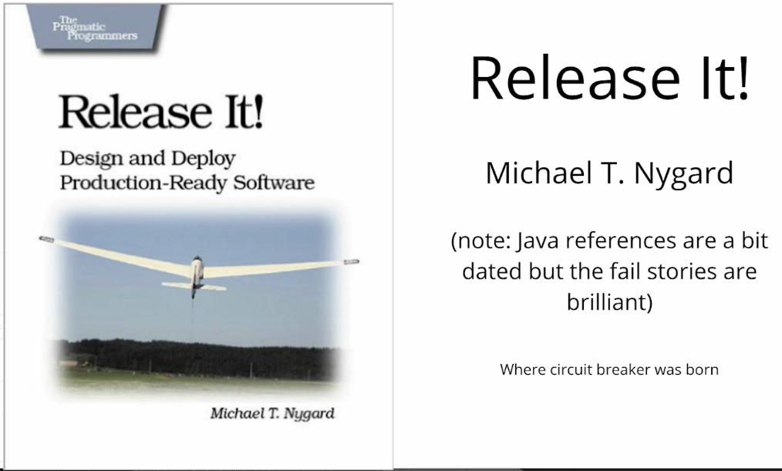

Q. How do you deal with a cascading failure & do you intercept it so that it doesn’t cascade all the way to the point where it actually disturbs end users?

Ans: Netflix OSS actually gave us a specific circuit breaker called Hystrix. Hystrix is a very cool circuit breaker & bulkhead implementation.

> Let’s think of it from a housing standpoint, If you look at the house your circuit breaker board over in your garage, or whatever it might be. The whole idea is that when you overdraw the circuit, the circuit heats up & the switch flips off. It basically goes open i.e., it opens the circuit, so electricity doesn’t flow anymore & that’s essentially what we see here. “**Open the circuit**” & you don’t have to worry about any form of overheating the architecture.

> The Same principle applies here; we’re ensuring that our microservice architecture doesn’t burn down.

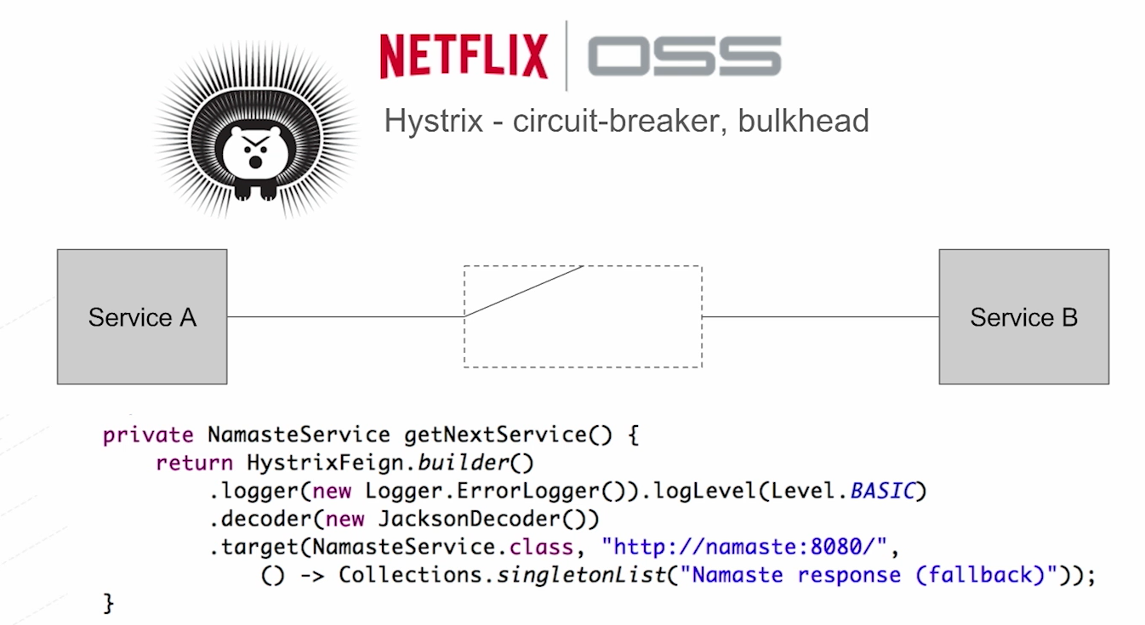

> Now, this is the Hystrix dashboard. It’s super comprehensive & exactly very neat.

> We can actually see how our different endpoints are performing & if they’re failing or not failing.

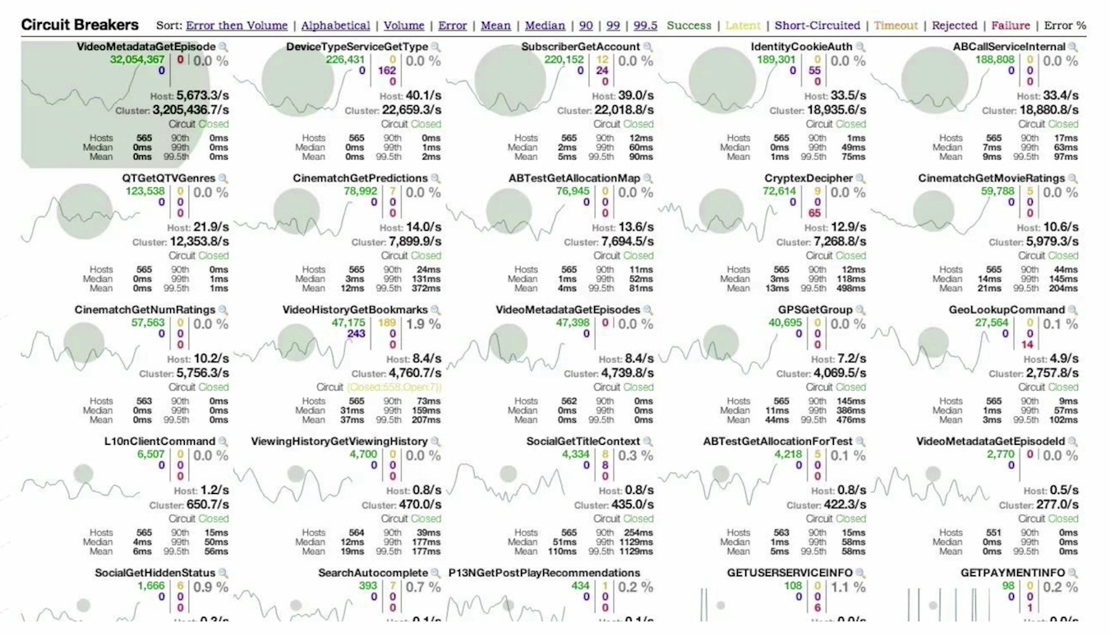

> Here is a good example where you kind of see the detail.

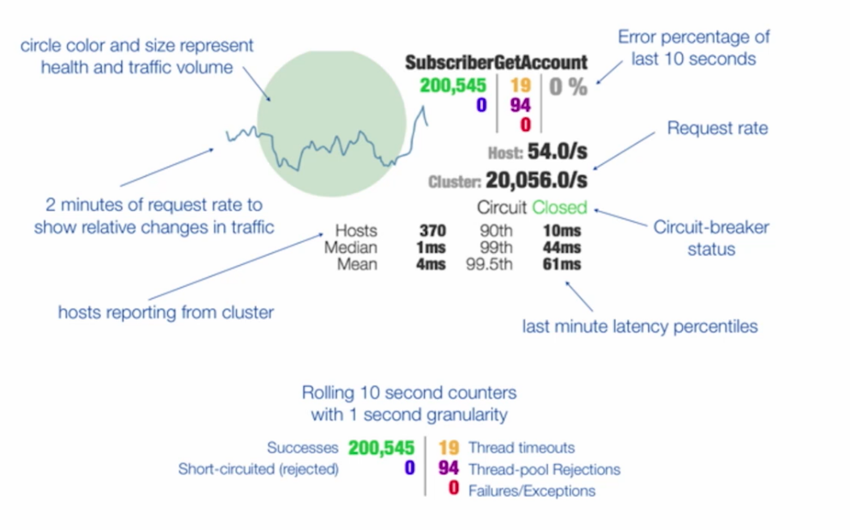

**7. Pipelines (and demonstration)**

> Now, we’re going to talk about the power of the pipeline. That concept of where we actually have different stages, different components or different environments of our overall application where our microservice has to roll through this pipeline to make it out to production.

> So, the concept of the pipeline has actually been with us for many, many years. For most organizations, they don’t actually have an automated pipeline, they just have hopefully, a described or a documented pipeline.

> In this case though we’re going to show you an automated pipeline.

> The idea that when a SCM check in happens, basically something happens to that source code base, we automatically do a bill, we automatically push it from a DEV environment to a QA environment, to a staging environment, & to a production environment.

> The concept is that we can move that automated payload i.e., the docker image with its microservice inside it through an automated pipeline

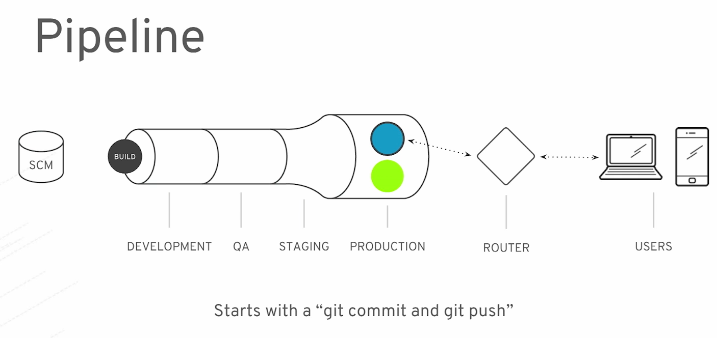

**8. Authentication (and demonstration)**

> Authentication & Authorization are super important; you need to be secure in your microservices. We actually have a solution called Keycloak, that’s the upstream project, it is also known as a Red Hat SSO that is part of the subscription when you have a supported product from JBoss middleware & part of the Red Hat organization.

> But in this case SSO is handled by an individual server, the Keycloak server, that can be applied to any endpoint that you have out there throughout your entire distributed system, & it can actually be used for your mobile applications, or for your web standard web application, etc.

> It is super easy to integrate, we actually provide you the JavaScript file, & then you are off & running.

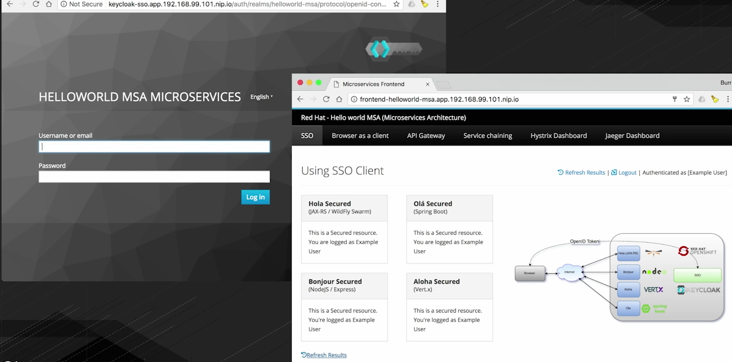

**9. Logging, Monitoring, and Tracing (and demonstration)**

> We’re going to quickly walk-through logging, monitoring, & tracing to kind of give us an aspect of what it means to understand our working environment, your production environment, & get a little feel for how do we make things production-ready.

> So, the concept of having all those different distributed microservices, let’s say 10, 20, 50 of them actually running against a clustered environment, so they are running against all these nodes & you have no idea whether they are even running.

> Having a form of aggregated logging is super important.

> One nice thing about Kubernetes in general, & OpenShift takes advantage of that certainly is that it actually has the ability to grab anything that standard out. So, if we just logged a standard out, System.out.println for java guys, it will grab that content & aggregate it for us, using something called EFK (Elastic Search, Fluentd, Kibana)

ELK – Elastic Search, Logstash, Kibana

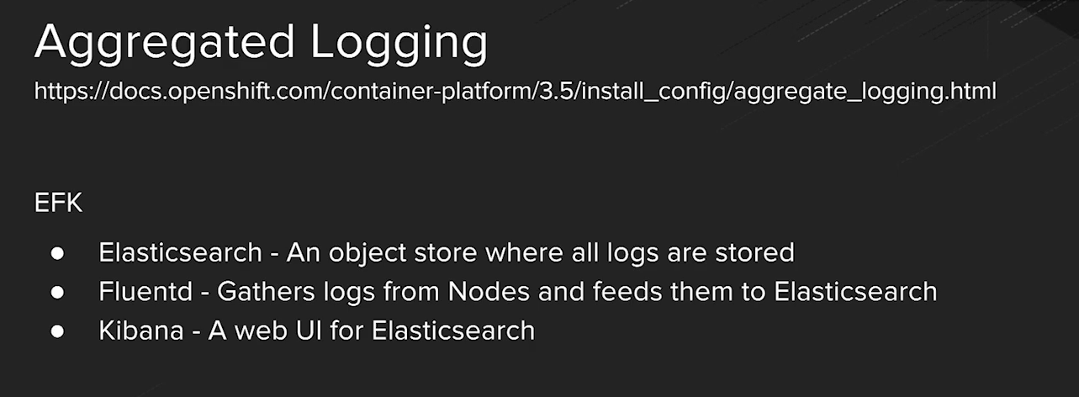

-> Kibana – It is a way to actually interact with that data.

**Monitoring**

> By default, monitoring is based on Heapster, Hawkular, & Cassandra. Casandra is the datastore for that.

> We can also run it locally with minishift when we do our minishift-start.

> In this case we can do minishift –metrics start that kicks on the Heapster & Hawkular capabilities so we can actually see the monitoring being gathered. Also it has some of nice graphs on our main overview page, we can actually see how much CPU, Memory, & things like that we’re using.

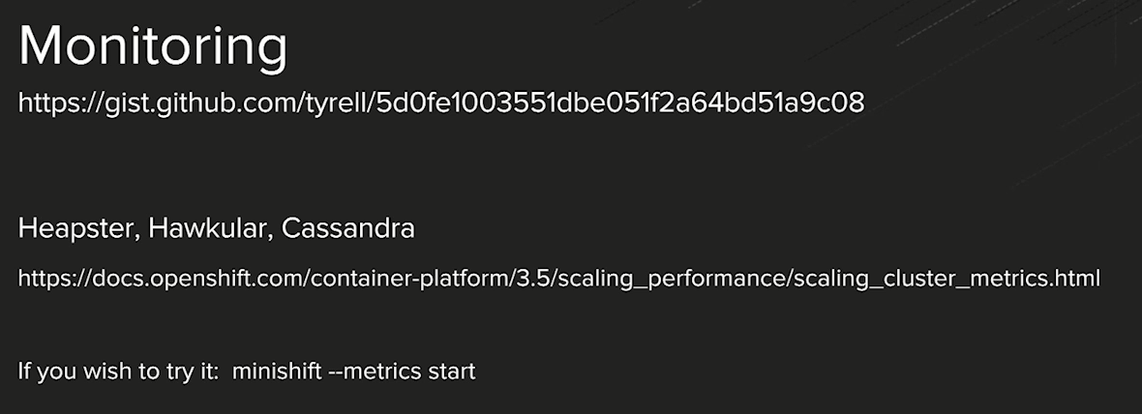

**Tracing**

> If we have a specific user transaction flowing throughout 10, 20, 50 different microservices, how would you know which microservice is the bad guy, when things fail.

> We have the circuit breaker to protect us from cascading failure, but how would you know which was the one that did fail & actually figure out what to do about that.

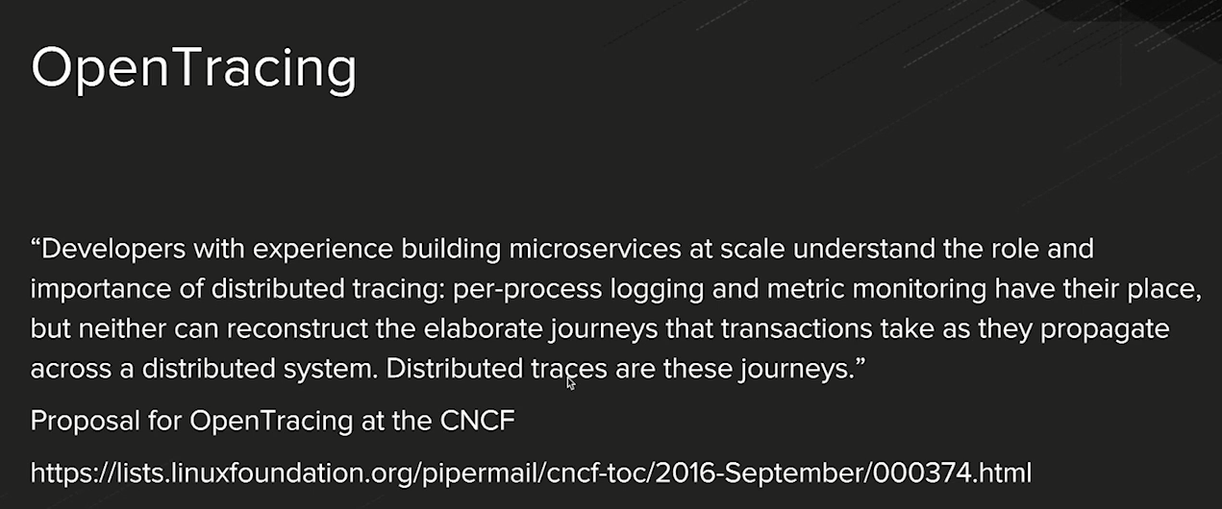

> So, the one that is very notable out there is called Zipkin. Zipkin was the one that was the first one, if we will, into the space that gave us the ability to see spans across the different microservice applications, & then gave us an aspect of timing across all of those.

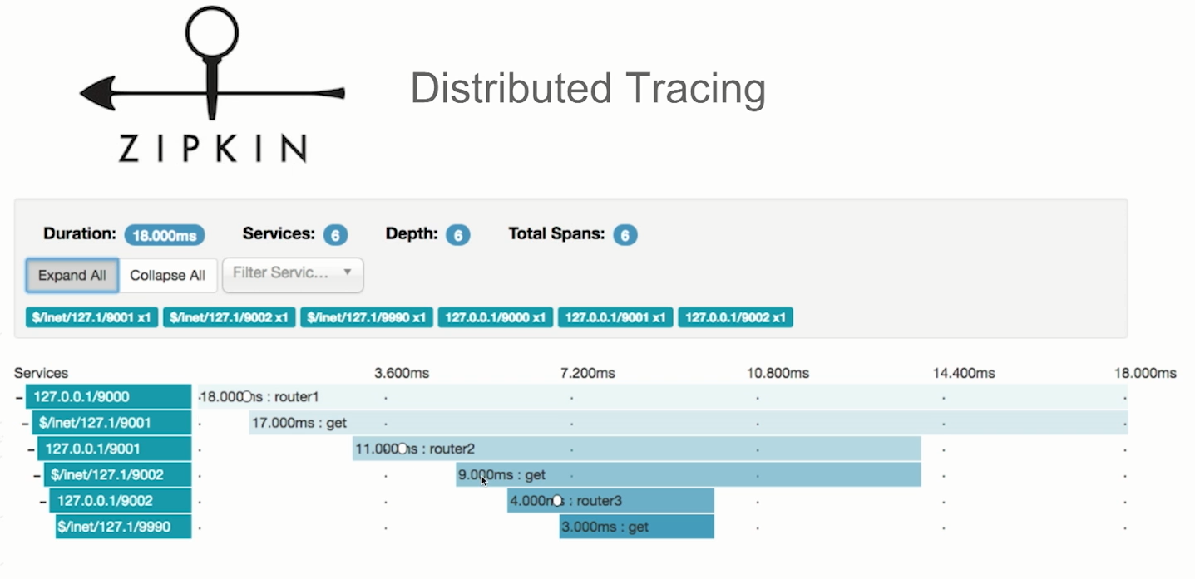

> There is also another one coming from UBER team is called Jaeger, provides a same kind of capabilities.

> It’s more OpenTracing-native.

> We’re going to hear about Zipkin a lot in this space, Opentracing.io & Jaeger. If we look at Opentracing.io actually has a lot of different supported tracers that are available to us.

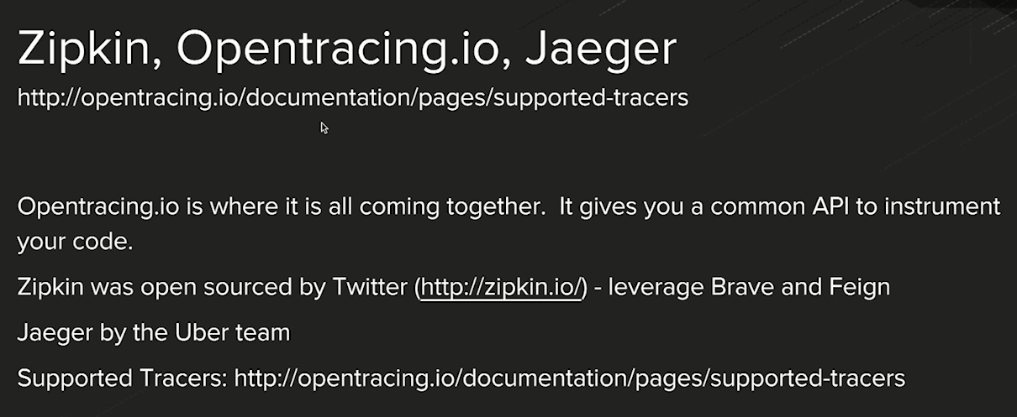

**10. Blue/Green Deployment (and demonstration)**

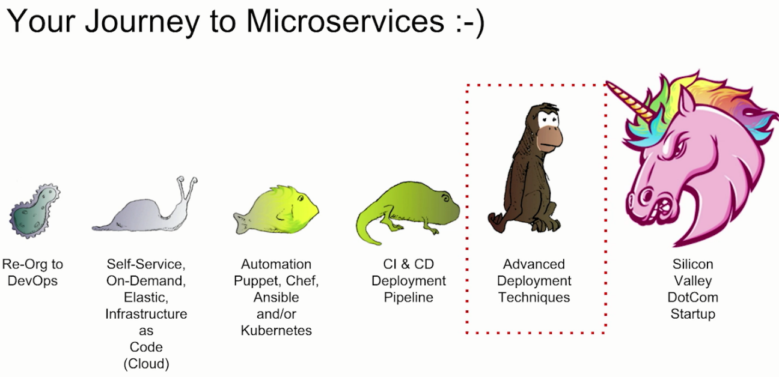

> We talked about the fact that there is a whole lot of steps in our journey to microservices. We kind of quickly ran through DevOps, & things like elastic infrastructure. We did spend a fair bit of time with things like Kubernetes & CI CD, deploying pipelines but now we really want to drill down on the concept of advanced deployment techniques.

Q. So, think about going super-fast to production, & what happens if we break things in production, & can we roll them back easily?

Ans: The idea of the Blue/Green deployment is exactly that.

> The idea being that if something happens at the SCM level i.e., we do a git push or git commit or SVN check-in, we have updated the source code.

> And in theory we have an automated deployment pipeline, that will grab that component, grab that change to our source code, actually do build of it, maven build, & of course a Docker package & move it from Development to QA to Staging to Production.

> The difference here is, the Production we have 2 production environments, a Blue & a Green. Now we can see that Blue is the active one. In other words, the router, the load balancer, is focused on Blue, & all our user traffic is focused on Blue and the last build that comes in lands on Green & when it’s on Green & happy on Green, we just switch the router.

> In case if Green for some reason is bad, the users are complaining, the Twitter verse is blowing up, people are complaining about our service, we can switch right back to Blue.

> So the concept of the Blue/Green gives us a lot more assurance, if we do make super-fast deployments, we are not breaking things & if we do break things, we can easily roll back, that is the concept of Blue/Green deployment.

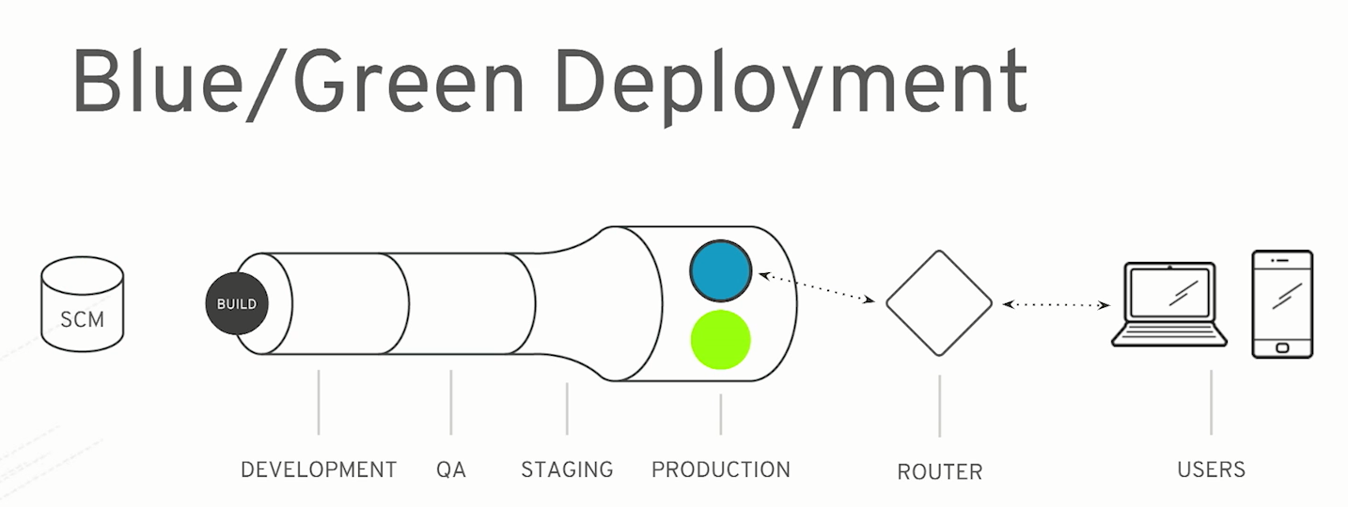

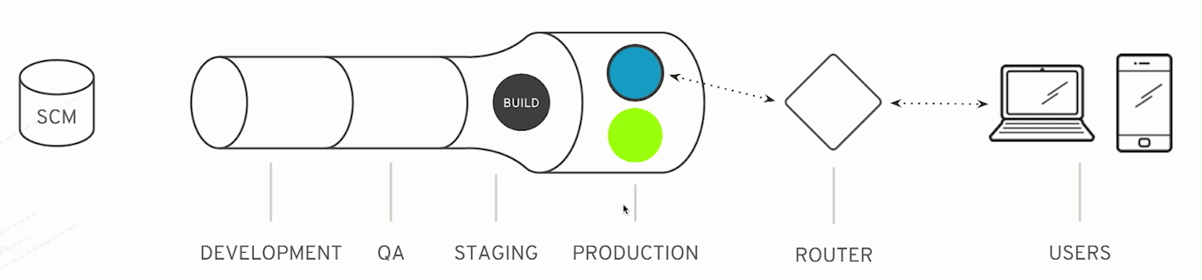

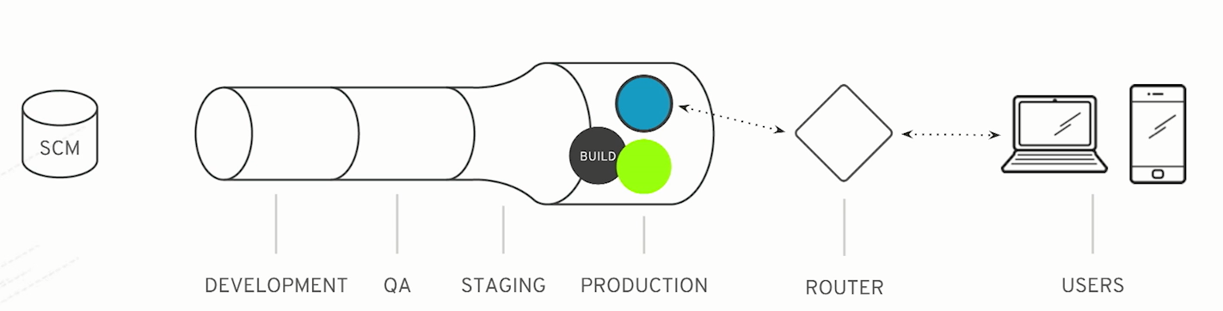

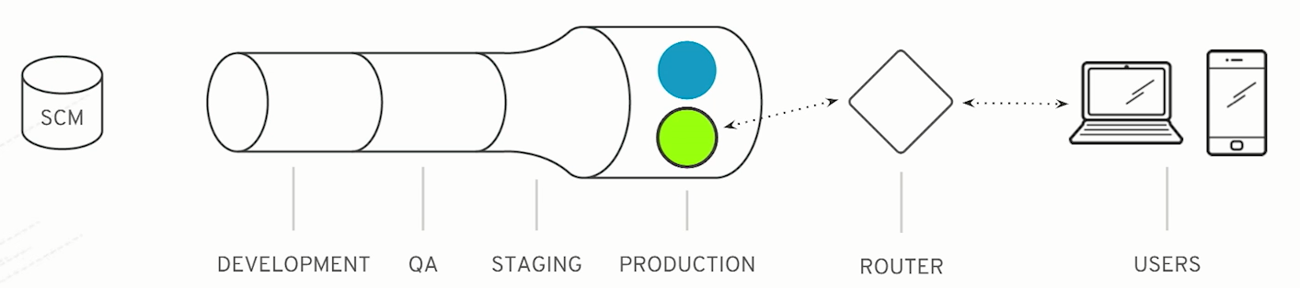

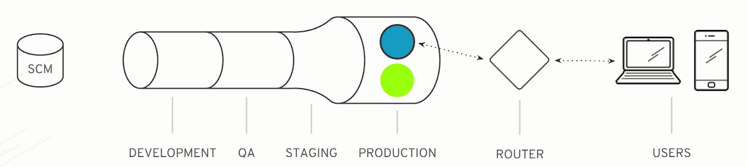

**11. Canary Deployment (and demonstration)**

> Canary Deployment model is even more sophisticated.

> Now there is a little history around, why do we call this a canary?

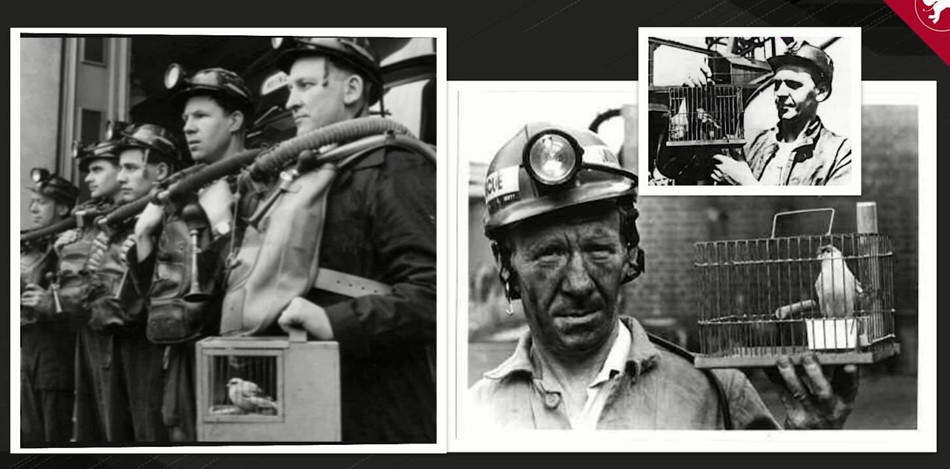

> These folks in coal mining have to dig well under the earth & in some cases, they encounter, say bad things like poisonous gases. So they used to actually take a canary down there with them. The canary in this case is the little song bird here in the cage.

> The little song bird would actually be down there with the miners who would sing for them & entertain them but at any point that canary fell off its perch dead, they know they need to get out of the coal mine quickly.

> The good news is that the canary died before the miners did, & that was a solution.

> Same things apply here in software, We are going to float our little canary out of production & if it goes badly, we know the bail & get out of there & so, this is even faster because in this case, unlike the blue or Green, where we actually set everything to Blue or Green, we’re actually going to send a tiny fraction of the user audience to a specific build.

> The idea being that the little change goes through Development, QA, Staging, & then lands on the current active environment, let’s say it’s Blue in this case, & it’s going to basically take a fraction of the user audience, a fraction of the user transactions, from the overall system, & if it is good we grow it over time and to eventually it fills up the whole that is the only runtime microservice that’s out there.

> And if it fails at any point we will roll it back.

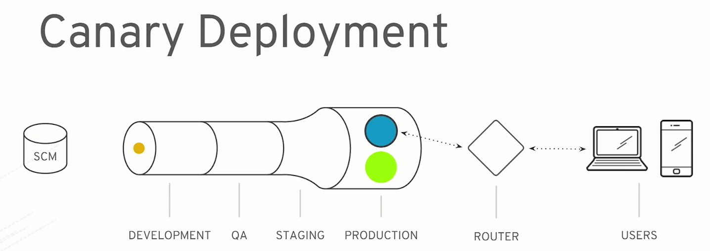

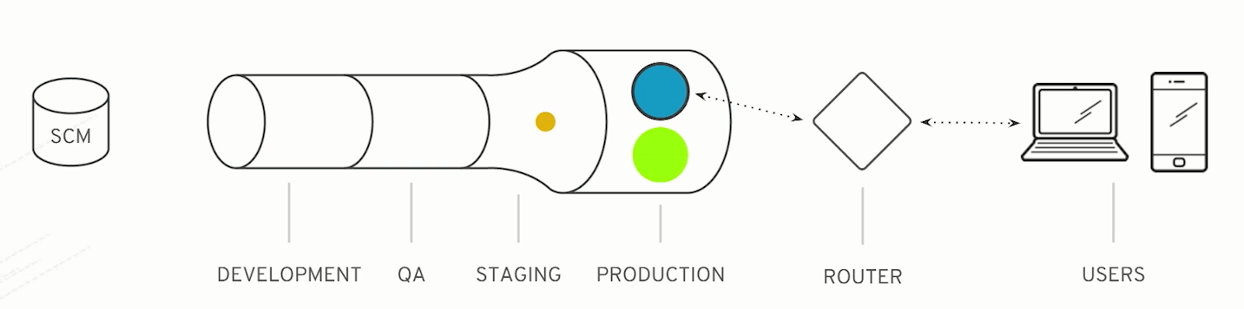

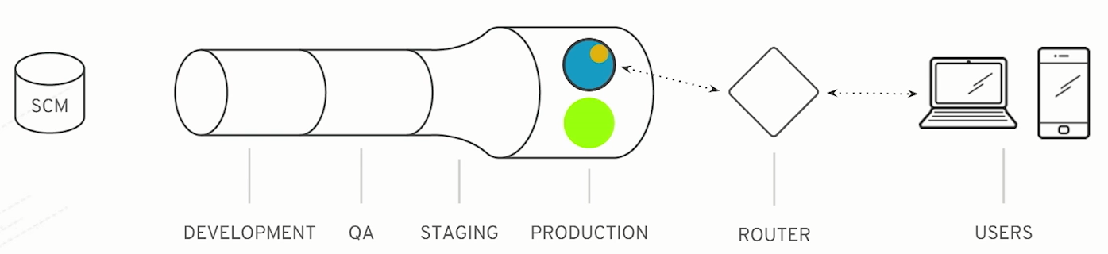

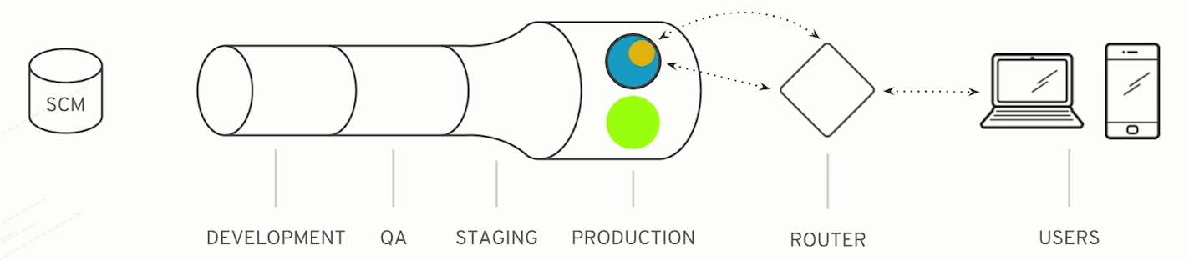

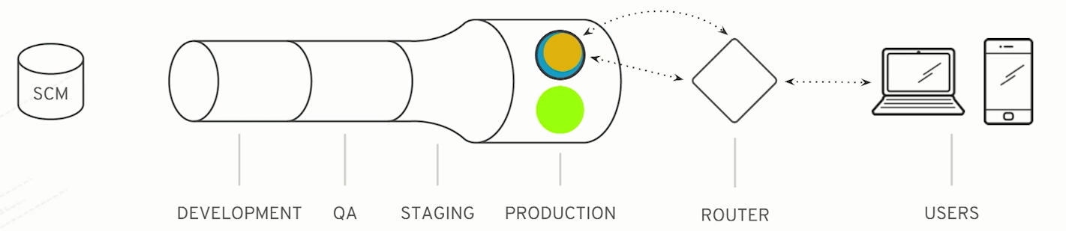

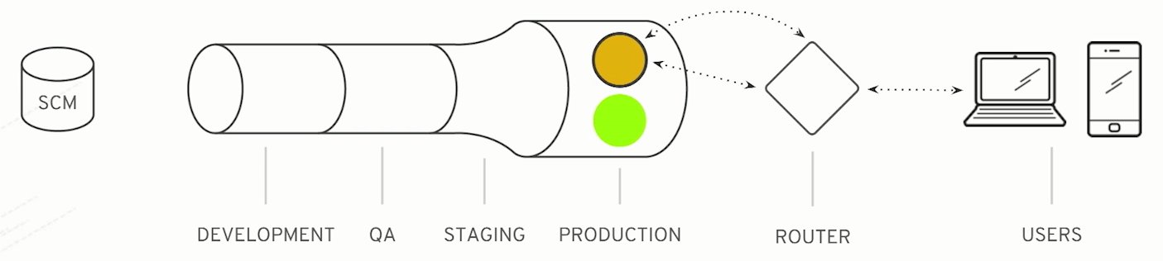

**12. Moving from Monolith to Microservices**

> Now we’re going to talk about moving from monoliths to microservices.

> Now this should be noted that microservices are actually not for everybody. There is a great blog article by DHH, the guy behind Ruby on Rails. They talked about the Majestic Monolith.

> And his case, his organization can produce to production their monolithic application every week, and they can move in one-week increments. We’ve seen other organization go that fast from 3-months deployment cycle or 2-month or 6-months down to 1-week & for their business, their organization one week deployments are fast enough to meet the need.

> In this specific case, he felt that microservices are not for him.



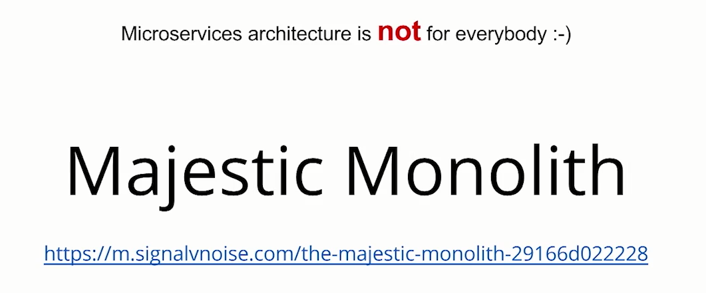

> Now also, Martin Fowler talked about the fact that you may not necessarily want to go directly to microservices architecture right out of the gate for brand new project. And he wrote a nice article about, maybe you want to go monolithic first because you don’t yet know all your requirements, & you certainly don’t know your bounded context.

> But think about that, there be dragons down the microservices-first path. So, just keep that in mind.

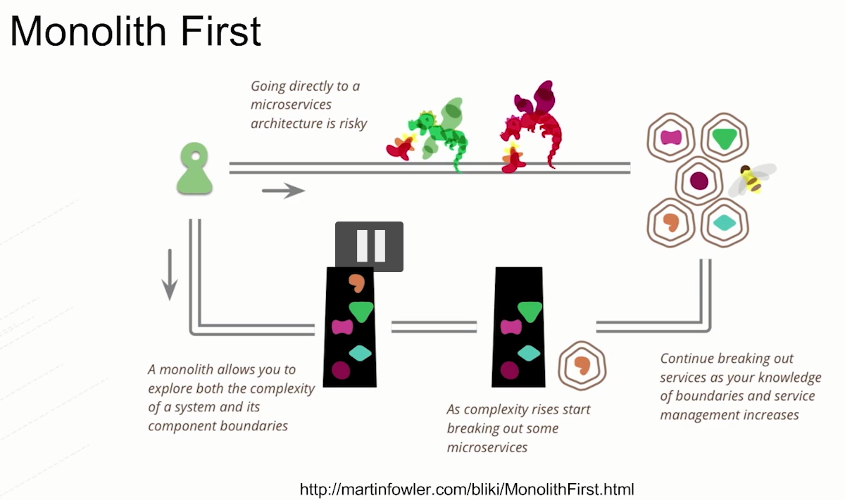

> Also keep in mind that you’re on a journey to microservices. If you have not matured along this evolutionary path, & you’re still awaiting three weeks to get a VM or your developers & operations team are still in odds with each other, and they don’t work together, deliver the product together, you don’t have developers yet on the pager, if you will. Or maybe you don’t have any kind of automation where they be around the containers or VMs or CI & CD and you can’t figure how to do Blue/Green to save your life, or Canary to save your life. You probably don’t want to go to microservices yet.

> Because, think about that for one second. You have a hard-enough time deploying your one monolithic application every 3-months. It’s hard to give birth to that baby every 3-months, and now you’re saying I want 30 or 40 or 300 of those babies to give birth to, all the time. Well that all this automation in place, I think you are going to struggle with that, and it’s going to actually be very problematic.



> Now remember we talked about all these properties, we showed how to build microservices, discover them, invoke them, how to scale them, make them resilient, we’re using circuit breakers & bulkheads, how to run a pipeline, all those kinds of things. These are critical to running your microservices that scale, and happily in production.

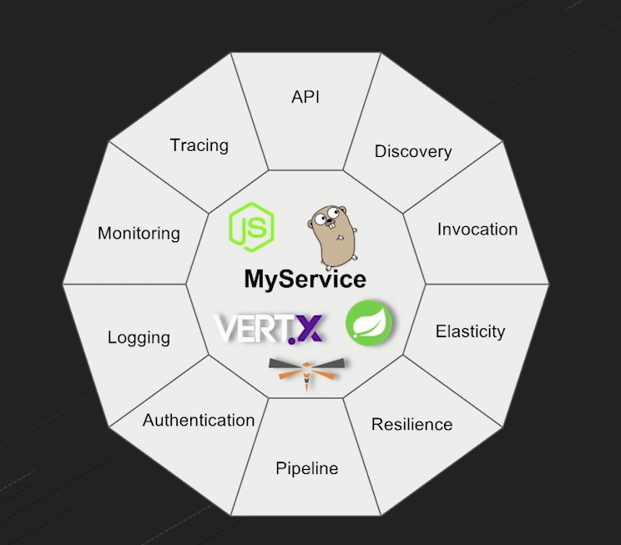

> So, let’s talk about what it means to take a monolith & potentially break it up.

> If we think from the original architectural vision we had, or even if it is big .Net application or whatever it might be, Ruby on Rails applications. We probably drew on the whiteboard a nice, layered application architecture i.e., with user interface separated from the business logic middle tier, separated from the data access tier, with a nice clean data model that, you know, the schema was super-tight, you modelled it all. You spent months agonizing over these diagrams & pictures, & thinking about it, & trying different things, & you had a beautiful architectural vision.

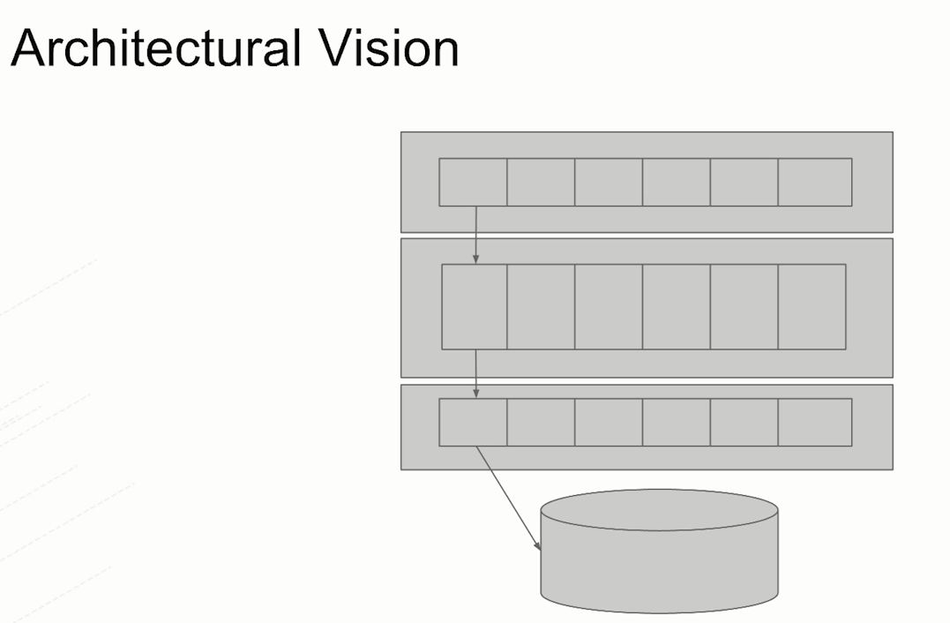

> Well, it actually didn’t stick that way. Over time, maybe it was perfect the first time around, but overtime, as people got in there & maintained the code, change things, or we didn’t know about that business requirement, etc.. Things start getting outside their boxes, and the UI starts interacting with more than it should on the middle tier, & the middle tier starts interacting with other components in the middle tier, and then other people start going after the database, maybe after pieces of the schema that don’t belong to them, & it gets even worse.

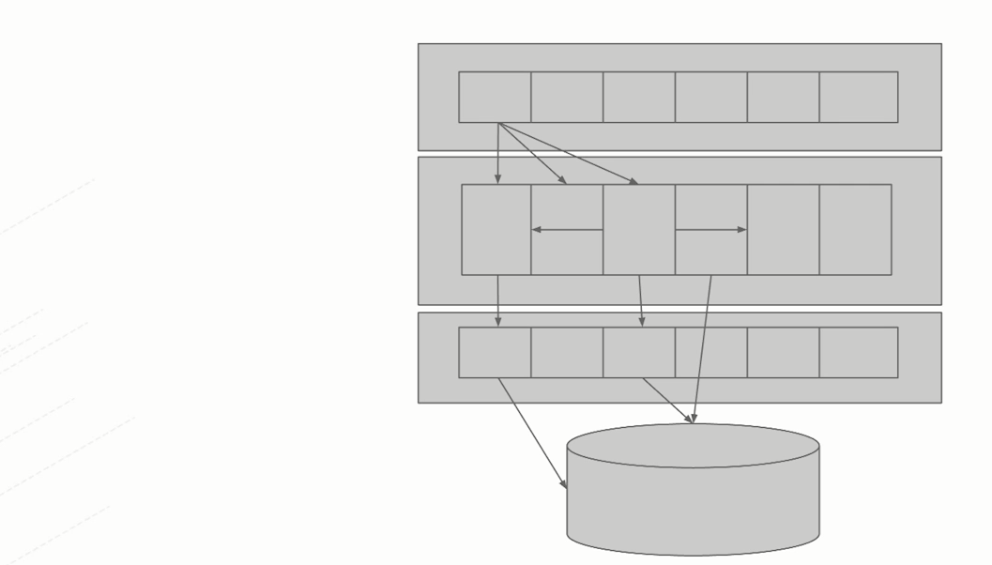

> So, we actually have a situation where now our UI interacts with maybe a third-party system, in some cases, talking directly to a database by passing the middle tier & it just gets crazier & crazier. So, this is actually where our big balls of mud come from, from an architectural standpoint.

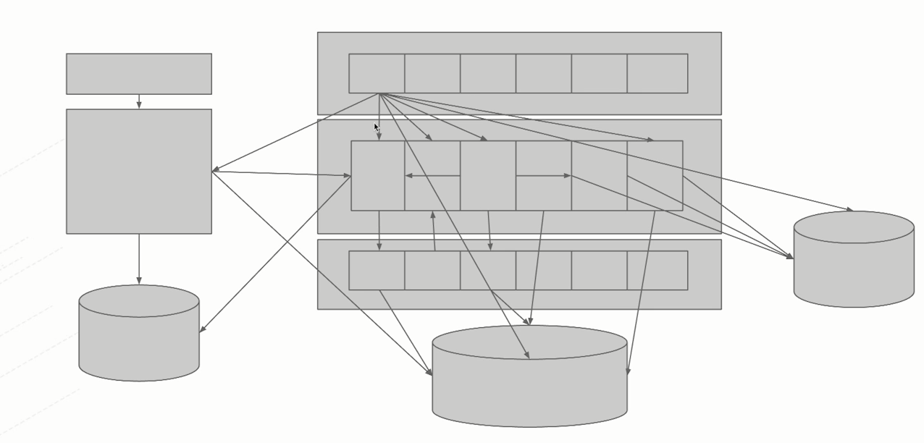

> This is where monolithic architecture – it’s not the fault of monolith architecture, it is the fault of not having good discipline over time.

> So, just keep that in mind, because if this is what your world looks like, it is going to be fairly hard to adjust, without getting that sorted out, to microservices architecture where you’re just going to take your mess with you. You don’t want to do that.

> Some people love referring to the concept of Evolutionary Architecture. That’s another ThoughtWorks Principle. Encourage you to read more about that either by Neil Ford or Martin Fowler.

> Now there is one pattern people love to apply & talk about when it comes to addressing the monolithic applications & it is known as **Strangler fig**.

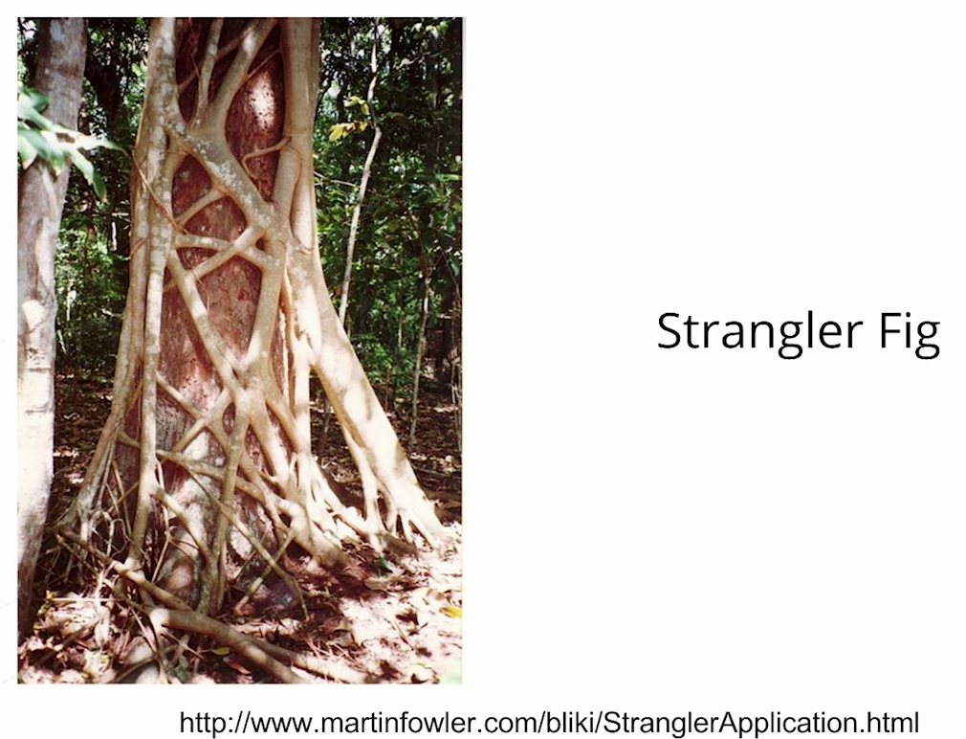

> The idea of the Strangler fig is basically a bird flies by a tree, drops little seed in, the seed starts growing at the top of the tree & the strangler fig actually grow down the tree, & overtime it will completely compress & destroy the internal tree & all you have left is the stranger fig. Strangling the tree to death is the idea.

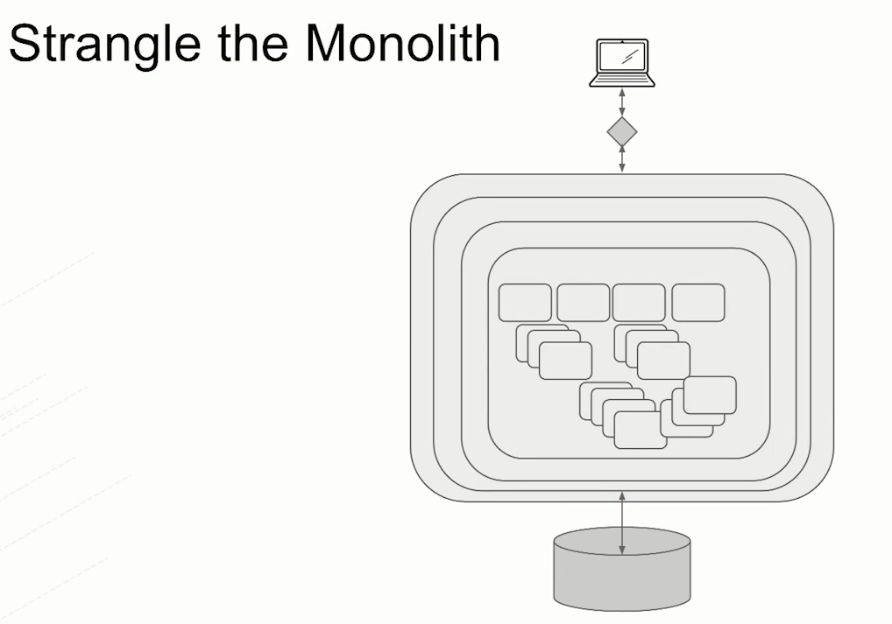

> And the same thing applies to this monolithic architecture that you might decide to turn into microservices.

> Instead of actually going & wholesale changing everything, perhaps just identify a segment of the application that can be turned into a microservice & just simply added on the side.

> The idea that we had, add this one little microservice, it has its own unique database, its own 2 teams, it is completely independently deployable, its own independent governance model etc. etc. They have got automation, they have got pipelines, they are taking advantage of Docker, Kubernetes, OpenShift & then simply have our router or interface.

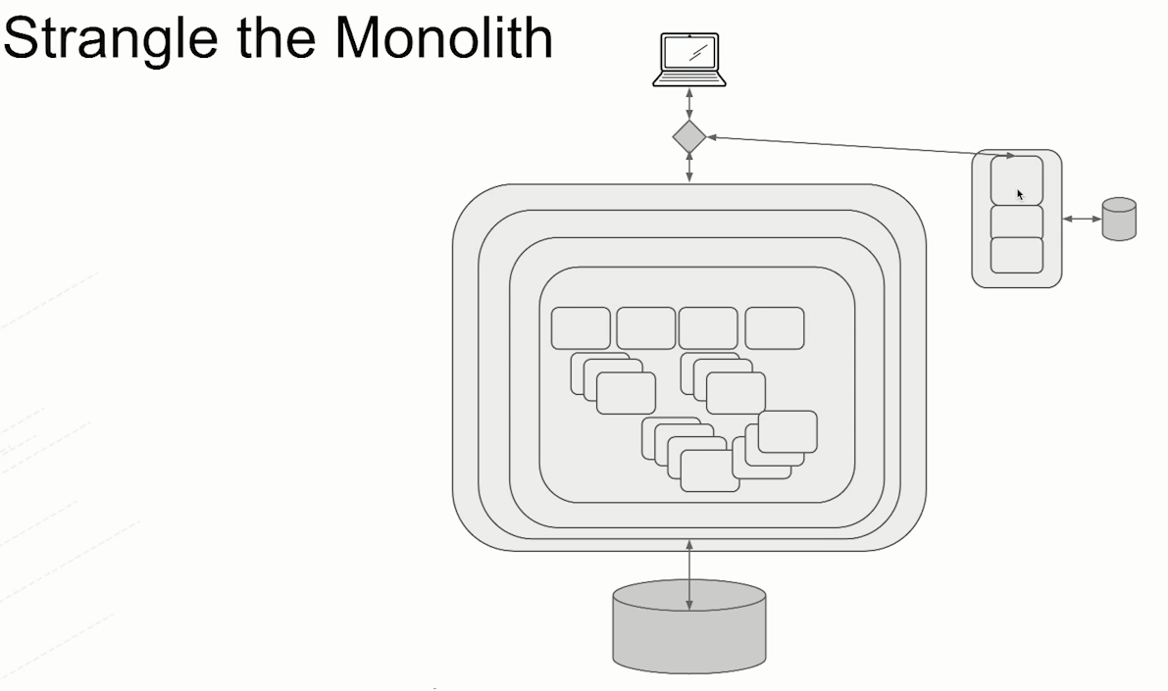

> So, you basically have duplicated in many cases, some of the functionalities over here but that’s critical that you would have done that duplication because you want to maintain your independence so you can deploy quickly.

> So, you keep adding on to that. Maybe it has yet another microservice it interacts with & maybe other microservices it interacts with and overtime you surround your monolithic architecture with new clean code bases that are focused on the specific use case, specific business capability, they have to.

> And those business capabilities may also be exposed to business partners so we have another outbound route here.

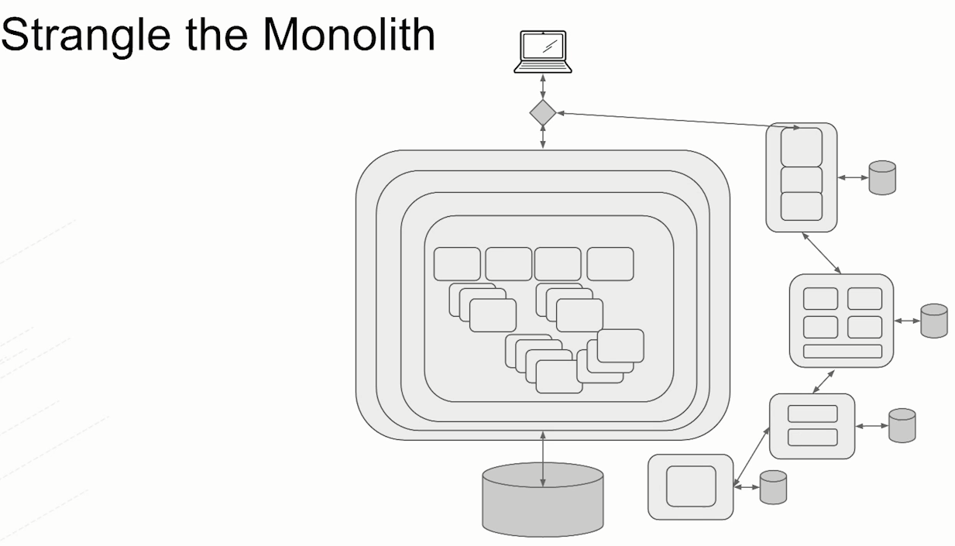

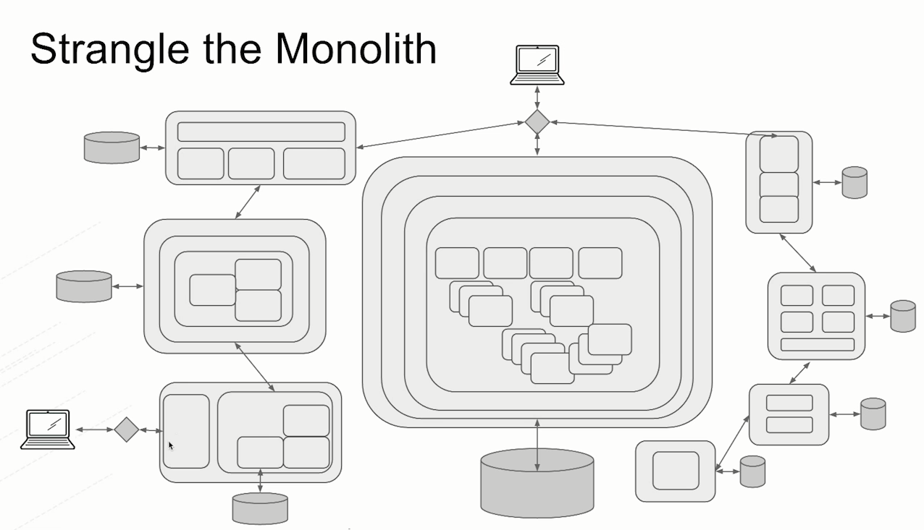

> And then overtime you actually will shrink that monolithic application to the point where it is actually nothing.

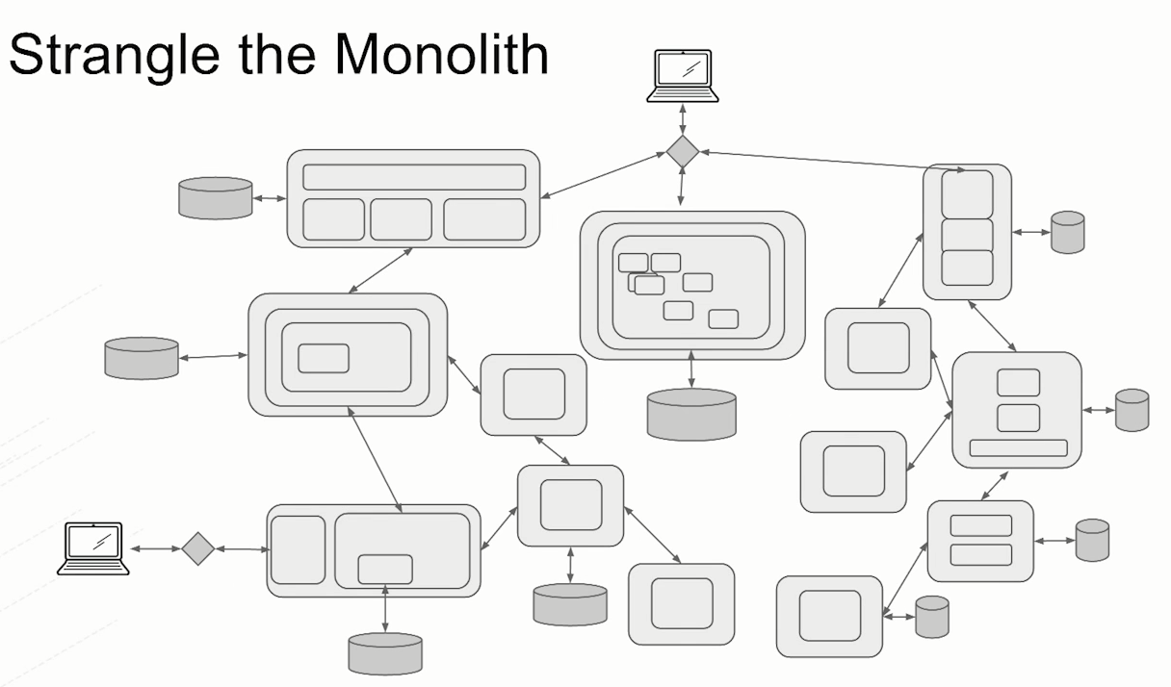

> That’s the idea of the strangler pattern. It’s much harder to apply because you have to think about all the culture implications inside your organization i.e. how to reorganize the teams, code bases & more importantly you have to decide how in the world you identify the component that gets peeled off & actually it is part of a strangler.

> This is where domain driven design comes in & the concept of the bounded context.

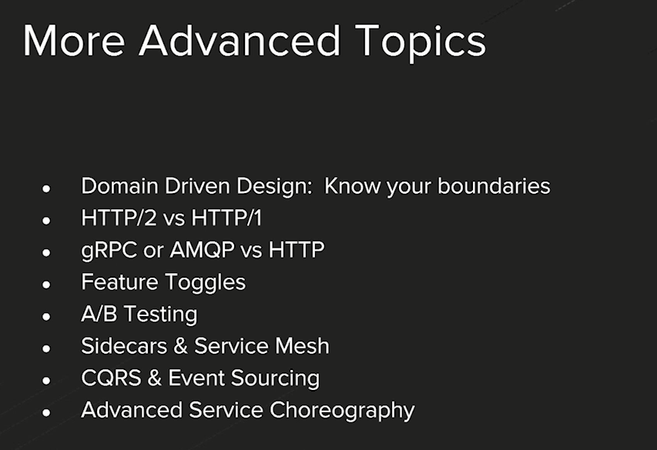

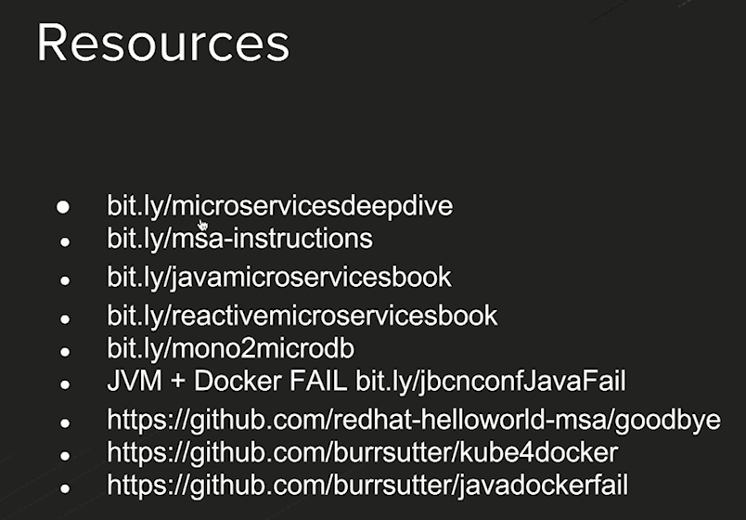

**2. Course Name:** API Fundamentals

**Focus Area**: API Fundamentals, Resources & Methods, HTTP Responses, Representation Design

**Resource:** Accenture Resource

**Media Exchange Url**: <https://mediaexchange.accenture.com/media/t/1_w8dpvb2t>

**Web API Design**

> Let’s say we’ve created a microservice. Now we want to expose the service so that our clients can access our microservice. So when we’re designing the microservices, we need to think about the ways those services can be exposed i.e., how the clients are going to access our microservice.

> Mostly it’s based on REST APIs where people will be using the HTTP protocol for the communication & they will be hitting some url to access the microservices.

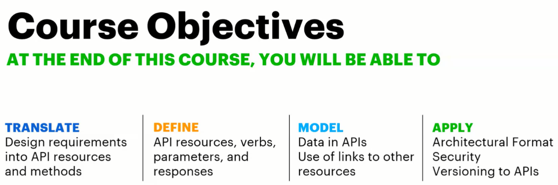

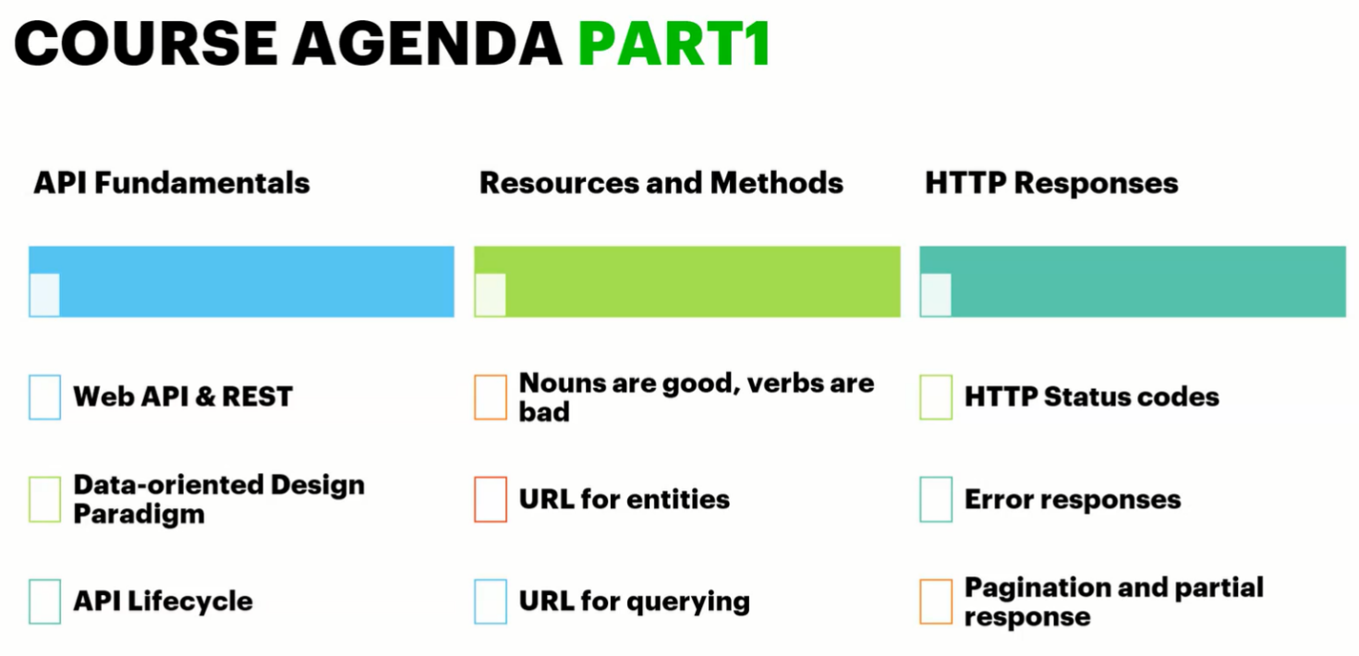

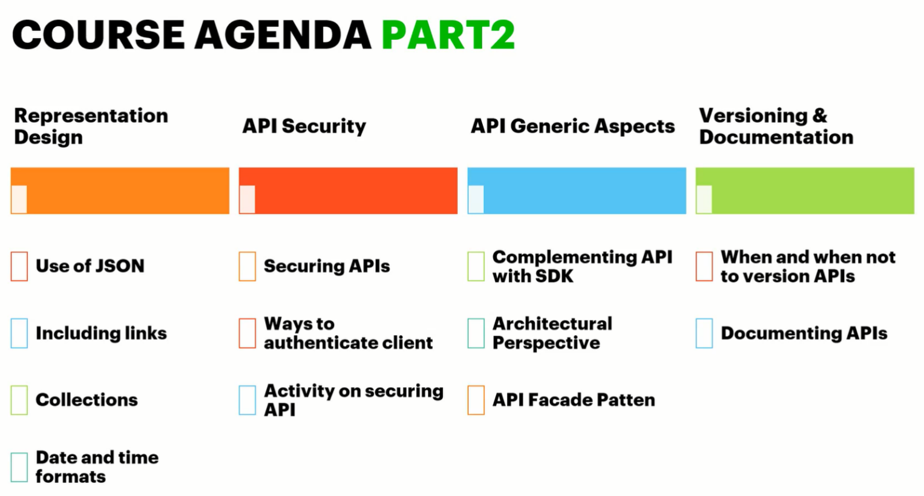

For example: let’s see we have core banking application interacting with a database having details about customers, accounts, transactions, credit cards etc. Now the use case is we want to check account balance.

> We can access the account through different ways like Teller app, Net banking, ATM, Mobile App, Paytm or Gpay etc.

> All these applications don’t have access to the data directly. Only core banking has access to the data.

> We need to design a layer of APIs i.e., **Application Programming interfaces** on the top of the core banking application (can be in form of .Net or Java or microservices application) that will communicate with core banking application. Here we will be using some integration tool or language where we will write some logic to connect with the core banking application.

> We won’t be needing this layer of APIs if we’re designing a microservice core banking application. We can directly expose microservices as a separate API.

> APIs are used to communicate between two different applications.

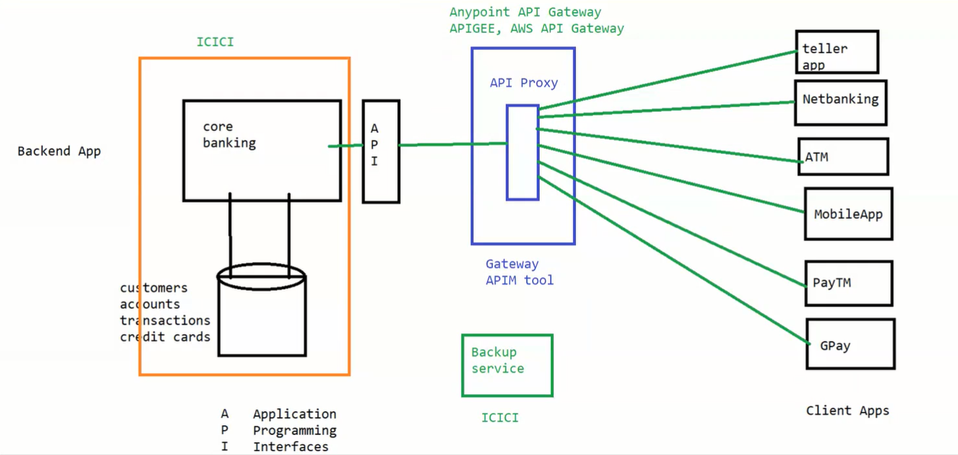

> Now we want to check our account balance through mobile app but it doesn’t have direct access to the database as it is too risky. Also, these clients apps like mobile apps etc. can’t have the huge logic or drivers to directly connect to DB. So, now a days all of our applications are just a REST call to the APIs. Then these APIs will connect to the backend application & the backend application will connect with DB. (Backend applications can be in the form of microservice or normal java or .net application or cloud native application or any application running on the premise or legacy applications)

> To connect front end application to back-end application, we use APIs.

> Websites are GUI created for users while APIs are created for applications.

> Generally, we don’t connect with APIs directly. We have one more component in between APIs & client apps i.e., API gateway.

> We create proxy at API gateway. So, all the client apps will connect with API proxy. API gateway will do first level of scrutiny (means close watch or surveillance). It will scrutinize the request & once the request is authenticated followed by authorization then only the request will be moved forward to APIs. Then the API response will be returned to the client app through API proxy.

> API gateway is not mandatory but it depends on client. If the application is designed & used on premise then gateway is not needed. For e.g., Backup service is on premise application, it won’t be needing API gateway to connect with APIs, it can directly interact with APIs as request is not connecting to internet. In case of different premise, its good to have gateway.

> API proxy is a software. Any point API Gateway or APIGEE etc. allows us to create API proxy. This can be hosted within client’s environment depending on the gateway vendor’s option (can be on premise or vendor’s platform as service) & client’s requirement.

> 2 principles while performing digital transformation

1. Modern business isn’t just about adopting a mobile or cloud strategy to generate savings. Most crucially, it’s about embracing a shift in the nature of supply & demand i.e., it’s not only about high availability, what’s required is high availability in various forms.

2. Digital transformation is bigger than IT investments or even platform strategies. Successful digital journeys require overhauling the organization’s operating model.

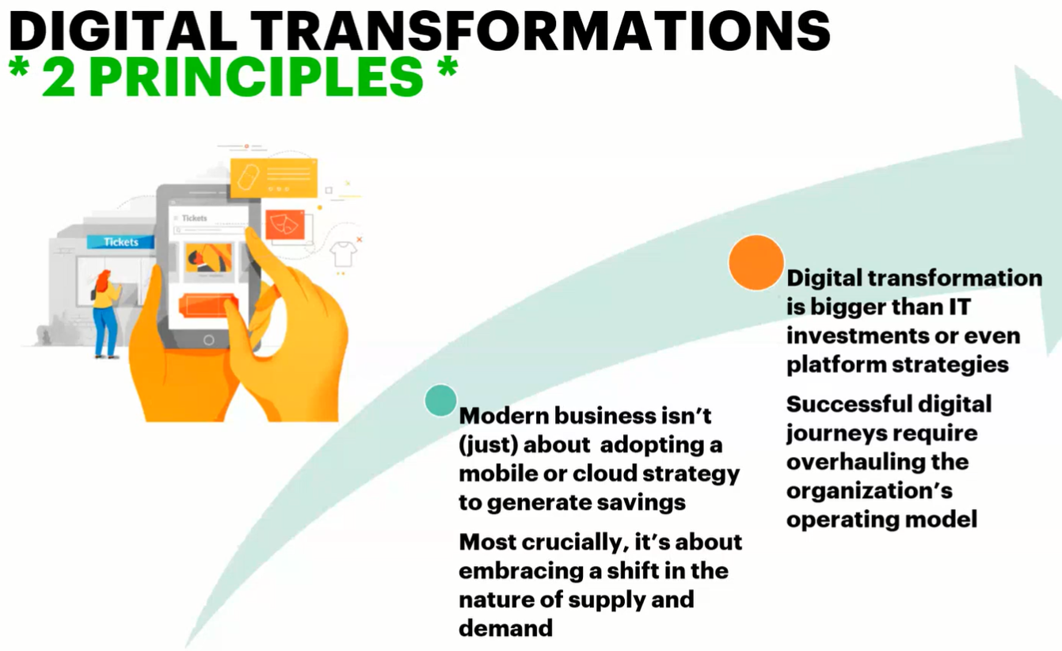

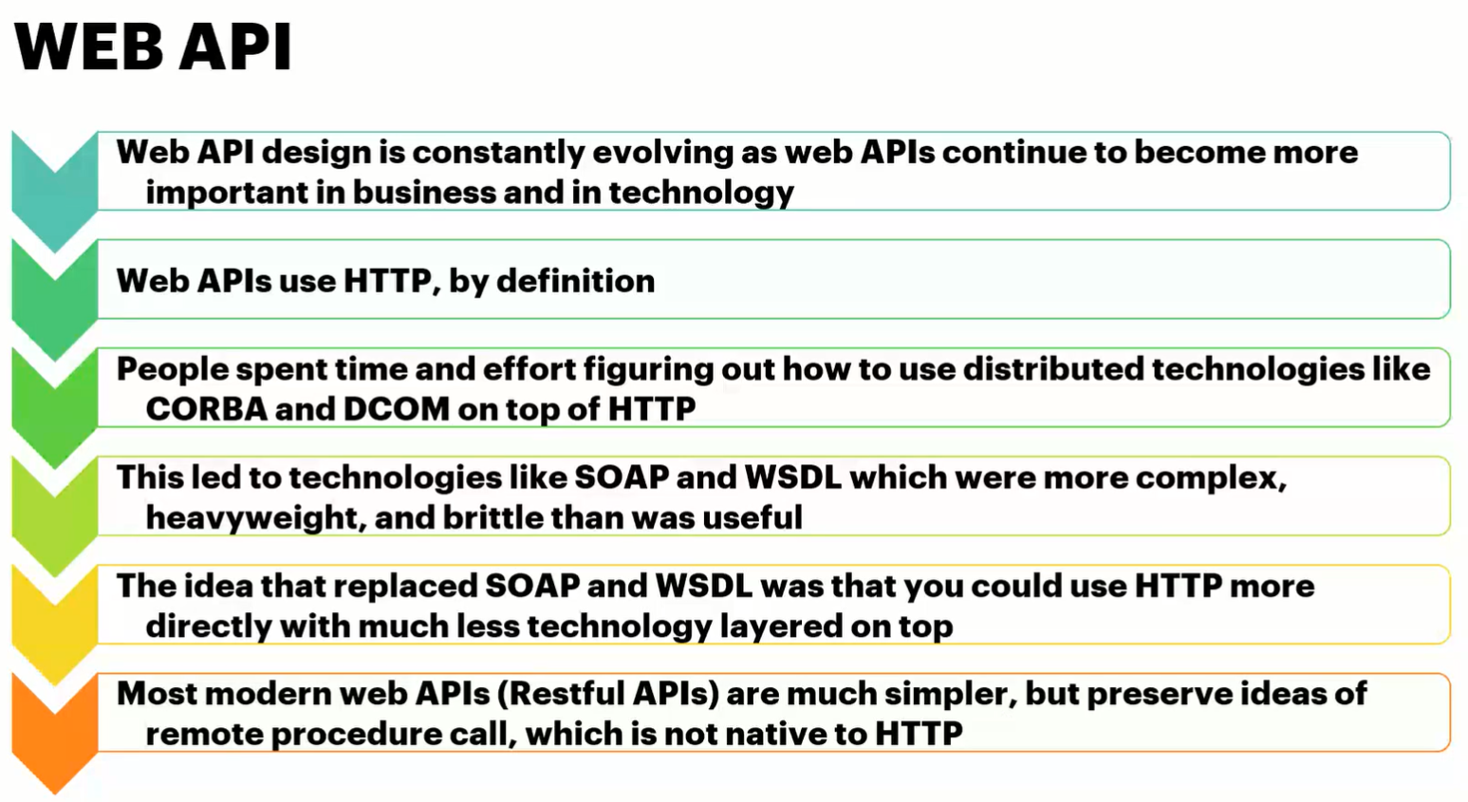

> Web APIs are independent of language or platform. It has libraries for each language.

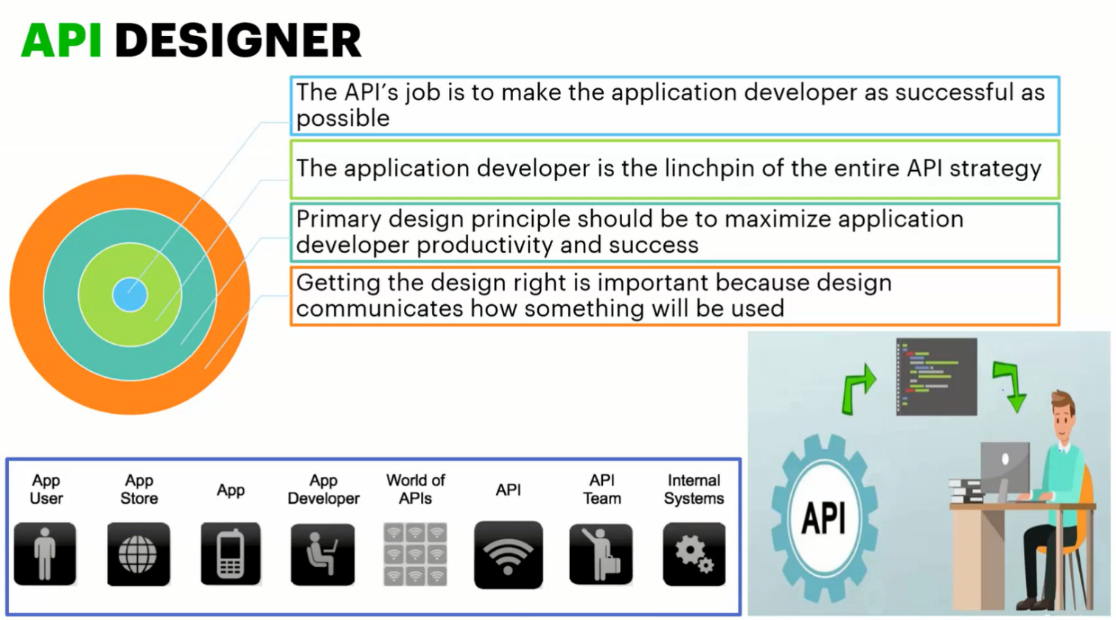

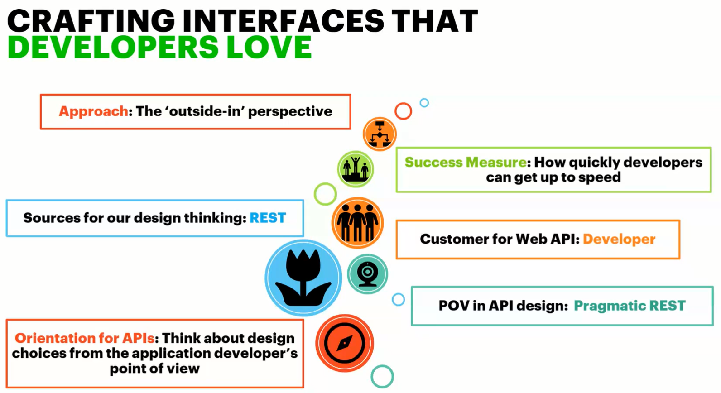

> Pragmatic REST means APIs will follow certain standards that are programming & understandable by any developer & more useful.

> The ‘outside-in’ perspective means we have to think from developer’s perspective what they want rather what we have.

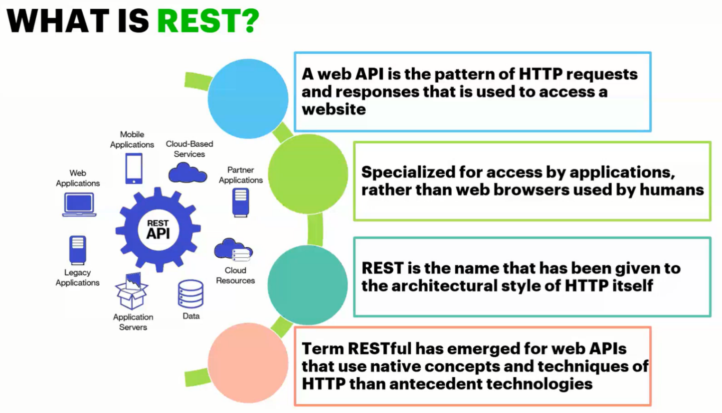

> SOAP has a specific format of exchanging the messages. It internally uses only POST method of HTTP protocol & inside

the HTTP body, the SOAP body is incorporated while In case of REST APIs we can directly embed the data into HTTP body.

> REST is Representational State Transfer i.e., when a RESTful API is called, the server will transfer a representation of the requested resource’s state to the client through HTTP.

> We should practice using specific design pattern as it brings uniformity to the APIs rather than just creating microservices & exposing them just like URL.

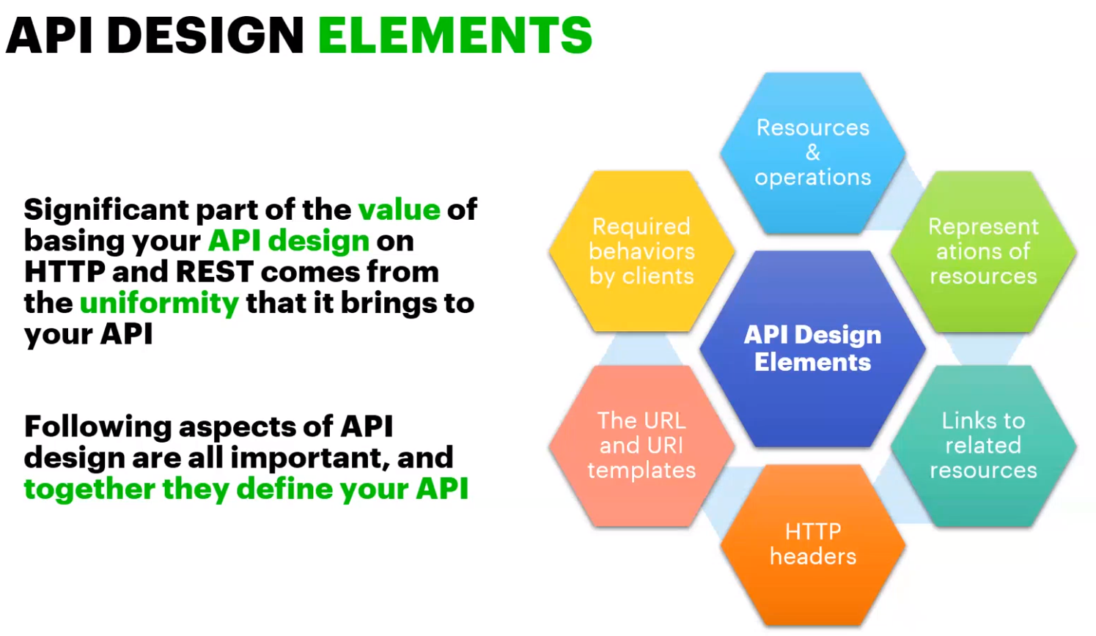

> When you’re designing an API, it’s equally important how you’re going to expose to the clients.

> When you’re designing an API, always we have to think from the data aspect i.e., it’s about what different data elements we’re exposing.

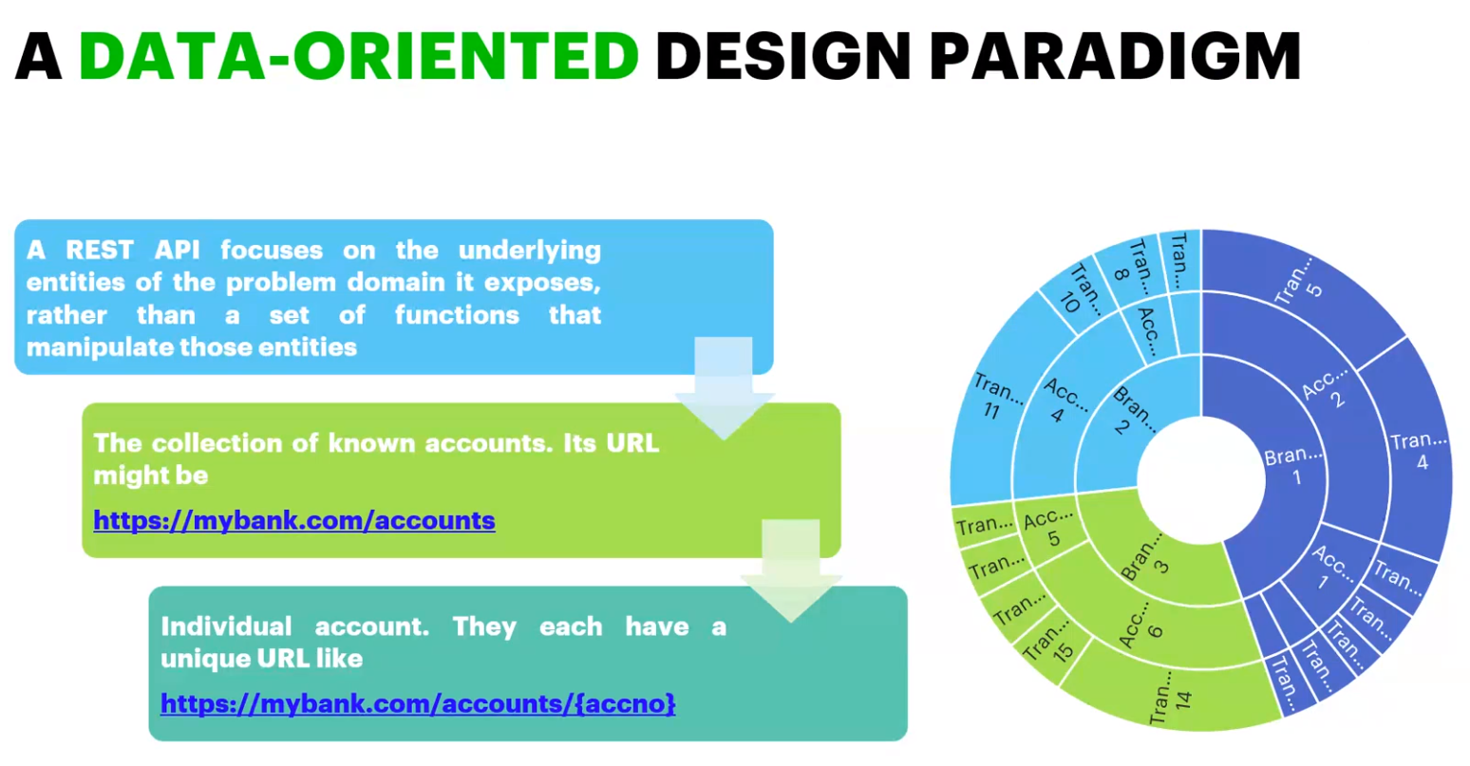

> API lifecycle has 3 phases basically

a) API designing

b) API Implementation

c) API management

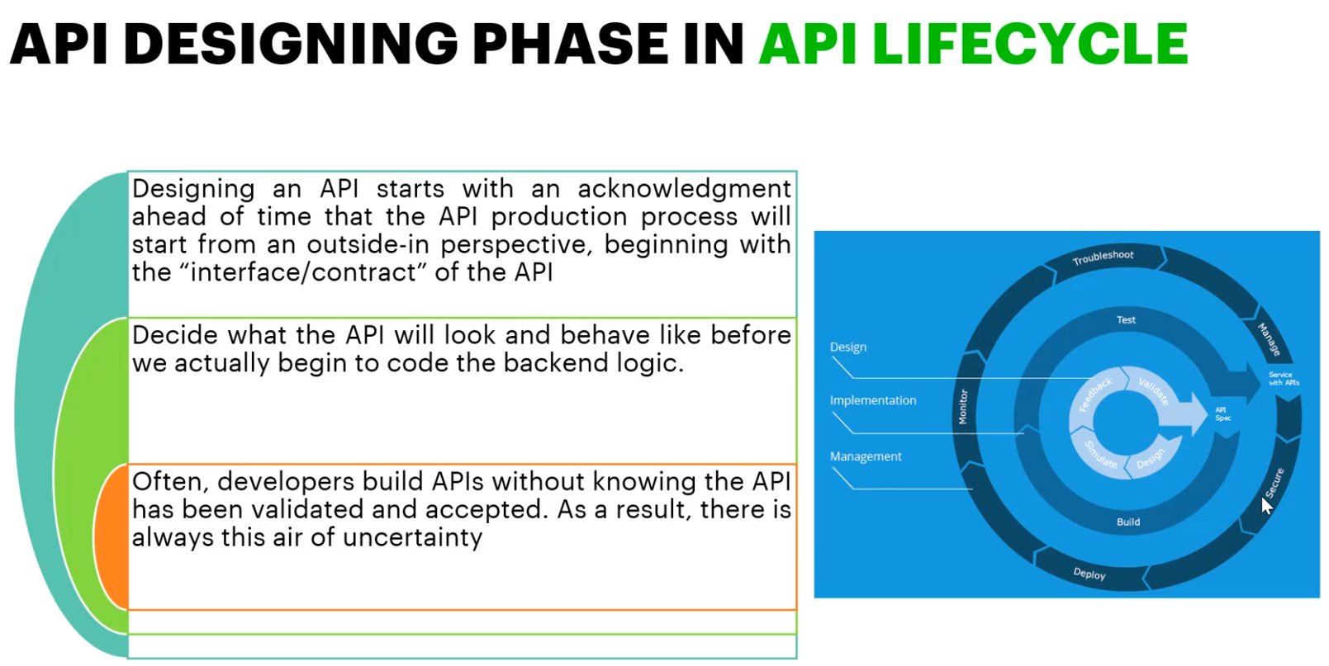

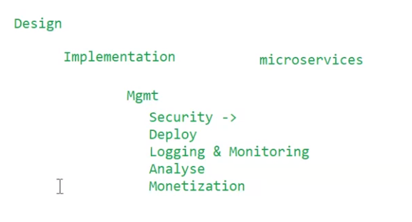

> Design Aspects

1. Resources & Methods

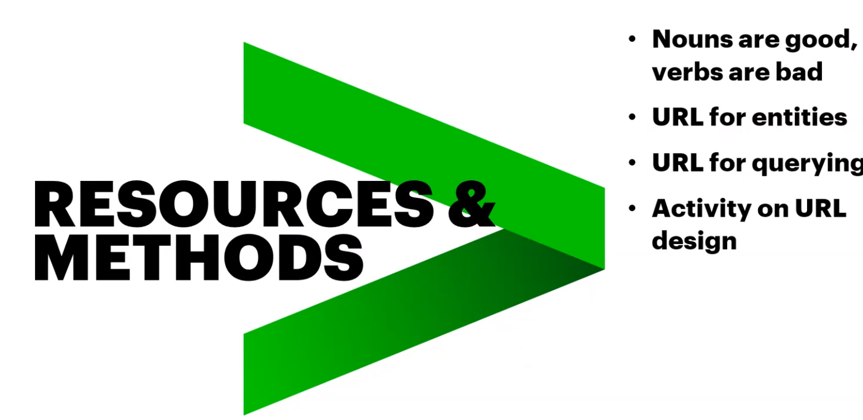

> While designing the URL, keep this in mind that Nouns are Good while verbs are bad.

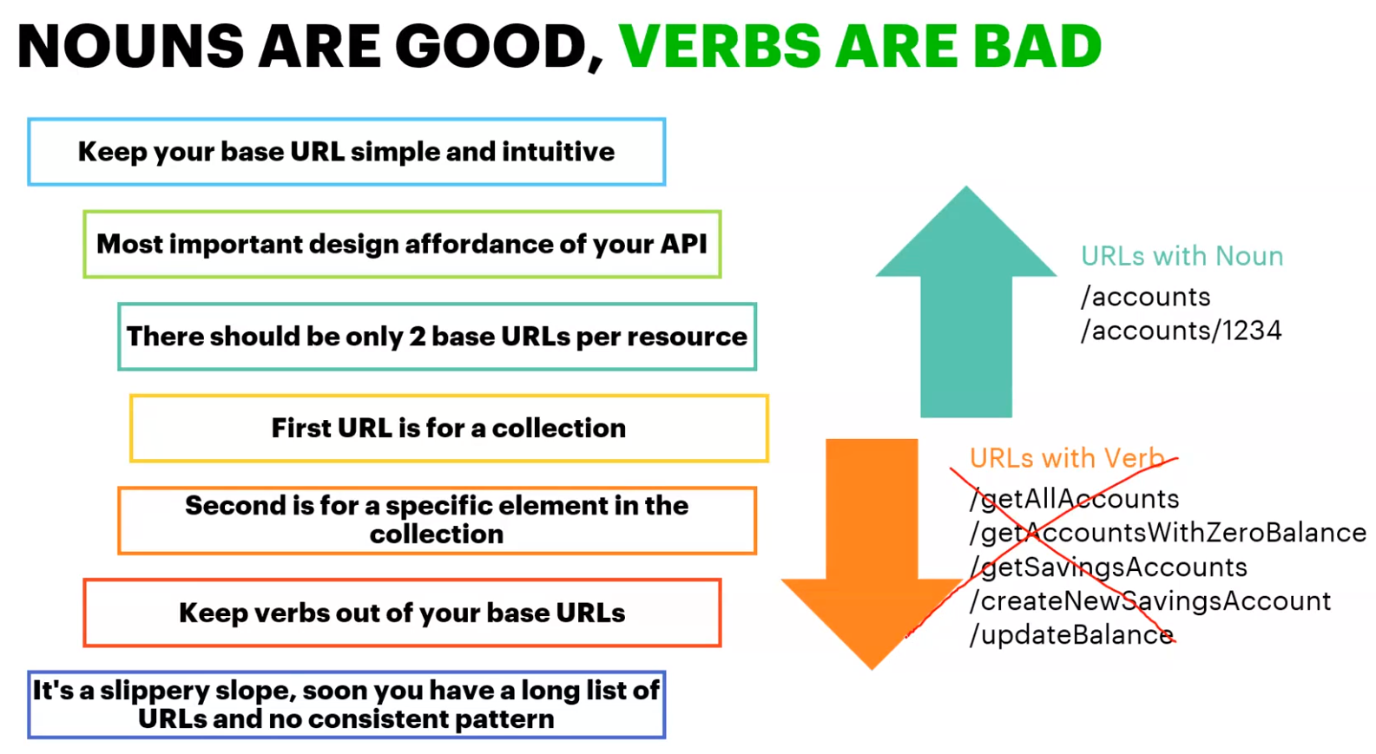

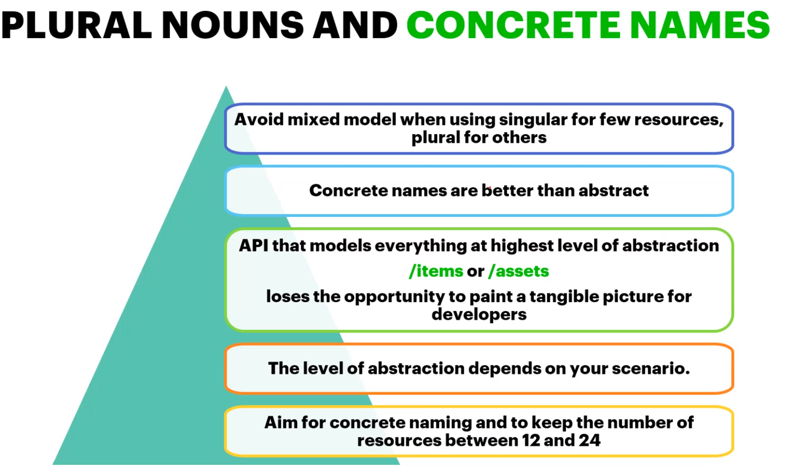

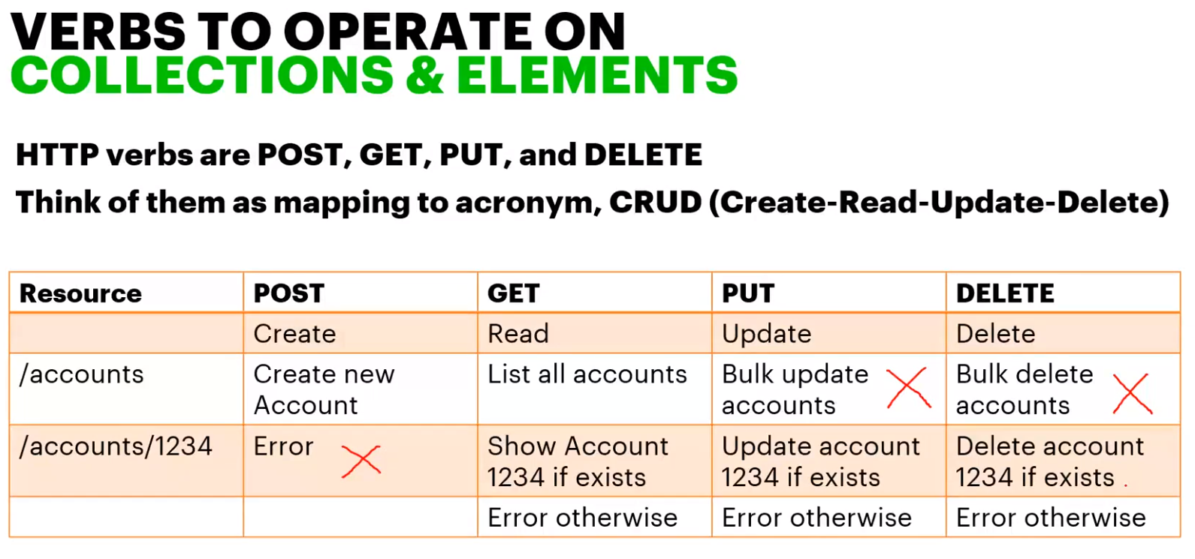

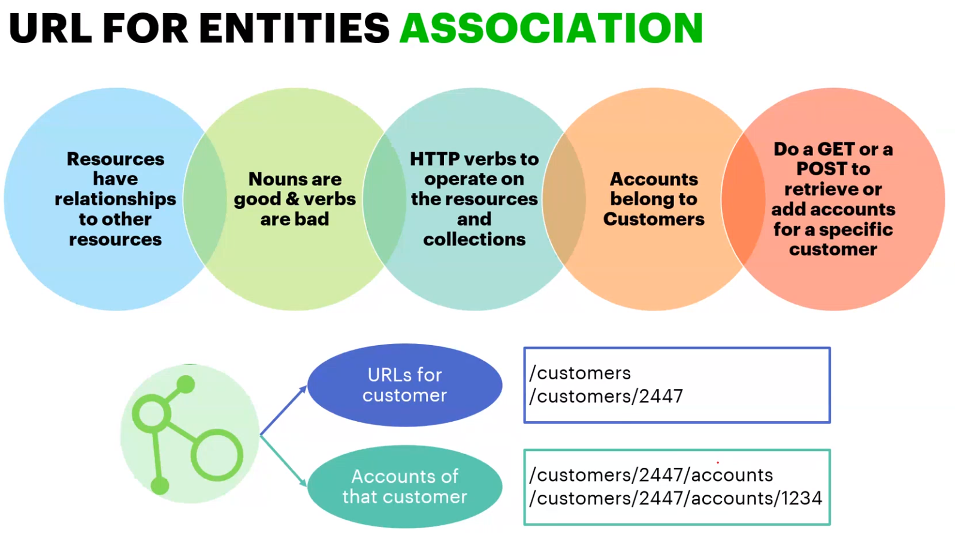

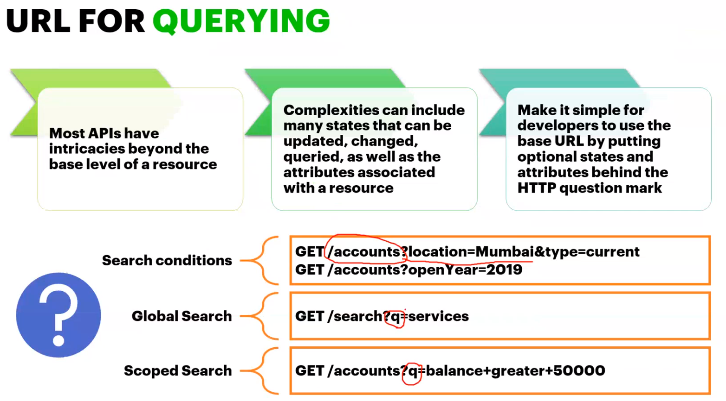

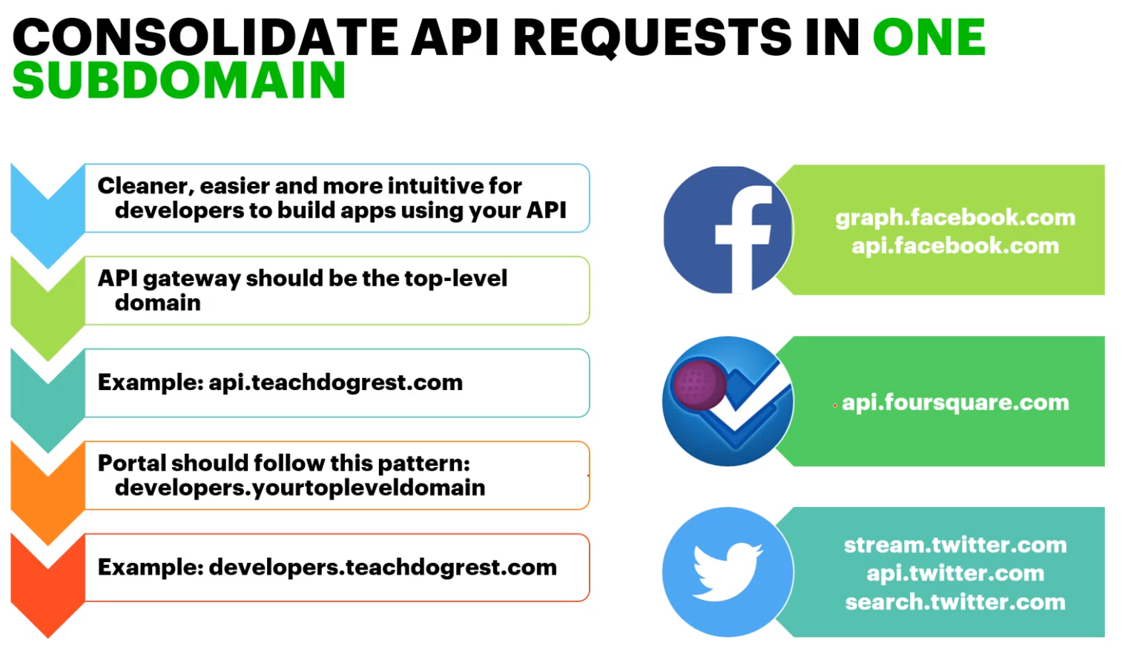

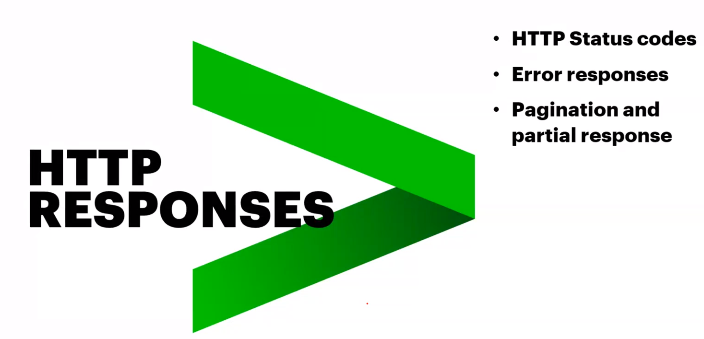

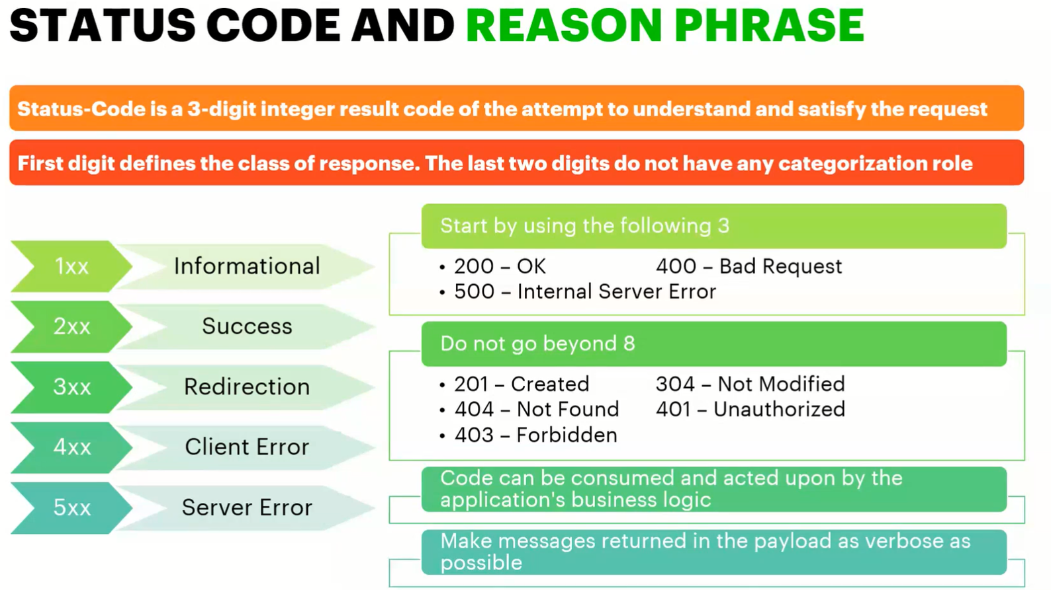

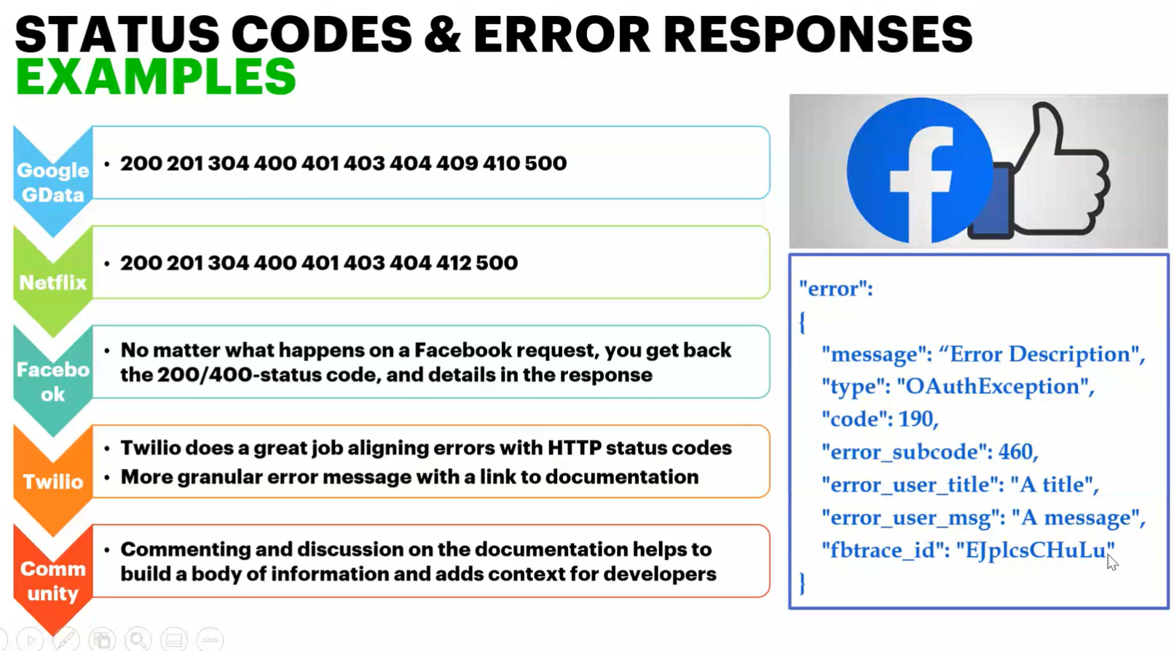

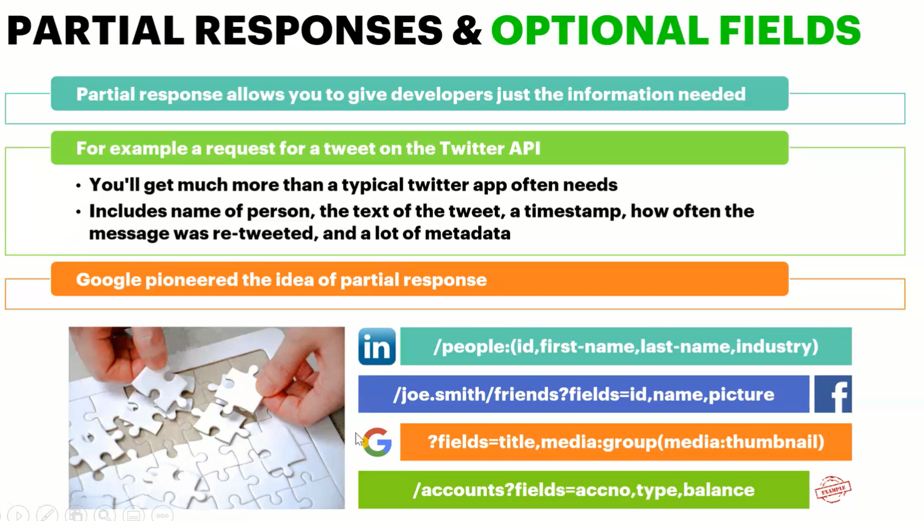

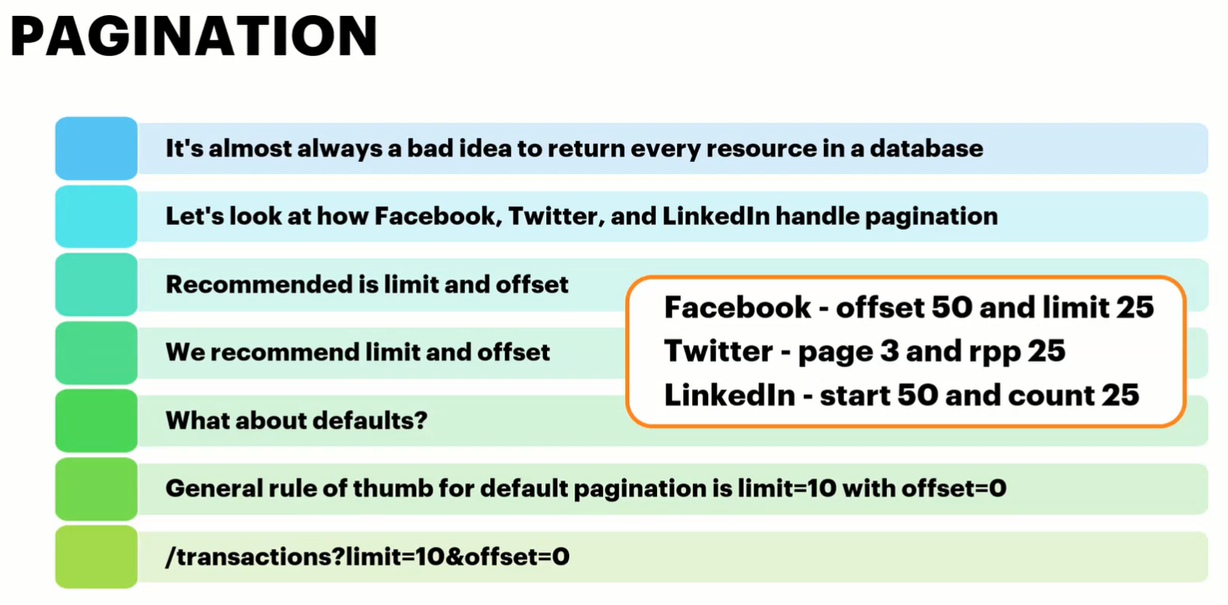

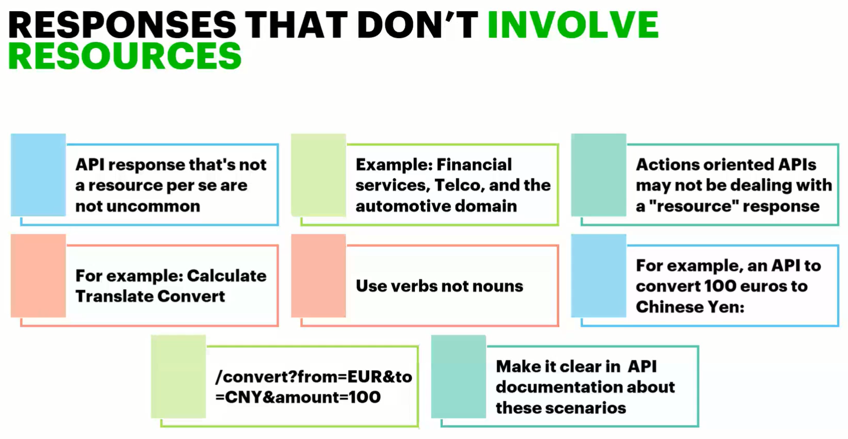

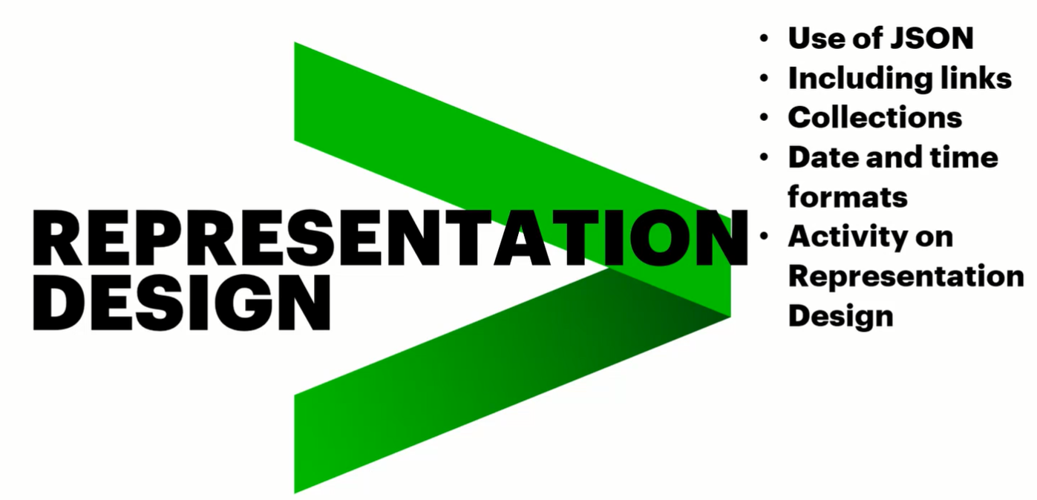

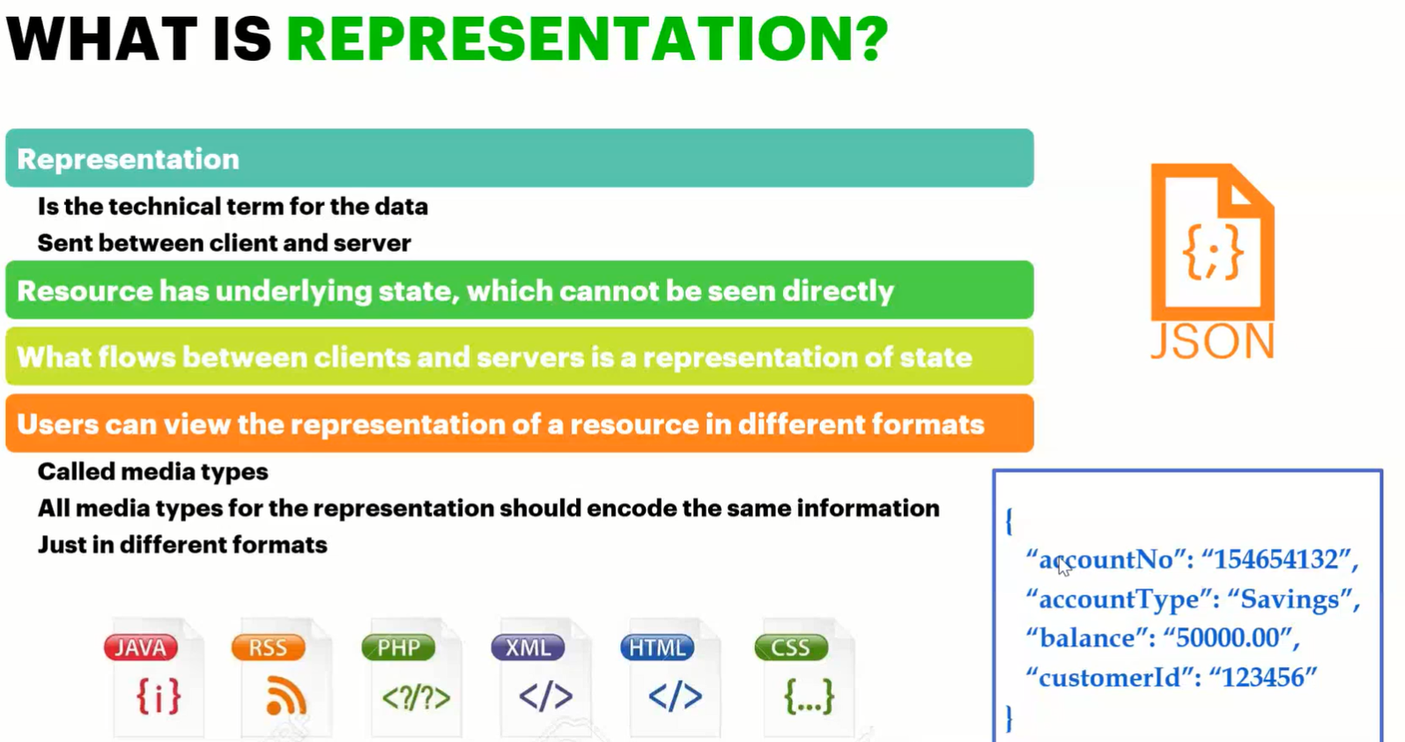

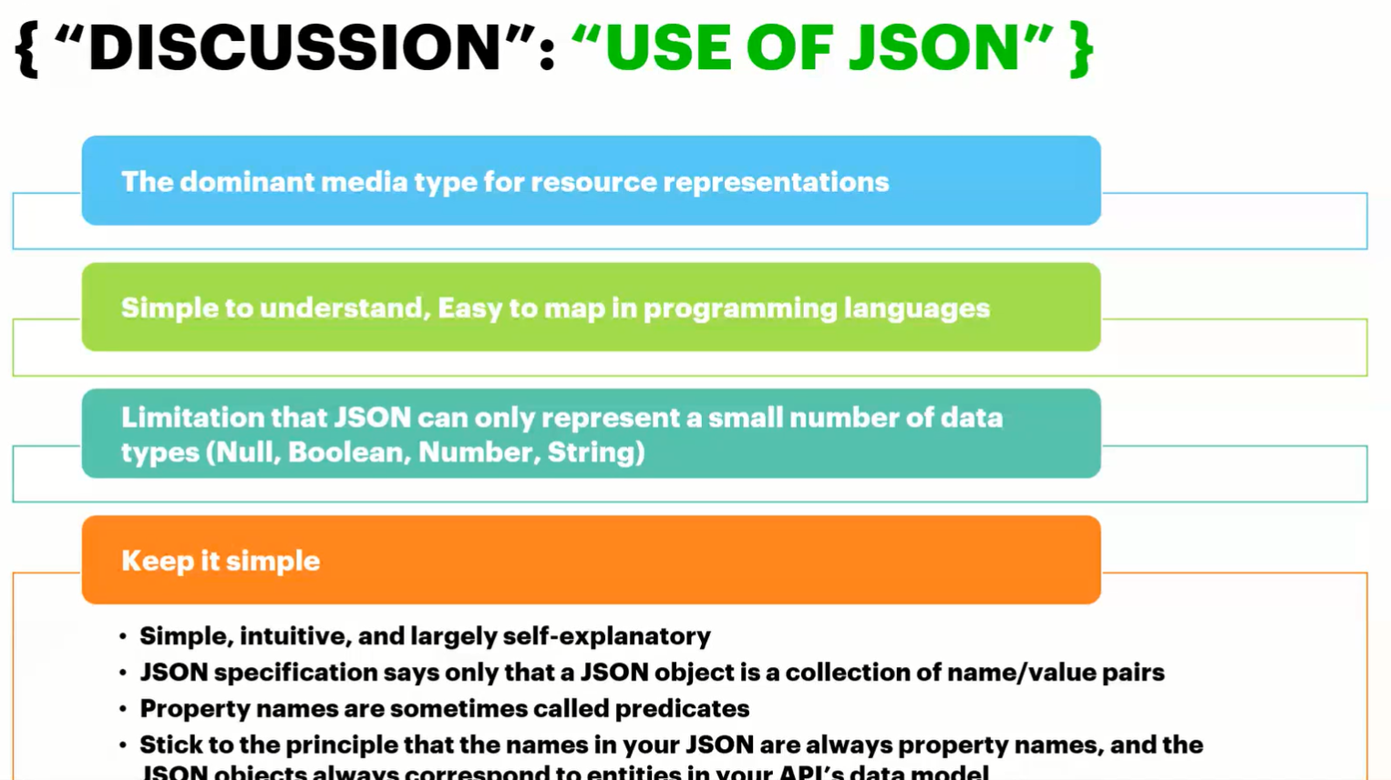

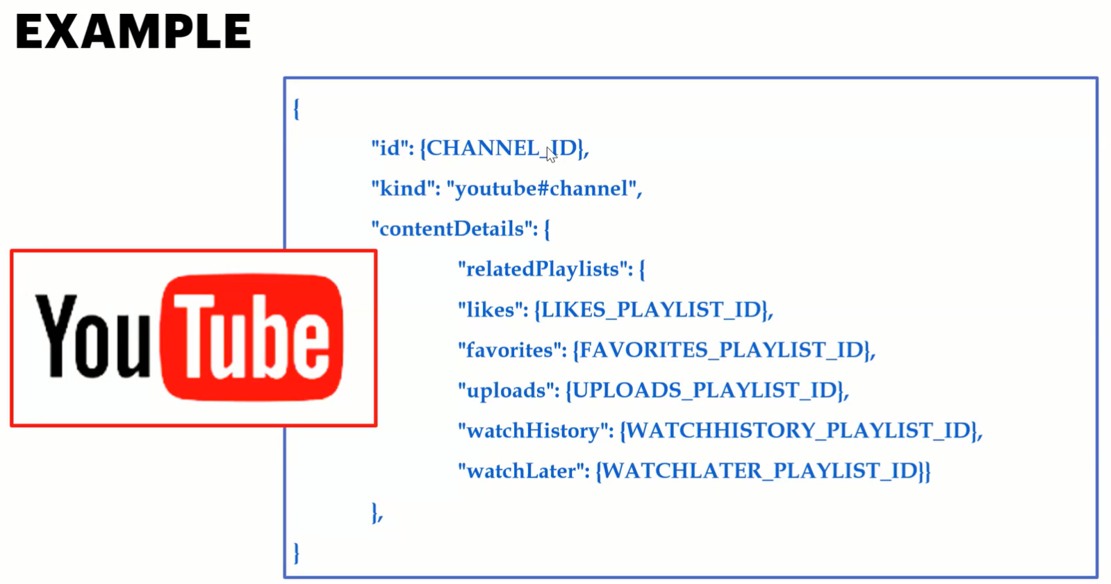

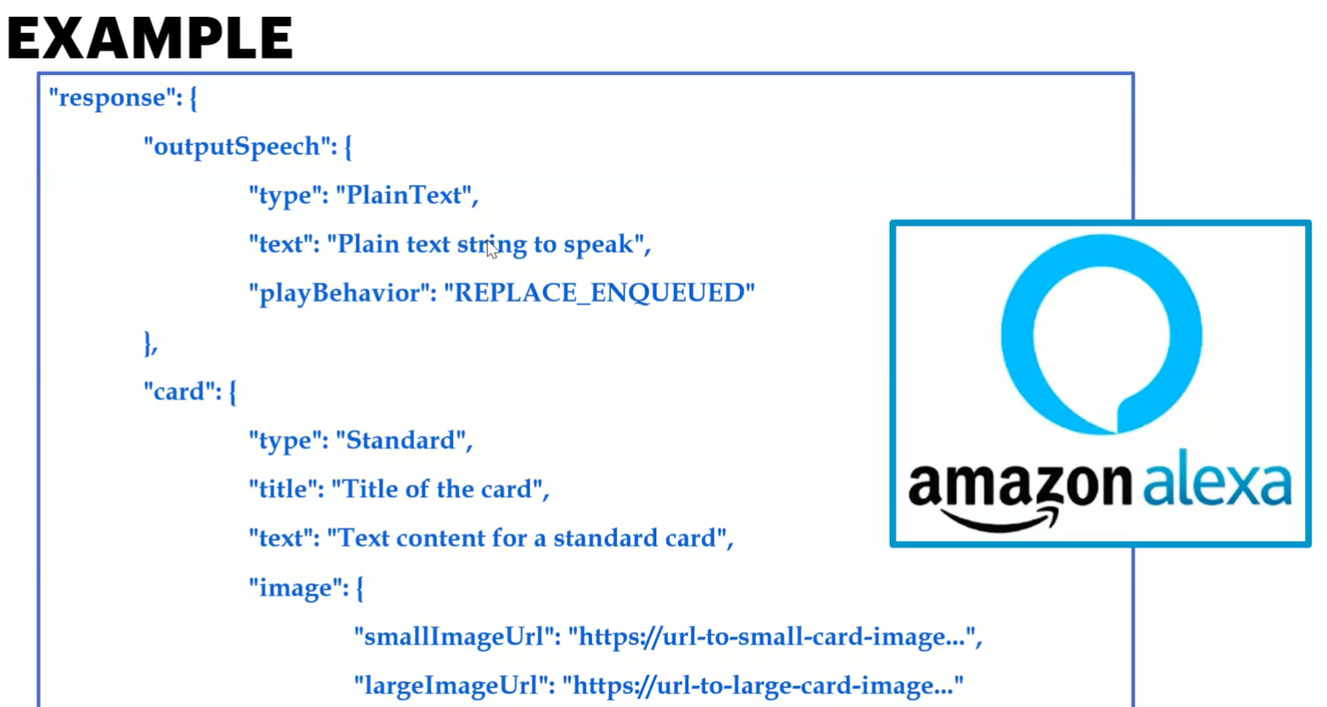

> The facebook way of JSON is not recommended as Key is also get changed which is difficult to map.

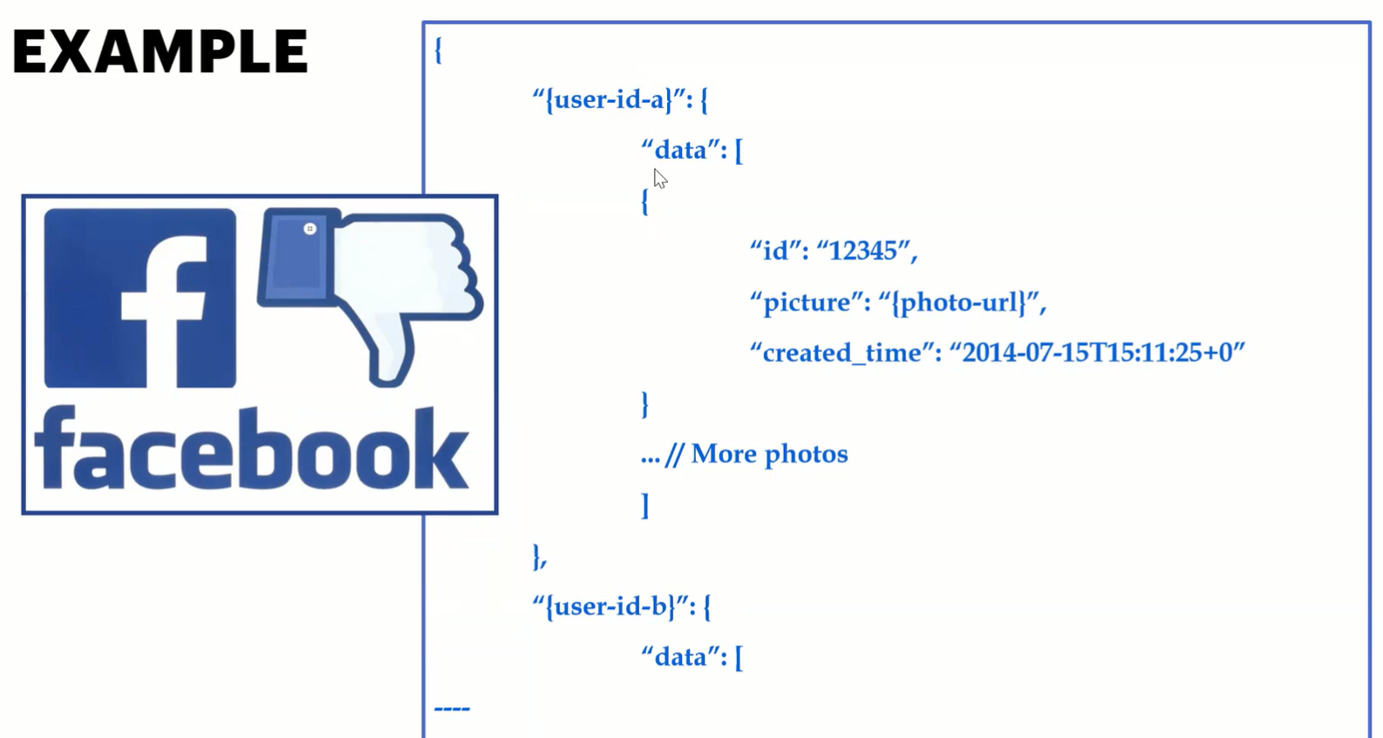

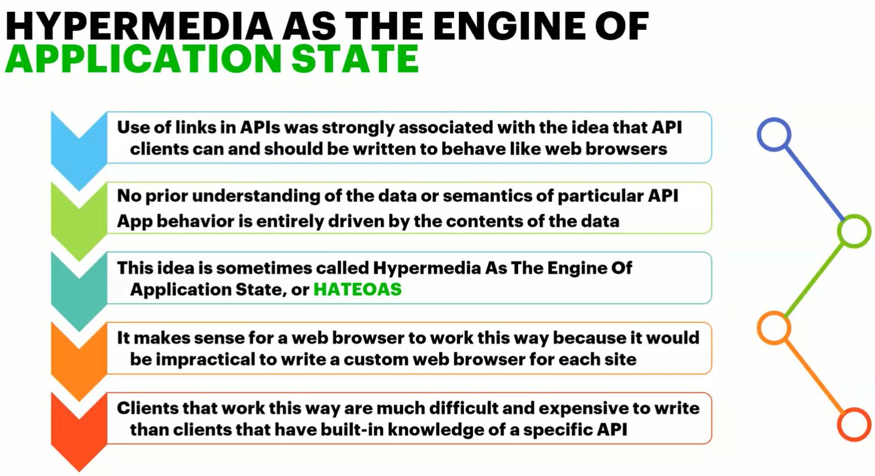

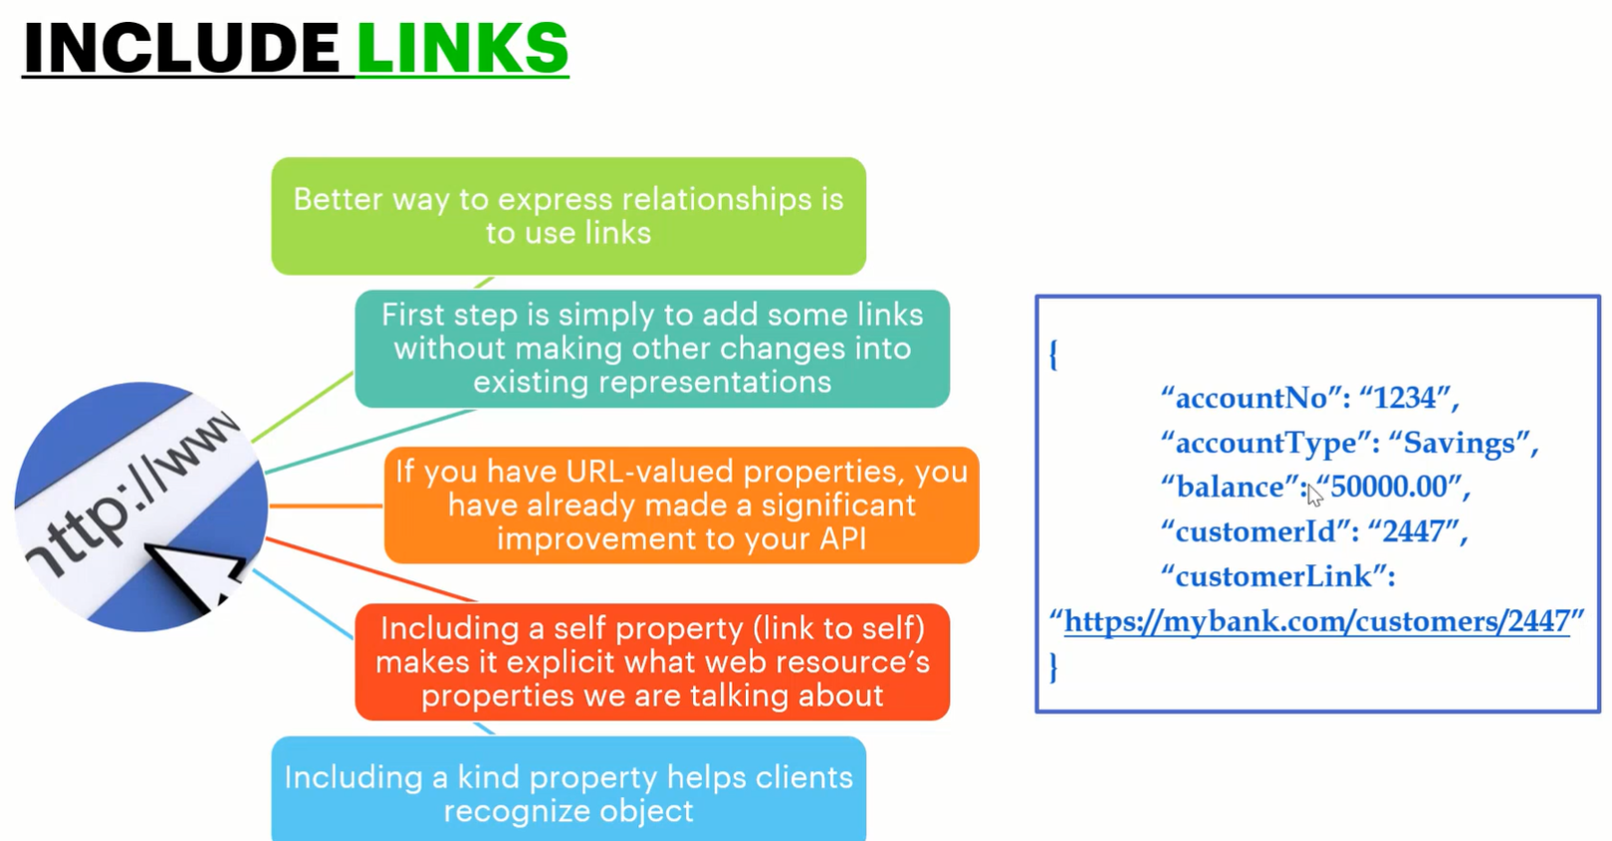

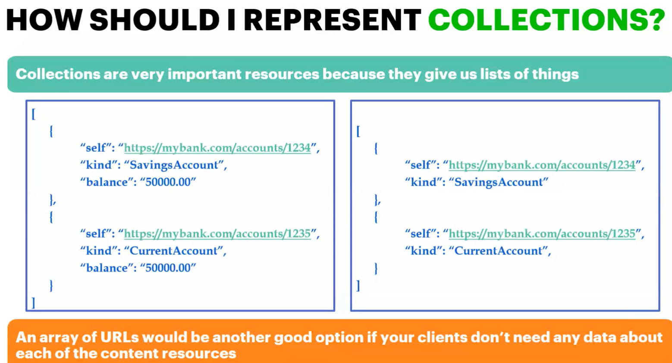

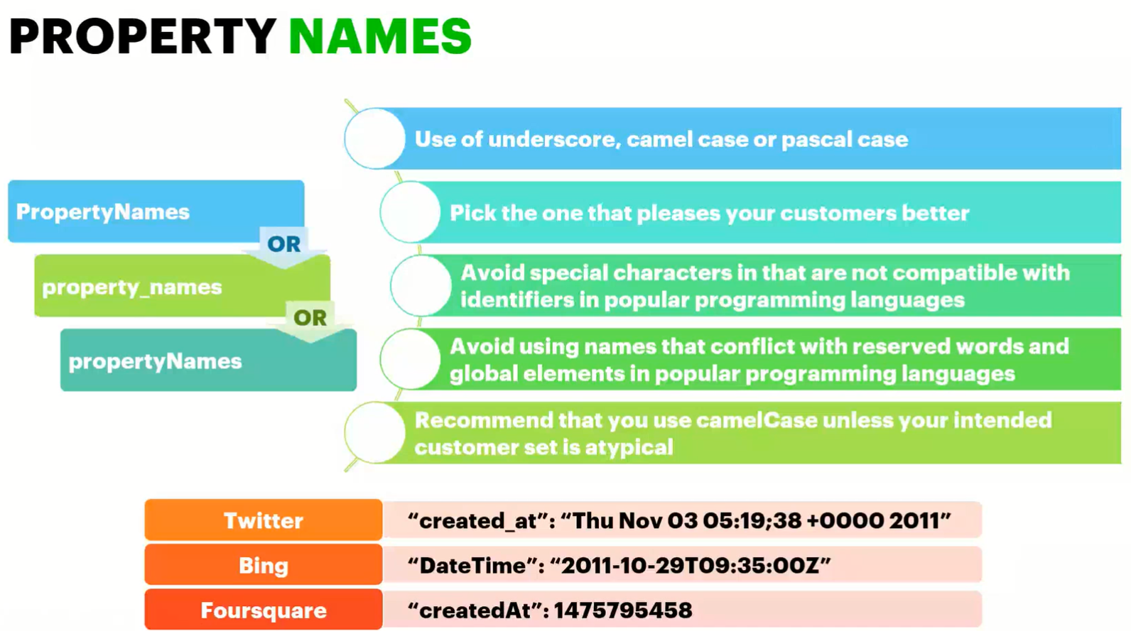

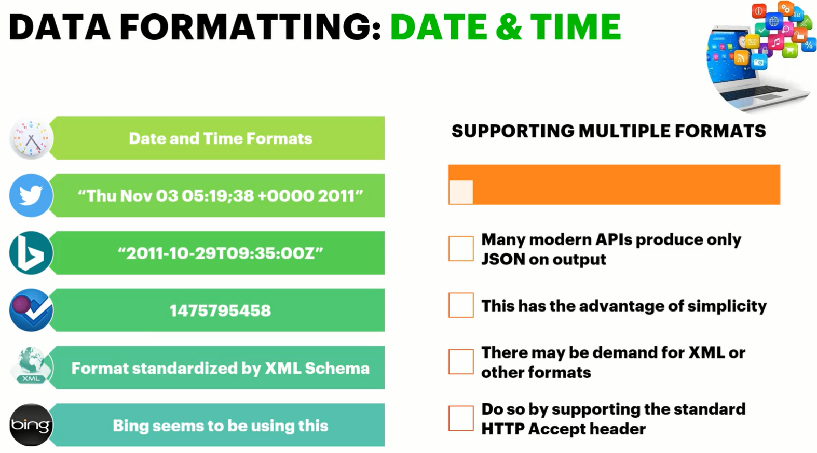

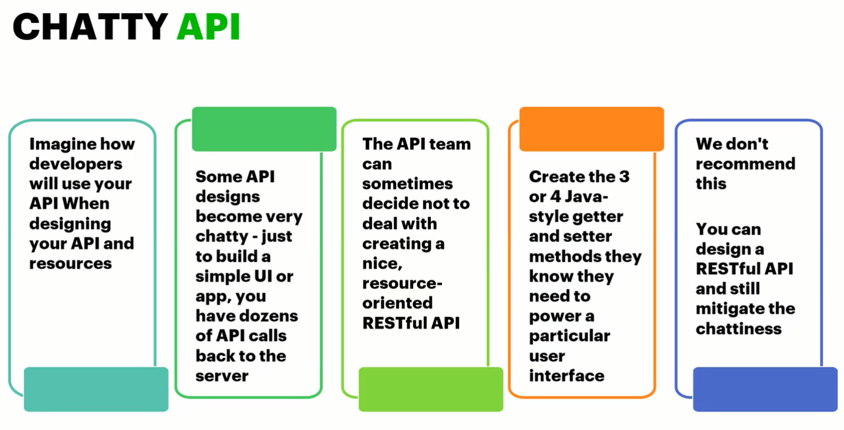

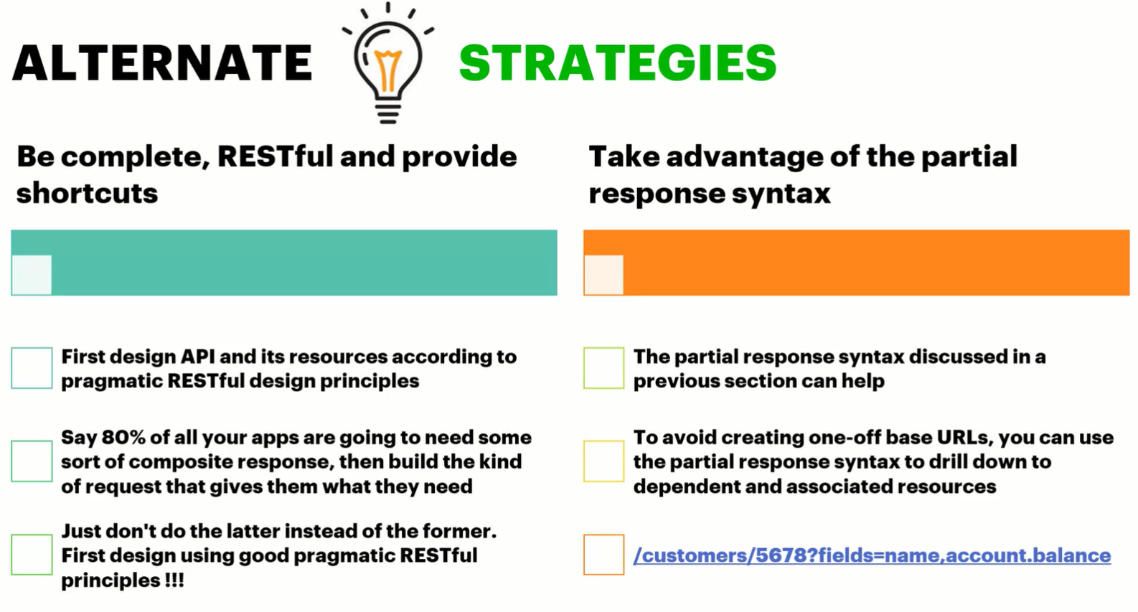

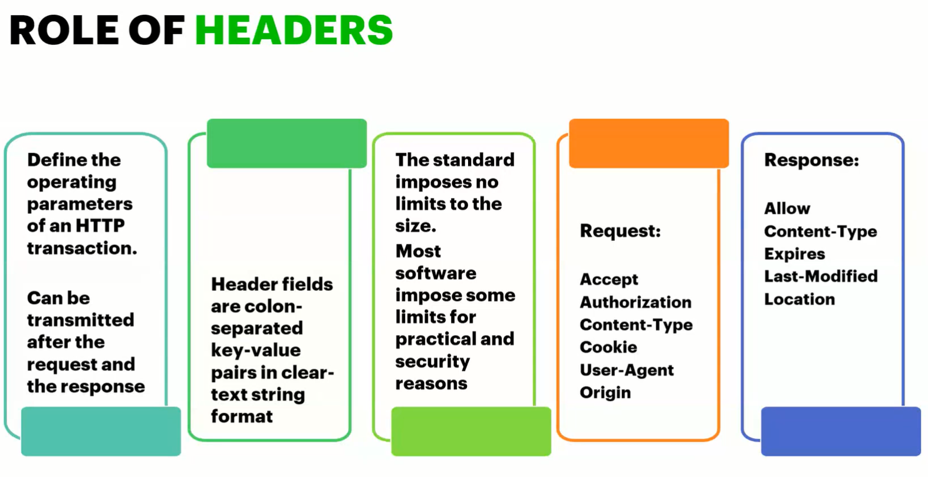

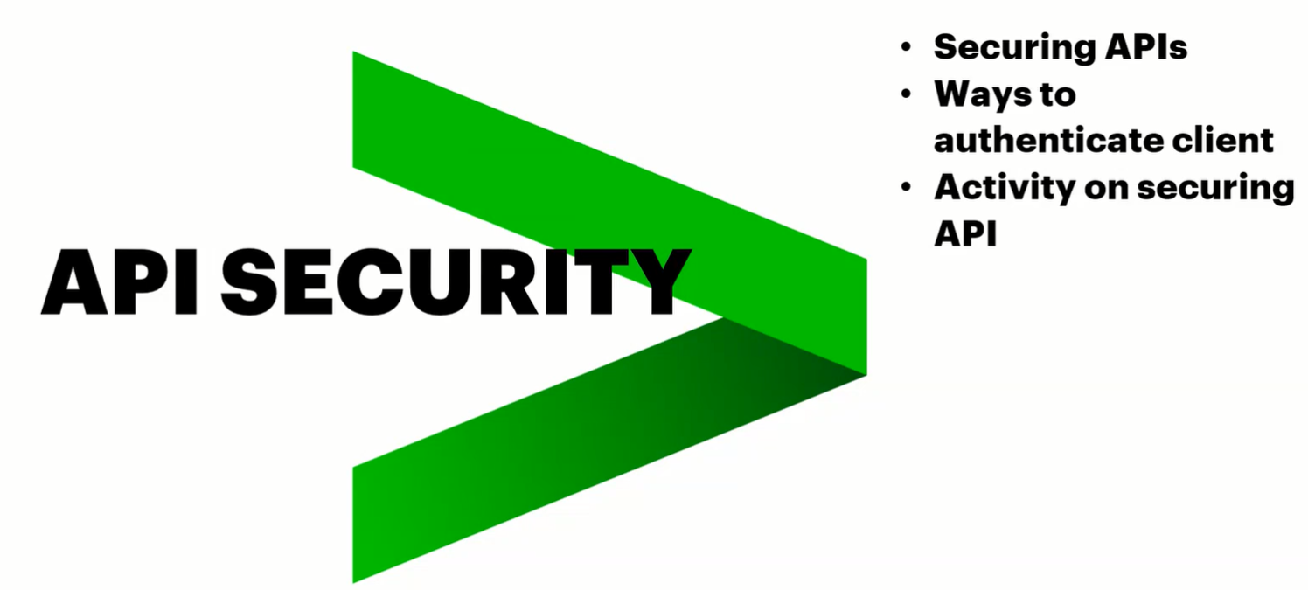

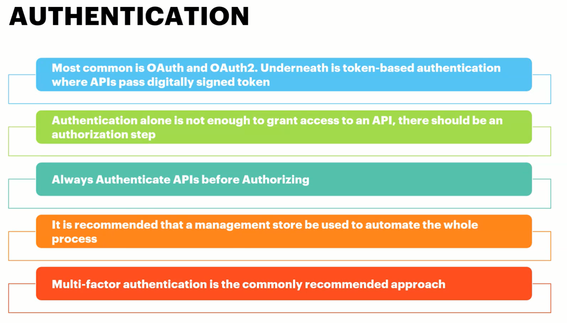

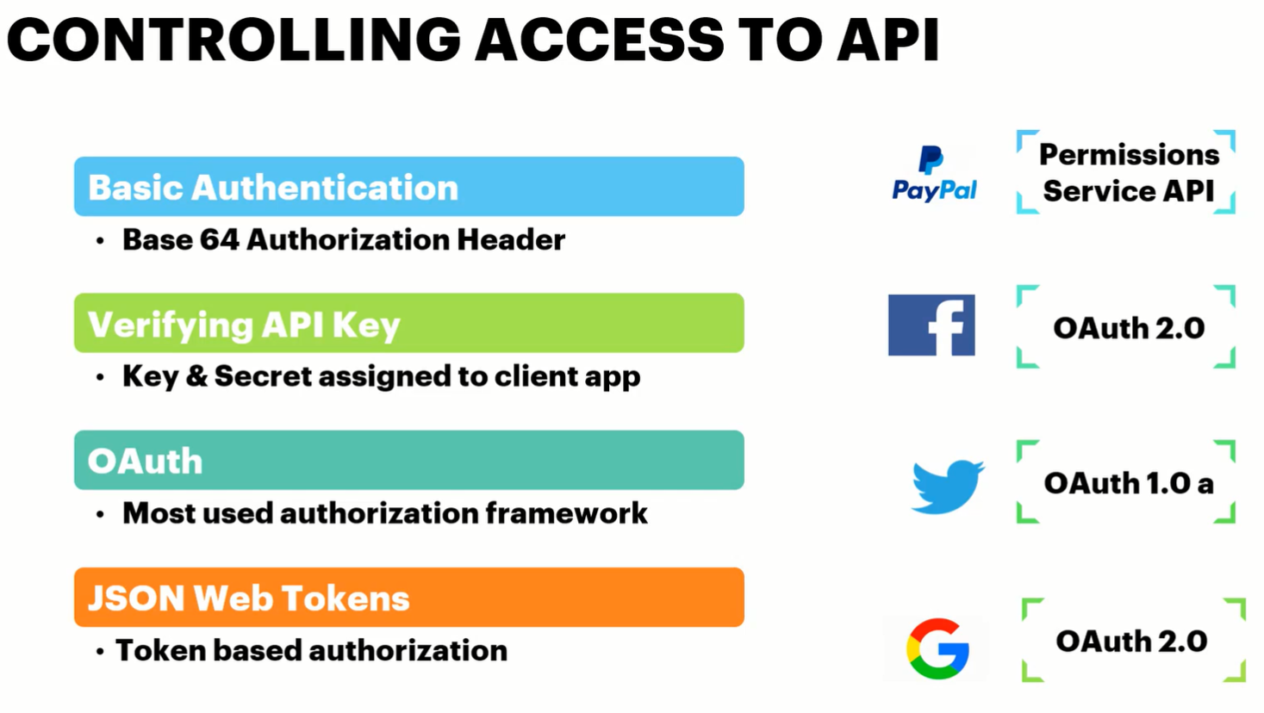

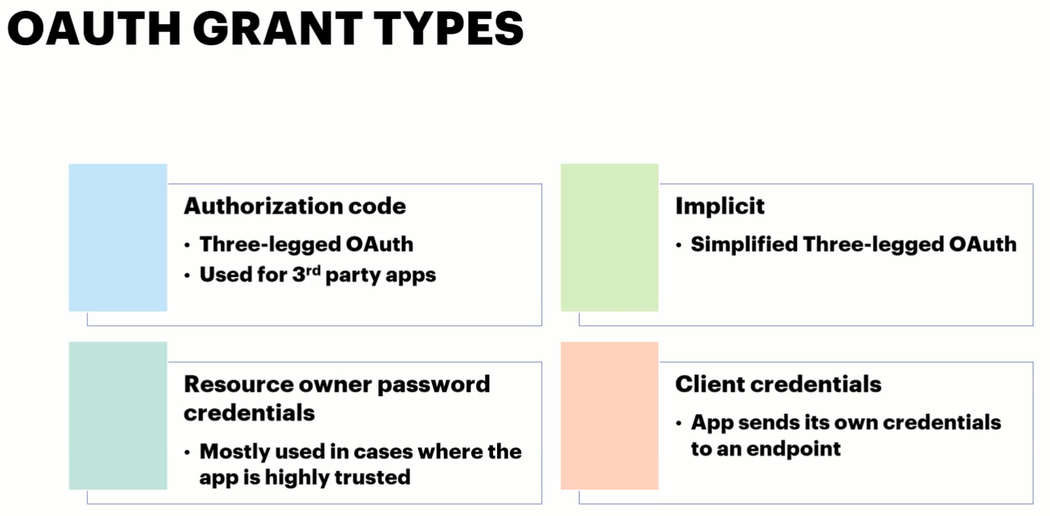

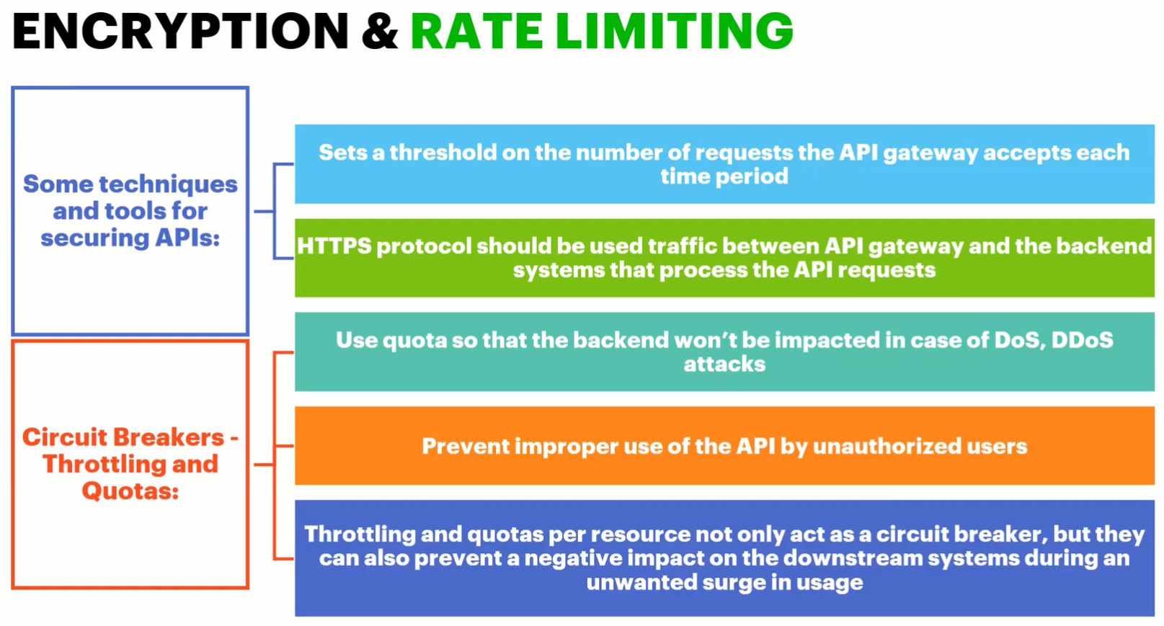

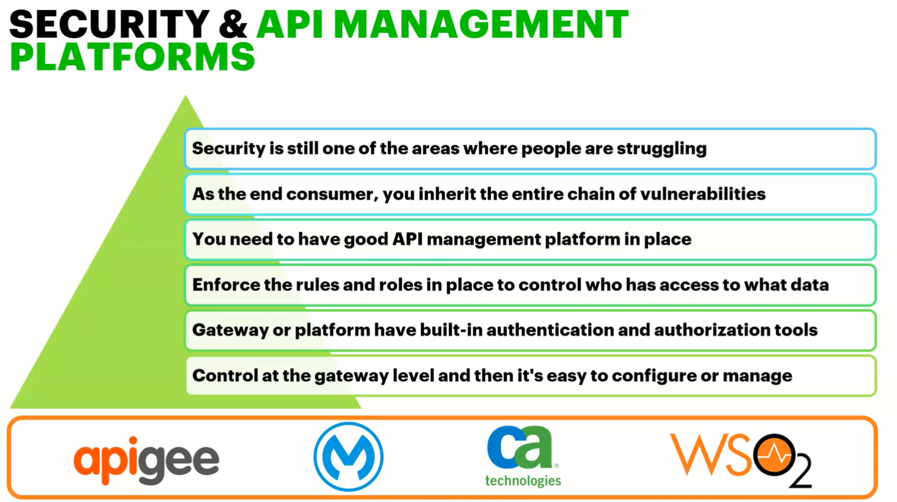

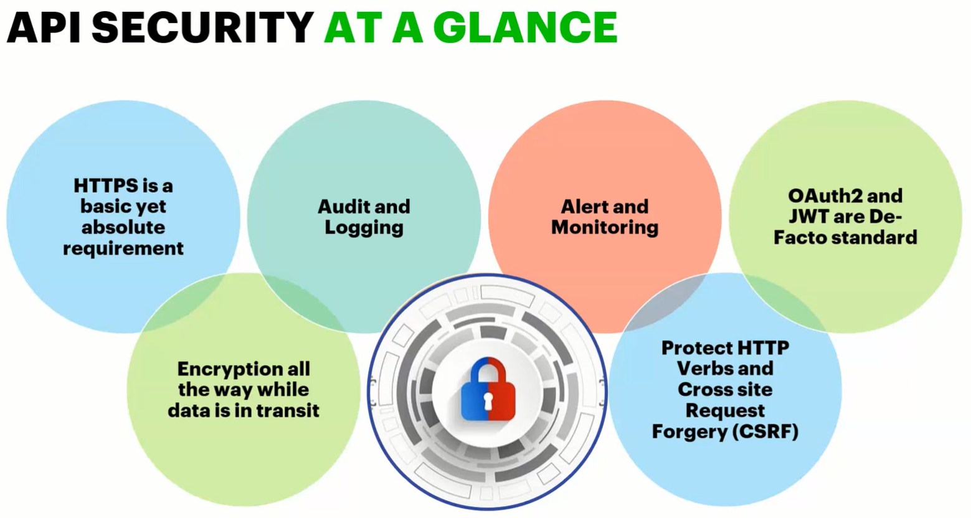

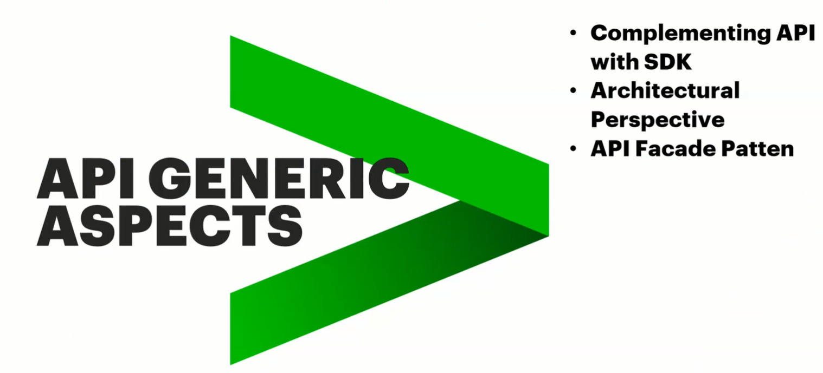

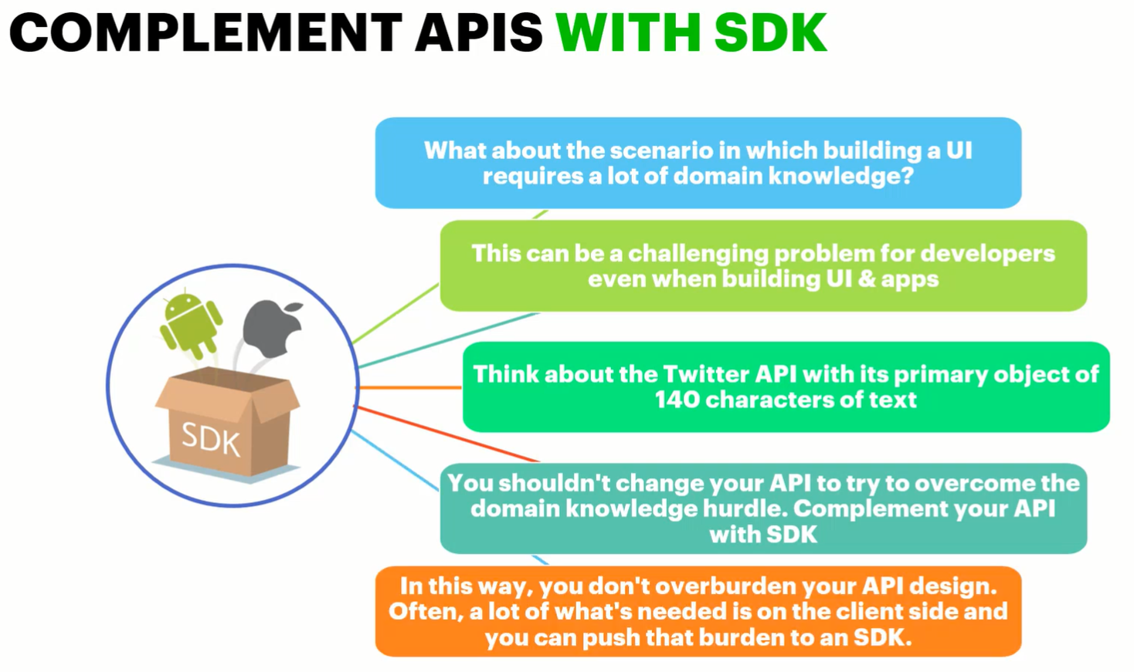

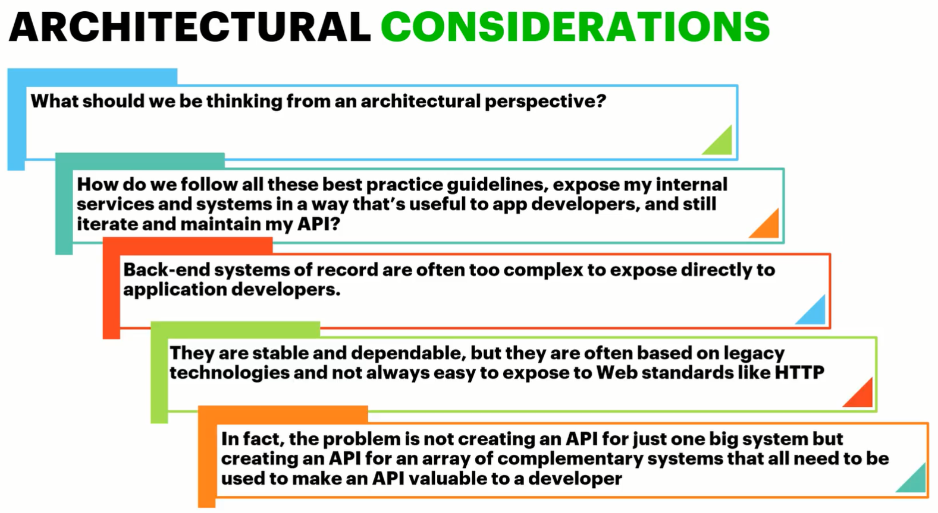

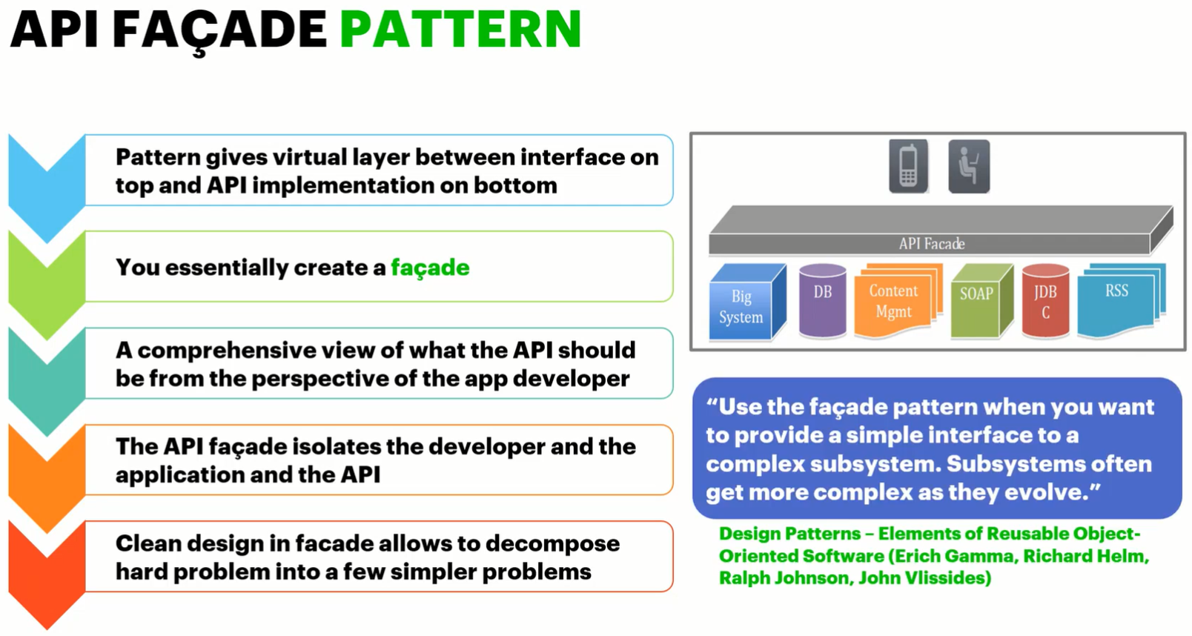

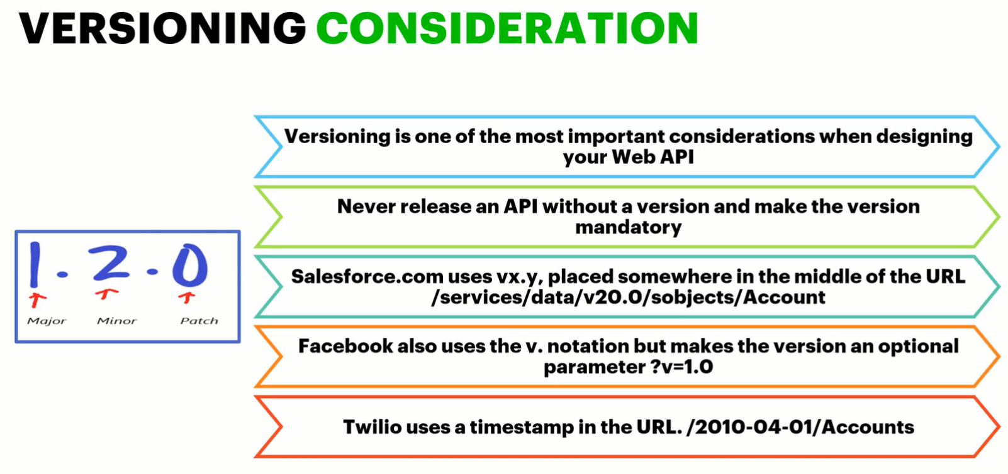

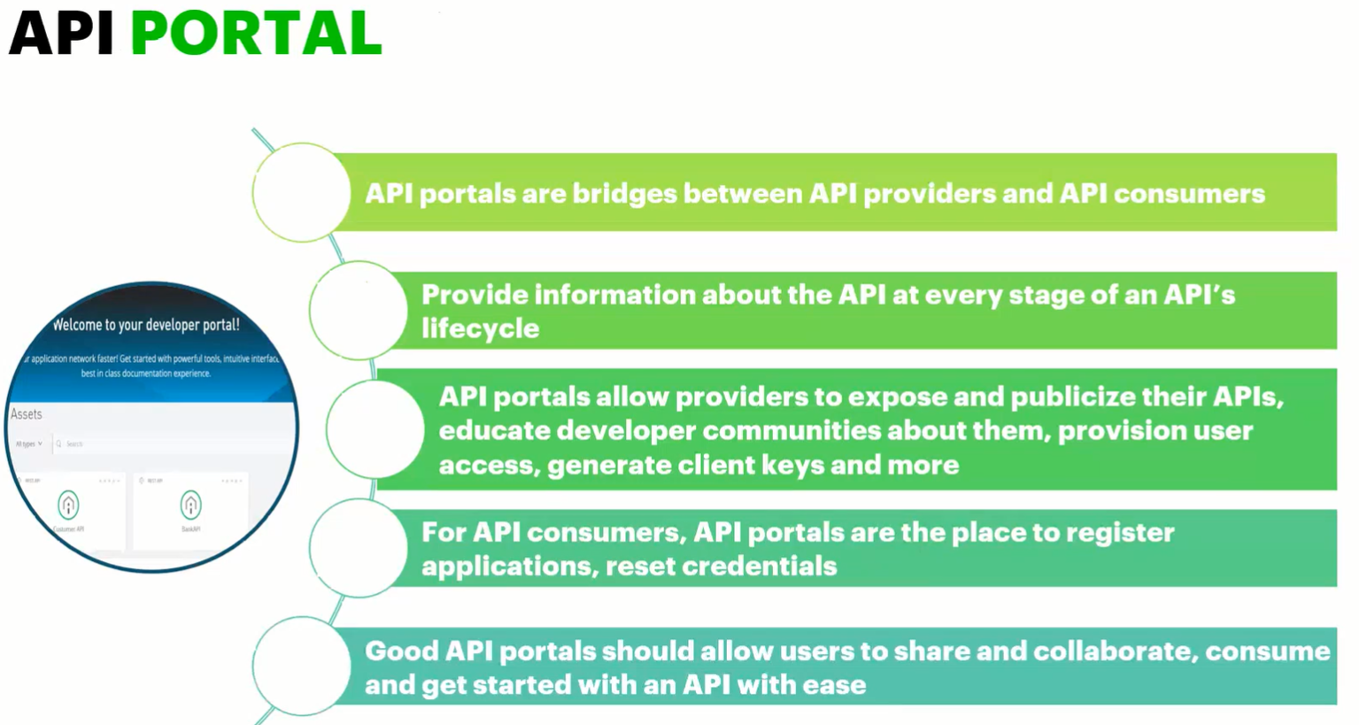

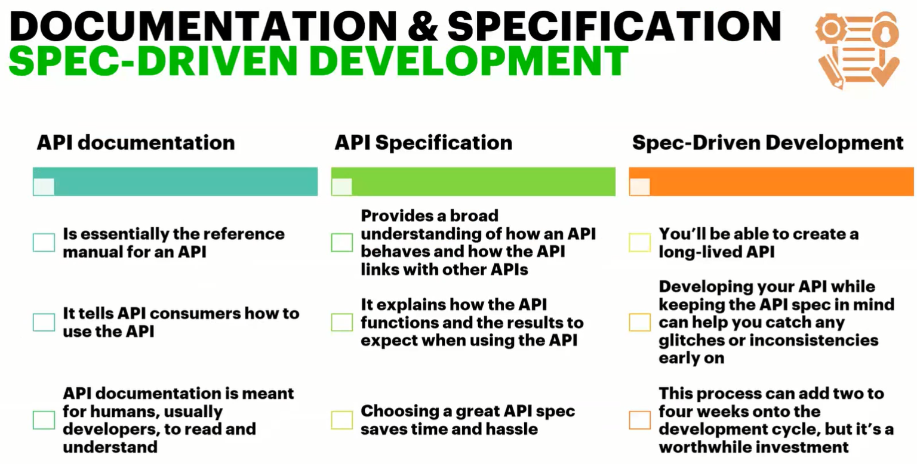

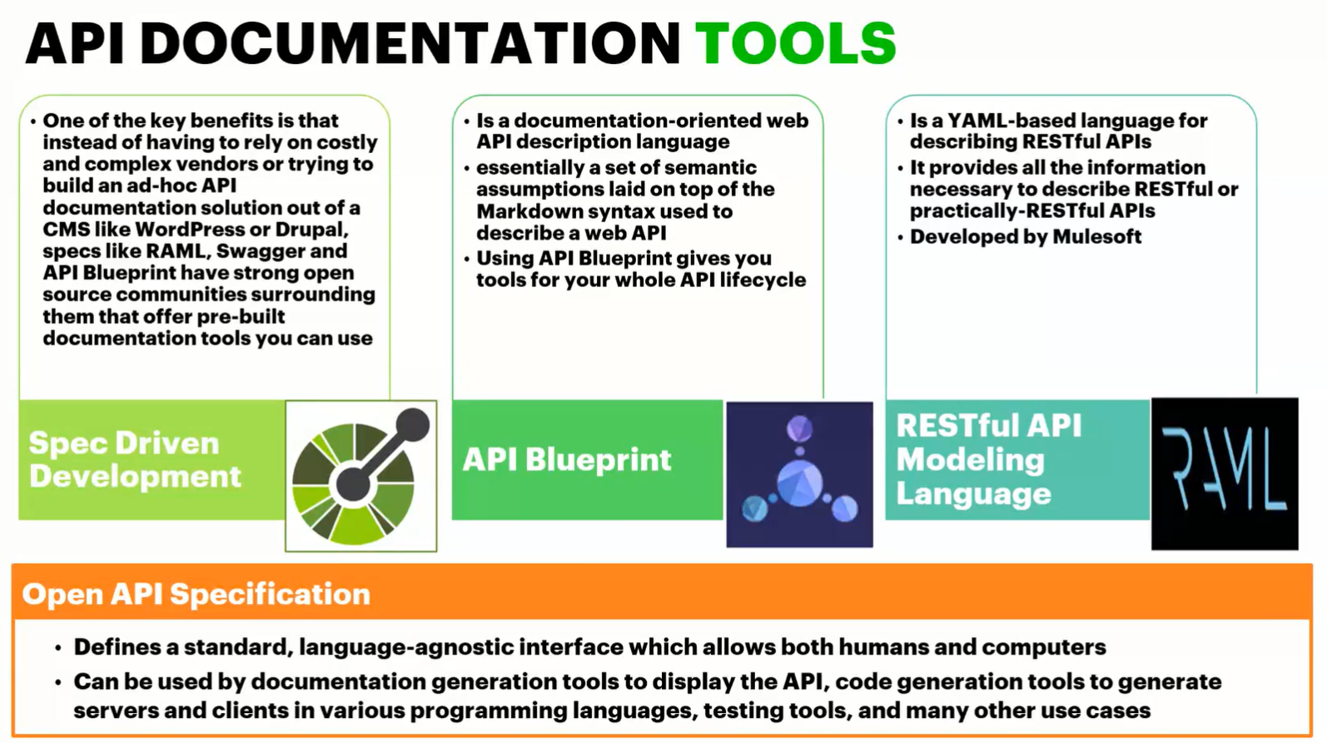

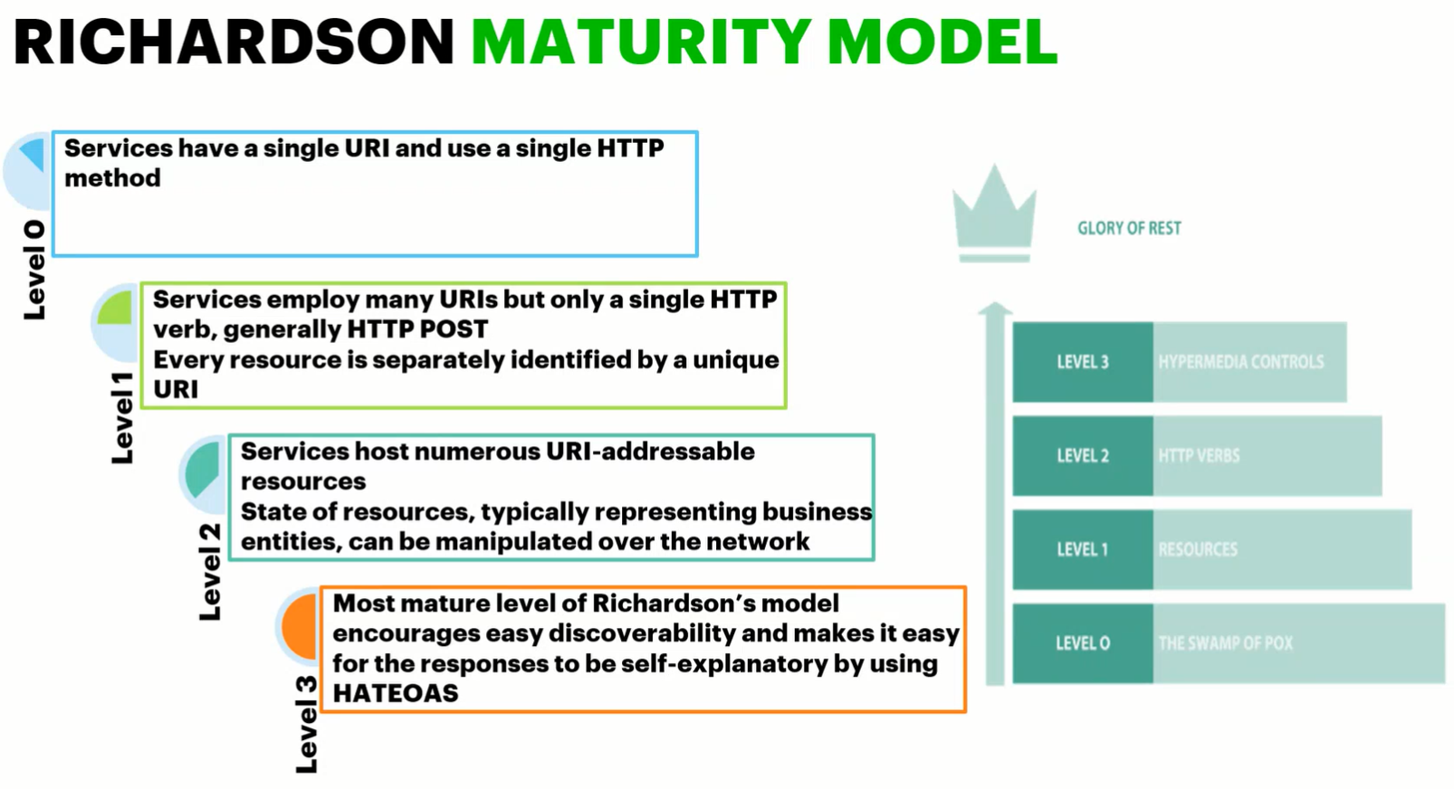

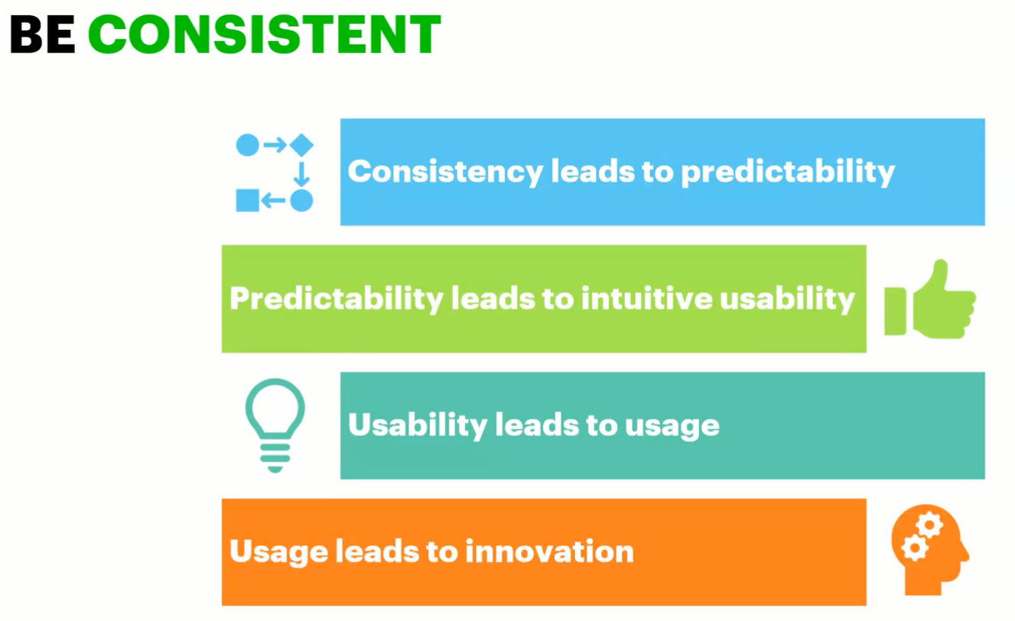

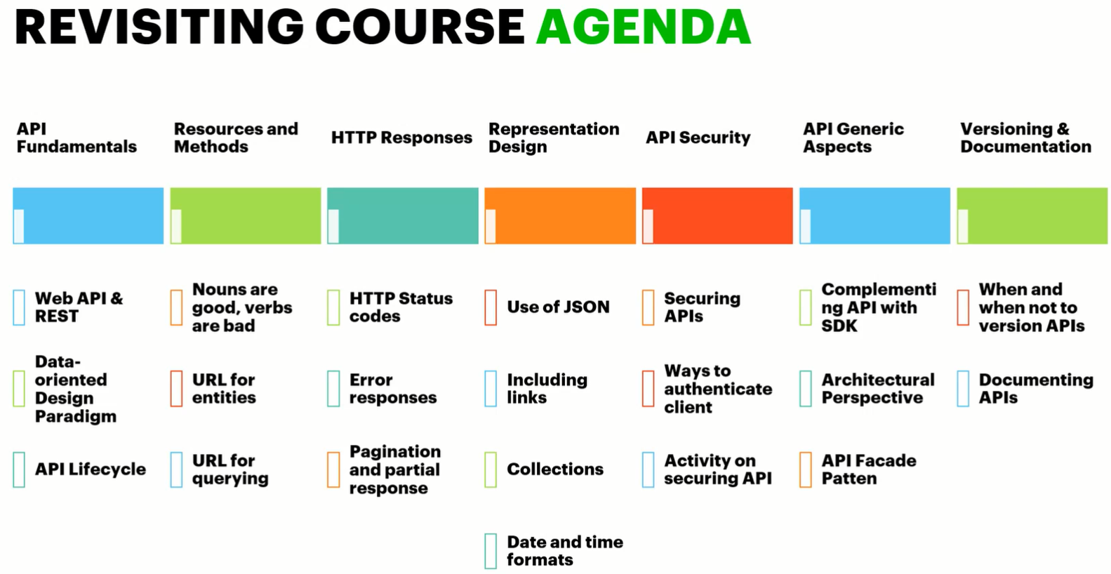

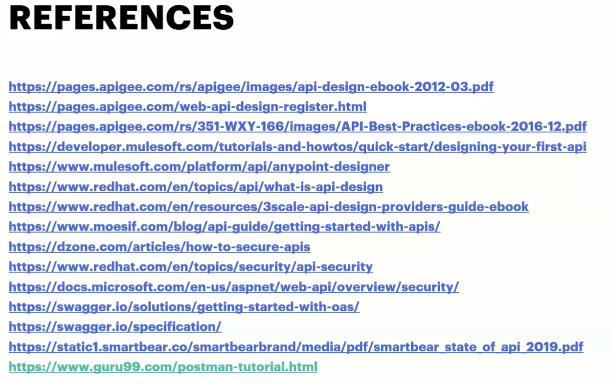

**3. Course Name:** Docker & K8s in

**Focus Area**: Discover how to configure and use Kubernetes

**Resource:** Accenture Resource

**Percipio Url**: <https://accenture.percipio.com/courses/e153e420-0d01-11e8-a73a-2deba30e2d97/videos/0a67f180-0d02-11e8-a73a-2deba30e2d97>

**4. Course Name:** DevOps Introduction

**Focus Area**: Concept of DevOps and the DevOps principles and practices that can help eliminate the problems associated with traditional software development approaches

**Resource:** Accenture Resource

**Percipio Url**: <https://accenture.percipio.com/courses/0bd0699f-173c-4dc0-b646-322791329f89/videos/1a57b416-47e2-433c-b515-da376fb1fe55>